Ely Runners Newsletter

OCTOBER 2009



NEW MEMBERS
This month we welcome the following new members of the club:

Jonah Balmford
Stuart Baumber
Molly Butler
Alexander Ellwood
Rob Harris
Tony Kirby-Cook
Claire Law (rejoining)
Gillian Martindale
Josh Murphy
Lionel Smith

DRINKING WATER AT THE PARADISE CENTRE
Following enquiries from members about access to safe drinking water at the Paradise Centre, John Turner has clarified the following with the centre’s manager:

Members can always ask at the bar for a glass of tap water. On Tuesday evenings, the duty barman puts a jug of water and glasses on the bar for anyone to use. Alternatively, members are welcome to use the tap at the sink in the staff room behind the notice board.

SOCIAL EVENTS
Christmas Drinks
The Christmas Drinks and draw for the club's London Marathon places will be on Thursday 3rd December this year. (The draw is open to members who were unsuccessful in the ballot for places in next year’s VLM.) The venue this year will be The Cutter on Waterside.

Pre-Christmas Run from Woodditton to Ely
The long training runs from Woodditton and Reach will be on Sunday 20th December this year. As in previous years, members are invited to meet for Sunday lunch in The High Flier afterwards.

Julie Foreman will be in touch nearer the time with further details of these events.

NEWS OF FORMER MEMBERS
William Clapp, a member of Ely Runners from 2001 to 2006 and now a member of Harborough AC, has attributed his recent improvements to a forced increase in mileage since acquiring a dog 2 years ago. “The dog mainly just walks with me, but those extra miles seem to have had a big impact on my fitness. I think there will be further improvement from increasing the run v walk mix…” he says.

Highlights from his performances this year include taking gold in 3 events in the Leicestershire Masters Track and Field Championships (800m in 2:16.4 mins, 1500m in 4:35.7 mins and 5000m in 16:54.0 mins), plus silver in the 10,000m (in 35:15 mins). He was part of the team that won bronze in the county cross-country championships and finished 3rd MV40 in the East Midlands Grand Prix. His new PB for 3000m, of 9:43.7 mins, is his best-ever race on the WAVA age-grading system (81.5%) “On that basis,” he says, “I should be able to knock ten sec's off my 5 mile PB -- the only one set in an Ely shirt (Huntingdon March 2006 27:48). Season's best is 28:09.”
On 6 September, former 2nd claim Ely Runner Claire Hallisey (née Willer), who now runs for Bristol & West AC, was 1st woman in 1:12:03 in the prestigious Bristol Half Marathon (and won £1,000). There is an extract below from the race website: www.bristolhalfmarathon.com.

As a measure of her progress, Claire was 2nd in the Grunty Fen Half Marathon in 2005 in 1:25:04 and 2nd in 2006 in 1:24:26.

Claire has now been selected to run for GB in the World Half Marathon Championships in Birmingham on 11th October.

East Anglian Cross-Country League
The club has been a member of the EACCL for the last two seasons. However, very few members have actually attended any of the races (10k for men and 5k for women), perhaps because they are held on Wednesday afternoons at 2.30 pm. John Turner (secretary@elyrunners.co.uk) has therefore asked for members interested in running in this league to contact him, so that the club can decide whether to enter the league again for the coming season.

The provisional dates (to be confirmed after the AGM on 14 October) are:
14 October 2009 RAF Barnham
4 November 2009 To be confirmed
18 November 2009 UEA
2 December 2009 Tri-Anglia
6 January 2010 RAF Barnham
20 January 2010 RAF Marham
27 January 2010 Wattisham
10 February 2010 GYRR
17 February 2010 St Edmunds Pacers
10 March 2010 RAF Barnham (to include EACCL Relays & Prizegiving)

ELY STANDARD 19th GRUNTY FEN HALF MARATHON, SUNDAY 13th SEPTEMBER 2009
Report by John Turner, Race Director
A special thank you to those members, families and friends who gave their time, effort and sponsorship before, during and after the event. Your considerable efforts contributed to a safe, successful and enjoyable race and County Championship. Details of the event, including the results and photographs, are on the race website www.gruntyfen.co.uk.

However, we were fully stretched, particularly Brenan Morgan's marshals whom he had to skilfully leapfrog around the event to keep the race secure. There would not have been an adequate number of marshals without a large contingent from neighbouring clubs March AC and Ramsey Road Runners, to whom we are extremely grateful.

Membership of Ely Runners provides many benefits which are made possible by the income flow from our open events and we have more than enough members to avoid such a precarious level of support. Therefore, please could all members understand that our hard-working Committee and Events Working Group need much more support for our popular open events as these are essential for the future viability and development of our club, and the many opportunities and enjoyment of our sport.

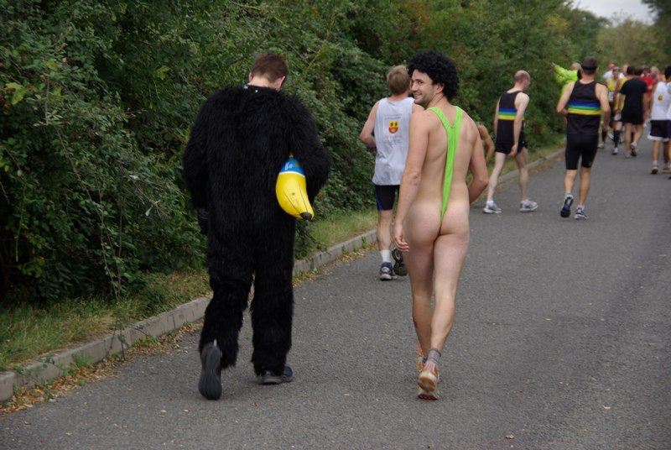
These competitors obviously hadn’t checked the same weather forecast before the race....

FORTHCOMING EVENTS
Frostbite Friendly League
The 2009-10 FFL kicks off this Sunday (4 October) with the first fixture at Priory Park in St Neots. For the first time, the club has entered both a senior and a junior team in the league. In the senior league, the top 7 men and 3 women from each club make up the scoring team, whilst in the junior league, 5 runners, including at least one female, score. However, any number of club members can run and ALL runners influence the result, so please make a note of the fixtures and turn out for the club if you can.

Any junior members (aged 9-15) wishing to run should contact Alan Rutterford (Alanatrdsltd@aol.com or 01353 741534 or 07821 988959).

Junior races start at 10:15 am and Senior races start at 11:00 am.

Fixtures:
4 October 2009 Priory Park, St Neots (Riverside Runners)
8 November 2009 Bushfield Sports Centre (Bushfield Joggers)
13 December 2009 Hinchingbrooke Park (Hunts AC)
17 January 2010 Ramsey Sports Centre (Ramsey Road Runners)
7 February 2010 Bourne Woods (Bourne)
7 March 2010 Huntingdon BRJ Club (BRJ)

Further details are available on www.frostbiteleague.org.uk.

EVAC Cross-Country Championships
These championships will be incorporated in the 8k main race at the Ampthill Trophy Meeting on Sunday 18th October at 11am. (Details are available at http://www.ampthilltrophy.org.uk/.) Members wishing to take part should enter the race through Ampthill & FF and there will be no additional entry fee for EVAC on this occasion. The number of medals awarded in each category will depend upon the number of entries.

The Ampthill Trophy is a popular event but challenging event. It is a hilly course with a lot of good grass parkland.

ARC Championships 2009
Just a reminder that members can enter the various championships organised by the Association of Running Clubs.
ARC Postal Marathon Championship 2009
Please send your best 2009 result to The ARC Championship Secretary, Ian Vaughan-Arbuckle (also an Ely Runner and Race Director of the Round Norfolk Relay!), at championshipsecretary@runningclubs.org.uk.

Conditions of entry:
- You must be a member of an ARC-affiliated club
- The race must have been run under ARC/UKA rules and over a certified distance
- Your personal result must be verifiable either on a printed result list or on a race website
- The race must have been run during the period 1st Jan - 31st Dec 2009
- Application must be made in writing to Ian V-A’s email (championshipsecretary@runningclubs.org.uk), giving the following details:
Full name, gender, club. Age on race day. Name and date of race. Finishing time (gun to tape)
- Awards will be made at the discretion of the ARC committee.
- There is no entry fee.

Full details are available on the ARC website: www.runningclubs.org.uk > Championships

ARC Half-Marathon Championships
These will be held as part of the Stevenage Half Marathon on 1 November, organised by Fairlands Valley Spartans RC. Entries are via www.fvspartans.org.uk.

Hereward Relay
Alan Rutterford is now taking names for the Hereward Relay, to be held on Sunday 22nd November 2009. This event (organised by March AC) is a 4-stage relay from Peterborough Cathedral to Ely City Football Club (38 miles). The club usually enters 6 or 7 teams. It can be frosty, very cold, wet and muddy on the farm tracks, so is a good test of your agility and endurance.

Stage 1 - Peterborough to Whittlesey - 6.48m on footpaths and road

Stage 2 - Whittlesey to March - 11.35m on farm tracks, footpaths and road

Stage 3 - March to Welney – 10.30m on farm tracks and road

Stage 4 - Welney to Ely - 9.60m mainly on farm tracks and road

Check out the maps at www.elyrunners.co.uk click on races and then Hereward Relay.

As March AC kindly help us to marshal the Grunty Fen and New Years Eve races, we usually return the favour by marshalling the finish area from Little Downham to the finish, so Alan is also looking for 4-5 volunteers to help with this.

If you are interested in running or marshalling, please contact Alan at training, by email (alan@elyrunners.co.uk) or phone (07821 988959).

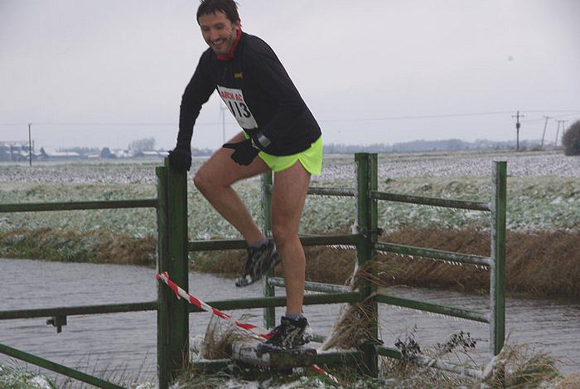
Steve Barker enjoys the challenges of Stage 3 of the Hereward Relay (November 2008)

RESULTS ROUND-UP
Ian Green, still in search of his endurance limits, tackled the UK Double Ironman in Bolton at the beginning of August. Having withdrawn from the same event last year, Ian was determined to “[get] the monkey of failing the double Ironman last year off my back”. He did this in grand style - read his vivid account in the Results section of the website.

Meanwhile, David Richards chose the same event for his first experience of an Ironman event. It was an impressive debut in less-than-ideal conditions, as he finished in an overall time of 13:17hrs, though David has promised to return to the Ironman start-line in 2011 in quest of a sub-12hr performance. David’s exploits are also detailed in the Results section of the website.

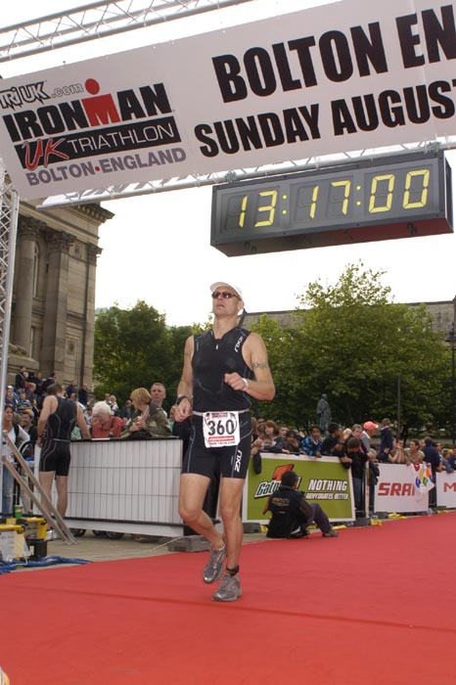 Dave Richards

Whilst his clubmates have been racing shorter distances over the summer, Club Captain, Charlie Barker, chose a couple of tough multi-terrain events for the focus of his summer racing – the Belper Rugby Rover 30k and the infamous “Beast” (c. 13m) around Corfe Castle in Dorset – where he placed well and demonstrated he is in good form.

Ian Day has continued his return from injury by racing over a huge variety of distances and terrains, from 3k on the track to the gruelling International Matterhornlauf in Zermatt, Switzerland, picking up several category prizes.

Despite having the final few weeks of preparations for her first marathon being blighted by injury, Mel Fisher achieved an admirable sub-3:45hr “good for age” performance at the first attempt in the Robin Hood marathon in Nottingham.

Round Norfolk Relay
This was the first year that the club entered two teams drawn entirely from the ranks of Ely Runners in the Round Norfolk Relay – a 17-stage relay covering 193 miles around the perimeter of Norfolk. The Open Class team (managed once again by seasoned campaigner, Alan Rutterford) finished 2nd overall (out of 55 teams) and also picked up the trophies for 1st Non-Norfolk Team and 1st ARC Team. Brennan Morgan was fastest runner on stage 5, whilst Stephen Pettit and Craig Holgate were both second on their stages.

Simon Jackson, experiencing the triumphs and tribulations of RNR-management for the first time, ably led the second team to 12th place in the Club Class (44th overall). He has provided the following account of his experiences:
For the last three years, I had been fortunate enough to have been included in the Ely Runners’ team for the Round Norfolk Relay. However, since plenty of Ely Runners were denied the chance to run in this great event because the team was made up of the fastest 17 runners available on the day, I formulated the idea of a Club Class team, open to all, and selected on enthusiasm for the event, rather than ability.
After discussing this with club members and getting the go-ahead at the AGM, I thought very little of it until July when Alan started seeking volunteers to run for the club’s two teams and then it hit home that this was going to take quite some organisation.
Team selection proved a difficult process. After getting 17 willing and able runners, things started to go downhill. Darren and Ture were hijacked by Alan to compensate for dropouts in the Open team. Several runners were unable to run on the stage I had originally allocated them to and requested changing stages. Natalle pulled out through pregnancy, Emma couldn't run due to lack of childcare, and Blatch pulled out due to injury the week before. On more than one occasion I did wonder whether it was all going to be worth it.
Needless to say, it was! On the day almost everything went to plan.
Mark Turner started us off at 7:00am on stage 1 and we didn't look back the whole way round. Julie followed Mark on the bike for the first part of the stage and Mark kept her entertained counting roadkill!

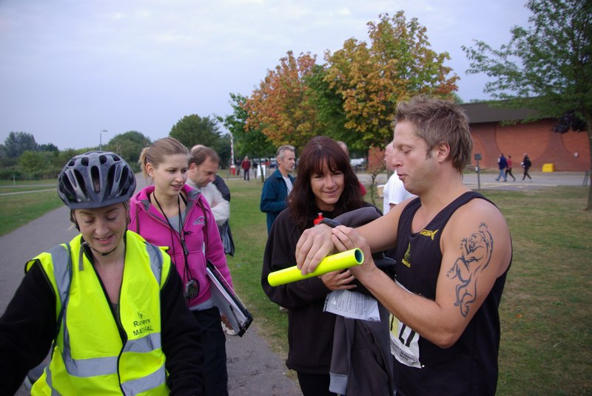
Julie Foreman, Hannah Shiell, Hayley Tooke and Mark Turner at the start in King’s Lynn
A chance for a quick cup of tea and bacon sandwich at the Hunstanton changeover before Mark handed over to Chris Bower, who steadily got muddier as the stage went on.
The stage 3 changeover got a bit edgy as Martin Courtney only arrived with a couple of minutes to spare before Chris arrived to hand over, leaving a rather relieved team manager to get to Wells.
By the time Martin handed over to JT at Wells, the weather was getting distinctly warmer. John suffered a bit as he, in his own words, “huffed and puffed” his way round and was grateful for Hannah's cycle support.
At the Salthouse changeover, there was, according to Rachel and Julie, a rather good fish and chip shop where we had planned to get some lunch. But we arrived in Salthouse 4 hours before it opened, so had to wait until later.
JT handed over to Steve Collett at Salthouse, and Hannah and I went to Sheringham to catch up with him, whilst Julie moved his car to the changeover at Cromer. By the time Steve got to Sheringham, he was not in a particularly good mood as he had not anticipated running over shingle beaches and up cliffs, but he made it to Cromer in one piece and handed over to Rob Comley.
Rob spent most of his leg trying to catch another runner, but with no joy as every time he got close the other chap pulled away.
At Mundesley, Rob handed over to Birgitta, with Julie following on the bike. Birgitta had saved the team when I didn't have enough ladies to make up a Club Class team. She ran her leg well handed over to Claire Irons at Lessingham. By this time, however, we were about 50 minutes behind schedule and thoughts of the wooden spoon for the worst time estimate were starting to appear in my mind. But Claire had a storming run and was the first member of the team to run under her time estimate, handing over to Adrian Stokes and his fan club at Horsey.
Adrian ran very well too, keeping a steady pace throughout and it was just getting dark as we arrived in Great Yarmouth, to be greeted by a firework display as we came along the seafront.
This changeover was a little tricky as Adrian was due to hand over to Hannah, who was timekeeping for us, so Julie took on that duty whilst Hannah ran and I followed on the cycle until we got out of Yarmouth.
This was a bit surreal, as unsurprisingly Yarmouth was packed at 8pm on a Saturday evening in mid-September. Hannah ran the down the prom, with me on the bike dodging in and out of the revellers. We got a couple of double-takes and one or two remarks which I suppose was not unexpected! On leaving Yarmouth, I packed the bike away, and Julie and I followed Hannah in the car until Hannah handed over to Charlie at Geldeston.
Another precarious changeover. Julie dashed over to Charlie to find out where his car was, Hannah handed over to Charlie, and then I had to wait for Hannah to get in the car before we set off following Charlie.
Charlie started off well, but after 10 miles or so seemed to be struggling a bit, and had to stop on a couple of occasions as he thought he might be sick. Fortunately a false alarm though, and after running 19 miles with only a couple of roundabouts to break the monotony, Charlie handed over to Claire Law at Scole in one piece!
Claire was brilliant. She had only rejoined the club the week before, and to then be asked to run 19.67 miles in a straight line in the middle of the night, in the rain, whilst every other team seemed to be overtaking you, and still keeping a smile on your face is some achievement. And she knocked 20 minutes off her time estimate too.
At Thetford, Claire handed over to Hayley, by which time my right foot was getting a little sore from controlling the car in 1st gear at 8mph. Needless to say, I was getting a little tired too, as was Hannah. We had hoped get to Feltwell before being overtaken by the Open team, but Adam overtook Hayley at Grimes Graves so that wasn't to be. Hayley ran steadily all the way to Feltwell, where she handed over to Kevin Fox, who shot off like a gazelle and I managed to get the car into 2nd gear for the first time in about 7 hours.
Kevin being Kevin, he was in competitive mood and managed to have a little race with a lady from another team, in which he eventually prevailed, and as the sun came up in Wissington, he handed over to Nick Dowdy and I was able to get out of the car at last and onto the bike to stretch my legs.
Nick raced off, and it took me ages to catch him up on the bike, and it didn't seem long before we arrived in Downham Market to hand over to Lisa Redman.
Hannah followed Lisa on the bike, whilst Julie and I moved cars to Stowbridge, and said Lisa ran very well to make the final handover to Ian Rutherford for the home run into King's Lynn.
I am immensely grateful to Ian for running this stage for me. When Blatch pulled out the Sunday before, I had no choice but to put myself down for it, even though I would really be in no fit state to run. Fortunately, though, Ian responded to my last desperate plea for help, (with a little coaxing from Hayley, I understand).
I actually had trouble keeping up with Ian on the bike, probably due to Ian running better than expected and my own tiredness, but I was glad to get off the riverbank and on to the streets of King's Lynn, where Ian just had time to fit in a race with a couple of local youngsters.
Finally, 27 hours 7 minutes and 3 seconds after setting off, we arrived at the finish line, 25 minutes 19 seconds behind schedule, but I didn't really care about that. I was just delighted that we had seen the team all the way round, everyone had turned up, everyone had finished and the only real mishap was that I forgot to give my car keys to Julie and Hannah at Stowbridge and they had to come chasing after me. I was tired, and exhausted but would I do it again? You bet I would!
I'd like to take this opportunity to say a few thank yous:
To all the runners in the team - you did the club proud.
To Charlie, for agreeing to swap onto one of the two longest stages and to Margaret for sacrificing a day out in Norfolk.
To Claire Law, who as said before had to rejoin the club to run the relay, and ran through the middle of the night in the rain.
To Ian Rutherford for saving me from running the last stage.
To Hannah, for timekeeping, support cycling, recovery driving, keeping me awake through night, whilst having to listen to my ramblings and still finding time to be the fastest Senior Lady on stage 10.
To Julie, for support cycling, recovery driving and taking over timekeeping duties whilst Hannah was running.
And finally to Alan, for his advice and support.

CONTRIBUTIONS TO THE NEWSLETTER
As ever, please send your contributions to the newsletter to me (Rachel Roberts) at: newsletter@elyrunners.co.uk. Many thanks!

RR
October, 2009
newsletter@elyrunners.co.uk
USEFUL INFORMATION

Data Protection
Email circulations by the club to members are done by the Bcc (confidential) option so that member’s email addresses are not circulated and also these do not take up most of the first page of emails.
See www.elyrunners.co.uk > CLUB INFO > administration for the club’s policy on data protection and use of photos and videos on the club’s website.

Membership
Subscription renewals (£10) were due from 1st January 2009. Members who joined after 15th November 2008 are covered for 2009.

To renew online:
Go to www.elyrunners.co.uk > CLUB INFO > Membership
OR
Send a cheque, payable to ‘Ely Runners’, to Club Secretary: John Turner, 22 Cromwell Road, Ely, Cambs, CB6 1AS.

If you did not renew your membership by the end of March 2009, you will be removed from the membership list and will no longer be entitled to attend training, represent the club in races, take part in club championships, claim affiliated entry fees, or wear club colours.

Benefits of membership include:
- £2 affiliated discount on open race entries
- club affiliations to ARC, ABAC, UKA, EA, TRA, FRA & CAA
- free registration (£5) with EA until 31st March 2010 (on request via John Turner)
- free changing and showers at the Paradise Centre
- free training and coaching advice
- free high-visibility bib for night-time training
- £12 subsidy on club fleeces
- 10-20% discount at most specialist running kit shops
- free entry to the club’s Cross-Country Championships, 10k Handicap and Straight Mile Handicap
- free entry to the six Frostbite League races
- free club team entry to county, regional and national championships and for club relay entries
- entry into the draw (if a member’s ballot entry is rejected) for the club’s guaranteed London Marathon places
- free snacks at club social events
- shared transport to races

Supporting the Club and its Events
Ely Runners hold three popular open races each year (Turing Trail Relay, Grunty Fen Half Marathon, and Ely New Year’s Eve 10k Road Race) that contribute considerably to the club’s reputation and financial stability. This enables the club to provide the many benefits listed above. In return, members are expected to show commitment to the club by helping with these events and taking their share of responsibility. Please don’t just rely on the usual loyal helpers and think of the club only as a convenient way to promote fitness and enter races. We’re all busy these days but commitment is realising the mutual benefits of putting something back into the club and sport we enjoy.

Training
For details of club training sessions at 7pm on Tuesday (intervals/hills) and Thursday (steady 5-8m runs) evenings, please see the homepage of the club’s website. Details of 9am Sunday morning training runs are usually circulated by email a few days in advance.

When meeting at the Paradise Centre for training on Tuesdays and Thursdays, please assemble either in the balcony/bar area upstairs or outside, around the corner by the side of the building. Please do NOT assemble in the foyer or outside the main entrance.

The meeting place for Sunday morning runs is the Paradise car park. The car park toilets are open by 9:00 am and the Paradise Centre is open for showers afterwards.

Please ensure that new members, some of whom are new to running, feel part of the club and are not left alone on training runs.

Club training sessions are intended to cater for a wide range of abilities and racing objectives. If you require specific coaching advice, please ask Club Coach Alan Rutterford to help.

To measure the distance of a route before or after running, see Google Earth > Ruler (toolbar symbol) > Path. Provided measurement is done carefully, the distance should be of similar accuracy as GPS.

Club Noticeboard
This is in the foyer of the Paradise Centre, to the right of the main entrance. It includes details of club events, training sessions, route maps, local races and other events of interest to members. There are usually several copies of race entry forms on the board but please leave the last copy or ask staff at reception to photocopy (Ely Runners' account) a few more copies.

Club Website
Webmaster, Rod Baron, maintains the Ely Runners’ website (www.elyrunners.co.uk) to provide an up-to-date record of the club's activities and a myriad of useful information. The website is frequently updated and well worth regular visits. For member’s general comments, there is a Message Board on the website’s home page and the recently upgraded photo and video section contains a huge selection of members in races. Rod also maintains the club’s websites for the Grunty Fen Half Marathon, New Year’s Eve 10k, and Turing Trail Relay.

Club Library
Grade 2 coach Max d'Ayala has selected a range of books on running and injuries for use by club members. Please see http://www.dayala.co.uk/elyrunners/booklist.htm for details: they have been chosen to provide a combination of interest, information, advice and stimulation for all standards of runners. The books are stored in the club's locker (authenticate membership and ask for key at Reception) at the Paradise Centre staff room. Please record which books you have borrowed in the notebook in the club's locker.

John Turner has the latest (2009) Fell Runners Association Fixtures Calendar & Handbook. Members interested in running a fell race can borrow this booklet. Most fell races are ‘up north’, though there are also many in Wales and other hilly areas of the UK. There is a huge choice throughout the year, including many evening races in the summer, some not too far away in areas like the Peak District. Alternatively, if on holiday in such areas, you can often find a local fell race. They provide an enjoyable, challenging and worthwhile experience, even for Fenland-based runners.

A recent addition to the club’s library includes ‘Feet in the Clouds – A Tale of Fell Running and Obsession’ by Richard Askwith.

Racing
Some open races are very popular and reach the entry limit before the race day. Many races no longer accept entries on the day (marked ‘no EOD’ in the Races & Events Guide). If you are thinking of entering a race on the day, check with the organisers or on the race website before setting out that a place is still available – turning up does not guarantee that the organisers will allow you to run!

Wearing Club Kit
Members wear their Ely Runners’ colours with pride in races far and wide (see www.elyrunners.co.uk > RESULTS) and are encouraged to do so whenever appropriate. Guidelines to wearing Ely Runners' colours (minimum club vest) in all events entered as an individual or team member of Ely Runners are as follows:
1. Obligatory requirement of governing athletic organisations in leagues entered by the club, relays entered for or by the club, all championships and events incorporating championships. Exceptions are members running for county, regional or national teams when they will be given the appropriate team kit to wear.
2. Necessary to avoid disqualification as a team member in open races.
3. Members normally wear their club kit in open races but there are recognised exceptions such as representing a charity, necessary kit change in an ultra run, spur of the moment race entry, non-availability of kit for whatever reason etc.
4. Not wearing club kit also makes it harder for other runners, race officials, and photographers to distinguish club runners, especially in relays.
5. Our distinctive race kit defines us as ambassadors of a well-respected running club.

Race Results
When you send your race results to Stephen Howard (results@elyrunners.co.uk), please advise if you have achieved a PB (including in vet categories), so that it can be included in press reports and to update PB information on the website. If possible, please send Stephen any information you have (including links to race results) by noon on Monday to avoid the extra work involved in updating press reports. Please email any photographs or links to event photographs (with your race number) to Rod Baron at webmaster1@elyrunners.co.uk.

Several members have put themselves on www.athleticsdata.com. This is a statistical website showing:

- UK year rankings
- All-time rankings
- Comprehensive results service
- Athletes’ profiles

This website will enable you to check your form relative to rival runners and allow them to do the same. It’s also useful for the prediction of race results for both runners and organisers.

Payment of club entries into championships, relays and leagues will be funded by the club provided they are team entries made by the club. The club will not pay for individual entries into open races that have an incorporated championship.

To take part in UKA National and SEAA championships, members need to be registered with England Athletics (EA). Also, a few open events still require EA registration to claim affiliated entry fees. However, most events (especially locally) either have ARC permits or, if they have UKA permits, require only membership of an EA affiliated club, like Ely Runners. Please could members who would like to be registered from 1st April 2009 with EA for 2009-10 please contact John Turner secretary@elyrunners.co.uk. It was agreed at the recent AGM that the club will pay the £5 registration fee. Registration number confirmation and cards will be supplied when received from EA.

To enter a County (eg Cambs AA) or Regional (eg SEAA) Championship, members must have been born in the county/region or had 9 months of continuous residency. If you qualify by birth and residency for different counties, you may only run for one county/region during each competition year from October to September.

Club vets who are not members of EVAC may run as guests of the club’s EVAC members in EVAC Championships. EVAC events are included in the Races and Events Guide and can be entered by sending an email to eastvetm75@ntlworld.com. Subject to the availability of funds, the club will pay for club team entries to EVAC and BMAF Championships. EVAC website: www.evac.org.uk
BMAF (vets) events are too numerous to include all of them but they have been circulated to EVAC members via regional and national veteran magazines or see www.bmaf.org.uk/fix/fix.asp

Running Kit
Mary Gates oversees the club’s kit supplies. The club’s joining fee of £33 includes a free club race vest and shorts. Please contact Mary on 01353 861379 or mary@elyrunners.co.uk to order. See www.elyrunners.co.uk for full details of club kit.

New club vests now have the Ely Runners’ cathedral logo top centre on the front. Any members with older vests who would like to have the logo added will need to give their vest to Mary to send. The cost (£1.20 for the transfer + 25p for application) will be covered from club funds. Race vests will continue to have ELY RUNNERS on the back.
Club fleeces are available from Mary Gates at the subsidised price of £10 to members only. This price is for one fleece per member. Subsequent fleeces will be at the cost price of £22.
.

Discounts on Kit Purchases
If you buy running kit from Advance Performance at Cambridge or Peterborough, please show them your membership certificate and the club will receive 10% towards vouchers that we use for prizes for our Christmas charity raffle. Advance Performance do not otherwise give discounts. Other running shop suppliers such as Sweatshop in Cambridge (who sponsor our three open races: New Years Eve 10k, Turing Trail Relay, and Grunty Fen Half Marathon) will usually provide a 10% discount to members on production of a valid membership certificate.

Natalle Etches has purchased a wide variety of fitness stock from a local Internet fitness company that closed down. She is re-selling the stock as low as half price to club members. The stock includes cycling, running, fitness and triathlon wear from brand names including Craft, Gore Bike Wear, Pearl Izumi, and Sugoi. If you’re interested, speak to Natalle at one of the training sessions or contact her on natalle@elyrunners.co.uk.

Social Events
Julie Foreman organises the club’s After Training Drinks on the first Thursday of the month. The next will be after training on Thursday 2nd April.

RACES & EVENTS GUIDE 2009

This includes local area/easily accessible races, club, county, regional and national championships, and a selection of UK/overseas events previously enjoyed by members.

October
04 SEAA 10k Road Running Championships, 1100 Crystal Palace, London, www.seaa.org
04 Budapest Marathon, Budapest, www.budapestmarathon.com
04 New Balance English Half-Marathon, 0900 Centre Park Warrington, £27 (no EOD), http://www.english-half.co.uk/
04 FFL, 5m, 1100 Priory Park, St Neots (meet at Paradise Centre to share transport)
10 (Sat) Peddar’s Way Relay (teams of 4), Castle Acre to Holme-Next-The-Sea, www.rystonrunners.org.uk
11 Great Eastern Run ½ Marathon, 1100 Laxton Square, Peterborough, £18 (no EOD)
18 Ampthill Trophy XC, Ampthill, Beds, www.AmpthillTrophy.org.uk, including EVAC XC Championships
18 Saxons Race, 5m (MT), 1100 Carlton Park Recreational Club, Saxmundham, £7 (+£3 EOD), http://www.thesaxons.org.uk
24 (Sat) Beachy Head Marathon (3,500’ climb), 0900 Eastbourne, depart Paradise 0500
25 Fenland 10m (CRRL), 1000 Marshland High School, West Walton, £8, www.fenlandrunners.org.uk
25 East Coast Run (10k), 1030 Great Yarmouth, £8 (+£2 EOD), www.gyrr.co.uk

November
04 Loch Ness Marathon (&10k/5k), www.lochnessmarathon.com
08 FFL 5m, 1100 Bushfield Sports Centre, Peterborough (meet at Paradise Centre to share transport)
15 St Neot’s ½ Marathon, 1000 St Neot’s Recreation Centre, http://www.half.riverside-runners.com/
21 (Sat) SE Inter-Counties XC Championships, Parliament Hill, London, www.seaa.org
22 Hereward 4 Stage Relay (39.1m Peterborough to Ely), club teams
22 Pine Ridge 10k, Wisley, Surrey, £15 (no EOD), www.pineridgerace.co.uk
29 Thetford Forest Duathlon (5k run, 14k bike, 3k run), 1100 May Day Events Field, £22 per individual/£30 per team (+£5 EOD), www.runbikeevents.com

December
13 FFL 5m, 1100 Hinchingbrooke Park, Huntingdon (meet at Paradise Centre to share transport)
13 Bedford ½ Marathon, 1000 Wotton Upper School, Beds, £15.50 (no EOD), www.bedfordharriers.co.uk
13 Bunwell Santa Fun Run, 5k/3k, 1100 Bunwell Village Hall, Bunwell, Norfolk, £10, www.bunwellstrollers.co.uk
20 Long/medium/short club pre-Christmas trail training runs, Woodditton to Ely 18.5m,

Woodditton to Chalk Pit 12m, Reach to Ely 11m, Woodditton to Reach 7.5m, meet 0800

Paradise for transport to starts
26 (Sat) Boxing Day training, meet 0900 Paradise Centre car park
31 (Thu) The 10th Ely New Year's Eve 10k Road Race, 1100 Lt Downham, entries on-line
only, no EOD, www.newyearseve10k.co.uk

2010

January
17 FFL 5m, 1100 Ramsey Sports Centre (meet at Paradise Centre to share transport)
30 (Sat) SE XC Championships, Parliament Hill, London, www.seaa.org

February
07 FFL 5m, 1100 Bourne Woods, Lincs (meet at Paradise Centre to share transport)
14 St Valentine’s Day 30k, Stamford (further details to follow)

March
07 FFL 5m, 1100 BRJ Club, Huntingdon (meet at Paradise Centre to share transport)
14 SEAA Masters Cross-Country Championships, Trent Park, Cockfosters, London (further details to follow)

21 Turing Trail Relay, 36m Ely-Cambridge-Ely (provisional date)

May
09 Eye 10k, Eye nr Peterborough (further details to follow)

June
10 (Thurs) Ely Runners 10k Club Handicap, Little Downham

July
08 (Thurs) Ely Runners 1m Club Handicap

September
12 Grunty Fen Half Marathon, Witchford

December
31 (Fri) New Years Eve 10k, Little Downham

NOTES

Races and events are on Sunday unless otherwise mentioned.

Race entry fees are the affiliated (ARC/UKA or just UKA registered) fees

Courses are roads and/or hard footpaths/cycle ways unless otherwise mentioned.
Distances without units (m or k) are probably m = miles.
Frostbite League races are 5-6 miles and entry (league membership) is paid for by the club.
Further details of events from the Club notice board in the Paradise Centre foyer, running magazines, websites, or from John Turner secretary@elyrunners.co.uk) who also has details of all RRC/TRA long distance road/TR/XC races and FRA fell races.

National, regional and county championship team entries are via Charlie Barker (captain@elyrunners.co.uk).

Club championship & club handicap entries are via Steve Tovey

Long distance team relay entries are via Alan Rutterford and paid for (if funds available) by the club.

Club website www.elyrunners.co.uk
Grunty Fen 1/2M website www.gruntyfen.co.uk
NYE10k website www.newyearseve10k.co.uk
Turing Trail Relay website www.turingrelay.co.uk
Association of Running Clubs www.runningclubs.org.uk

Rachel Roberts
July 2009
newsletter@elyrunners.co.uk

