Ely Runners Newsletter

November 2010



CLUB EVENTS

Considerable PB potential at this Sunday’s Bushfield Frostbite Race
The next Frostbite Race takes place next Sunday (7th. November) at the Bush Community Centre, Peterborough, PE 2 5QR, starting at 11am (www.frostbite.org.uk).

The 5m Bush course is flat with a mixture of road and firm woodland paths suitable for road shoes. Apart from a couple of tight corners it is a fast course. The weather forecast at present is for a cool and cloudy day which should make for quick times.

We have made a more promising start to the series this year with a particularly strong performance from the senior men, and after the first race we are in 4th place. The seven scoring runners all came in the first 20 finishers. Our junior team are in 6th place in their league.

For those wishing to car share we will meet at the Paradise Centre at 9.00am. There is ample parking in the shopping centre car park close to the sports centre.

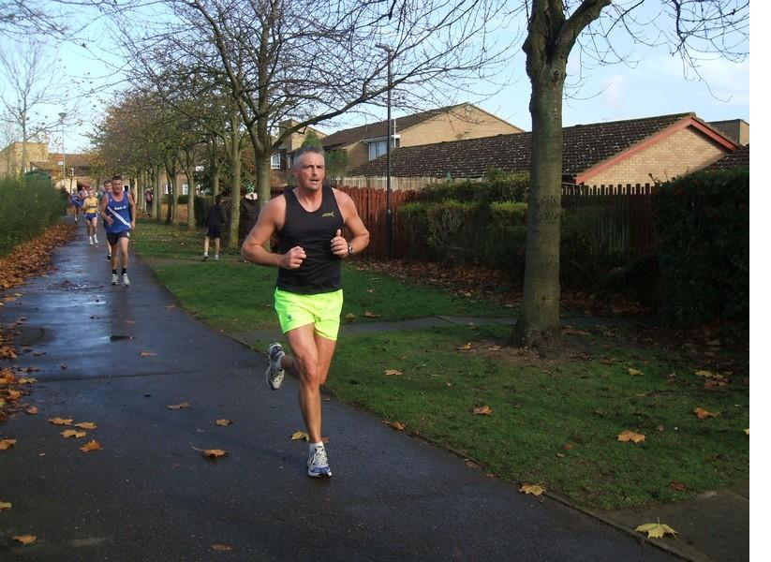
Ely Runner Ian Blatchford competing in last year’s Bushfield Frostbite race

Hereward Relay, Sunday 28th November 2010
As usual, we will have several teams of all abilities in this challenging four-stage mixed terrain relay race across the Fens.

Alan Rutterford is forming teams from members who’ve asked to run in the 2010 Hereward Relay and will try to accommodate individual requests to run specific stages. The club will pay the team entry fees.
- Stage 1 (Peterborough to Whittlesey): 6.1m of riverbank, farm drove and public road (probably the easiest of the stages).
- Stage 2 (Whittlesey to March): 10.5m of ever-changing terrain (not too demanding).
- Stage 3 (March to Welney): 10.3m incorporating the picturesque Nene Parade and some of the best agricultural land in the country.
- Stage 4 (Welney to Ely): 9.6m of road, track and possibly very muddy in Bishops Way.

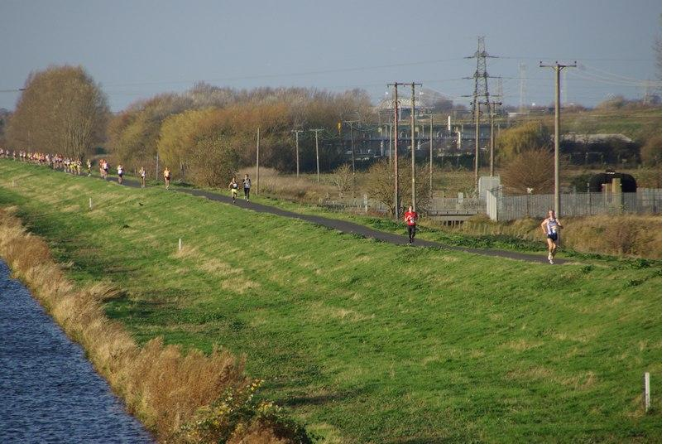
Runners taking part in last year’s Hereward Relay

Ladies team captain, Heidi Uff heidi@elyrunners.co.uk 07745 210592, would like at least one of the teams to be an all women’s team.

The teams will also need at least 2 recovery car drivers and up to 6 marshals to help organise the finish from Little Downham to Ely.

Please contact Alan Rutterford alan@elyrunners.co.uk ASAP if you would like to run or help.

The Hereward Relay has been particularly special to Ely Runners for many years in that we were involved with the inaugural trial event to our city and each year since then have entered several teams, marshalled from Little Downham, and set up the finish area. We enjoy such close co-operation with the organisers (March AC) because they reciprocate and help at our events, which raise the necessary funds to provide club entries and ongoing support, facilities and privileges for our members

Guidance on race entries for 1st Claim members of Ely Runners
Nearly all of our members joined as 1st claim UKA members because they live and train in the Ely area. Under UKA Rules they are obliged to run as 1st claim Ely Runners in team events such as the Frostbite League, Hereward Relay, and any other event with team awards, plus any championships that operate under UKA Rules and have UKA permits.

In addition to their 1st claim UKA club, athletes can belong to any number of 2nd claim UKA clubs. This can be useful if temporarily living or working outside the 1st claim club area. Requests for change of 1st claim club can be made via the club to UKA with genuine reason/s, such as moving out of the 1st claim club area or lack of competition facilties. Some UKA events accept only 1st claim entries (eg championships) and some allow 2nd claim entries in the absence of 1st claim entries.

This 1st claim obligation applies unless a member wants to make up another team, being a 2nd claim team or other organisation, in an event in which Ely Runners do not enter a team or do not have enough runners, including the member concerned, to make up a club team, and subject to the race organiser’s approval.

However, under UKA advice, Ely Runners can arrange for members to waive this obligation for any 1st claim member who would like - perhaps for special (eg charity) or individual reasons (other organisation) - not to run for Ely Runners in a team event in which we will have entries, such as the Hereward Relay, and this should be done by individual or joint request to the Secretary (secretary@elyrunners.co.uk) for approval by the Race Referee and Ely Runners Committee. This is to prevent objections from other teams and thereby avoid risk of disqualification.

More New Years Eve 10K volunteers required
Many thanks to those of you who responded to the first request for volunteers to help with the New Years Eve 10K. However, as always, we still need more people to step forward to ensure the race can be staged in as safe a way as possible. As we are now into November more of you may have decided on their holiday plans and can now commit themselves. Please let John Glover know by emailing eajwg02@yahoo.com.

NEWS & NOTICES
Future running star is born
Congratulations to Hayley Tooke and Mark Turner on the birth of their daughter Faith Elizabeth on Tuesday, 28th September at 6:20am, weighing 8lb 10oz.

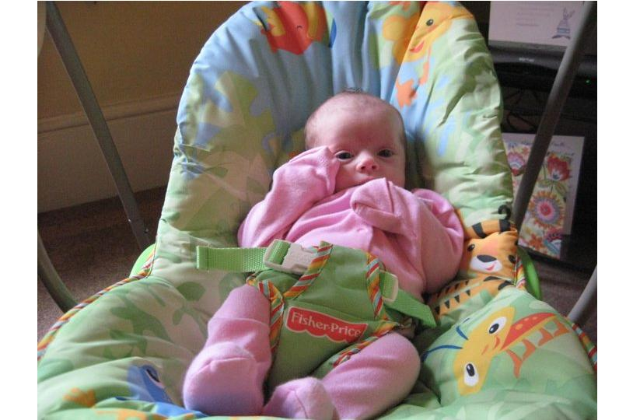
Faith Elizabeth

Craig Holgate breaks club 10m record
A fine run from Ely Runner Craig Holgate in last month’s Fenland 10m in Wisbech saw him set a new club senior male 10m record, coming third overall in a time of 53:02.

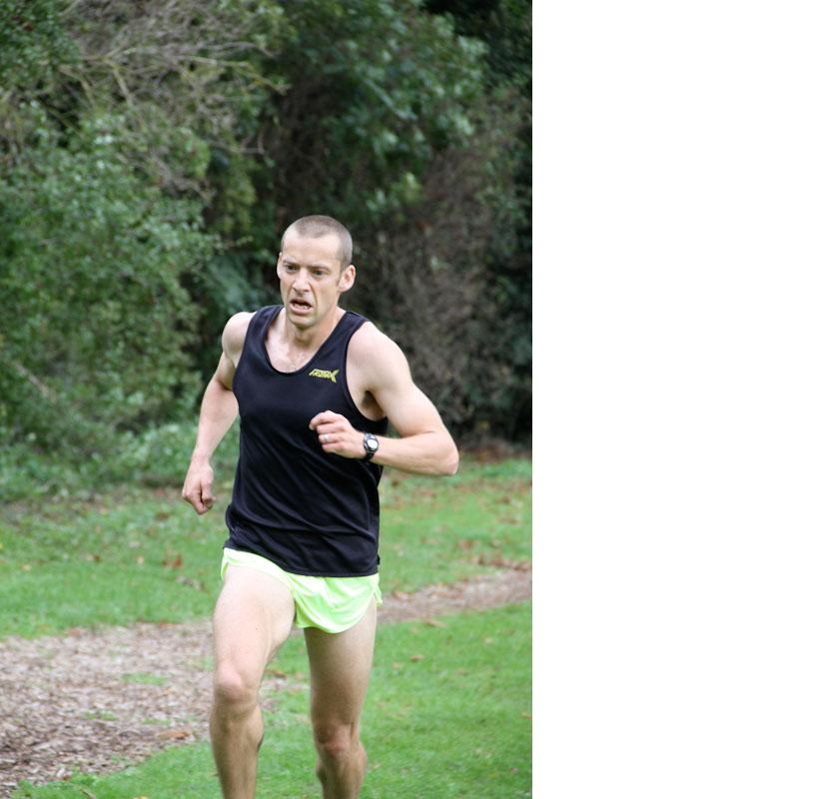

High Vis winter T-Shirts with Ely Runners logo now available
In response to requests from members, the committee has purchased a test batch of fluorescent yellow technical T-shirts which can be worn instead of bibs for winter training and wearing under a club vest whilst racing in chilly and/or wet conditions. We have small, medium and large unisex sizes with both long and short sleeves and which feature an Ely Runners' logo on the top right front.

The prices (at cost) to members are £8 (short-sleeve) and £13 (long-sleeve) and can be ordered by emailing Mary Gates ( mary@elyrunners.co.uk) or speaking to her at training when she will have them with her.

Former Ely Runner Claire Hallissey triumphs again
A few weeks ago, former Ely Runner Claire Hallissey won the Bristol 1/2 Marathon for the 2nd consecutive year, in a time of 1:12:02, to the delight of the watching mayor.

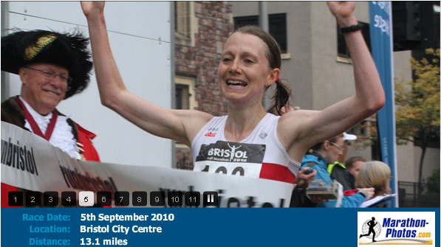

Club places for the London Marathon - Sunday 17th April 2011
We have received three club entries which will be drawn at the Club's Christmas Drinks at the Cutter on Friday 3rd December 2010. If you win one of these entries, the completed form and entry fee must be received in the LM office by 7th January 2011.

If you have a club entry and subsequently become ill or injured, please contact John Turner in good time to re-draw the entry under the substitution system for received club entries. Substitution entries must be received in the LM office by 11th February 2011.

To enter the draw, members must have applied for LM entry via the ballot system and been rejected. If you qualify and would like to be included in the club draw, please let John Turner secretary@elyrunners.co.uk know (with proof of rejection) as soon as possible.

This year we have instances in which members were not able to enter the LM ballot before it quickly closed, so fewer members may have entered than usual. Therefore, our Chairman Stephen Howard has suggested that, although it is unlikely to happen, if the number of contenders with ballot rejections is very small (eg two for the three places), then any member can enter the draw for any surplus club places.

However, since then, JT reports that 14 rejected members have requested to be included in the draw for the three club places!

Also, it would be useful for members supporting the race to know which Ely Runners have places, so please could those with confirmed places let John Turner know. This is also helpful for sharing transport to the LM and planning Sunday morning training runs.

Grunty Fen T-Shirt design competition details announced
Design suggestions for the front of the t-shirt are:
- It needs to be clear and bold with a theme
- The race title will probably be: Ely Standard 21st Grunty Fen Half Marathon 2011 and this needs to be incorporated into the design.
- Typical subjects are Grunty Fen, fenland, local area, race title, cathedral, running, runners, club kit, running kit, water, bogs, ditches, open sky, rivers, exhaustion, happy runners, male/female runners, river birds (eg heron), waterside meadows, or anything else!
- Colours are OK but bold best. Colours can sometimes be enhanced with black outline
- Humour or reasonable horror (eg Grunty Fen monster in Ely Runners kit!) OK
- Needs to be seen easily from a distance, so not too complicated.
The club's and sponsors' logos will be added by the printer who also puts the list of entrants on the back. The deadline for submission is 15th January, with members voting on the winner at the club AGM on 7th February.

GCAN launches endurance training scheme
The Greater Cambridge Athletic Network (GCAN) is hoping to launch a new endurance squad training initiative this year, open to runners in the area who would like support from qualified coaches and athletes of a similarly high standard able to demonstrate recent 10k times of 38mins for men and 42mins for ladies.

The initiative is the idea of level 3 coach Brian Corbett who has now been successful in attracting support from the local England Athletics Network, GCAN and its member clubs. The squad will offer training sessions, appropriate to the time of year (i.e. hill session in winter, possibly track session in the summer amongst a few), with sessions potentially held on a monthly basis, but athletes will be encouraged to form their own running sessions on an ad hoc basis. In addition it is envisaged that topical workshops and flying visits from top coaches will be organized.

GCAN hopes to get the first of these sessions kicked off in November, so to help organization could any interested runners please contact Robert at rammie.woodward@btinternet.com and let him know if you are potentially interested and if so, which Saturday mornings through November would be convenient.

Contributions to the Newsletter
We’re actively looking short articles about your running experiences which other members will find useful, interesting or just entertaining. Please send anything suitable preferably with a picture to newsletter@elyrunners.co.uk

SOCIAL EVENTS

Christmas Drinks and raffle for a place in the London Marathon
Ely Runners will gather for Christmas drinks at the Cutter in Ely on Friday 3rd December, when members will have their last chance to get a place in the London Marathon. The draw for the three coveted club places is traditionally restricted to those rejected in the official London Marathon entry ballot. But this year we have instances in which members have not been quick enough to enter that ballot in the small amount of time before it closed, meaning fewer may have entered the ballot than usual. Our Chairman Stephen Howard has suggested that, although it is unlikely to happen, if the number of contenders with ballot rejections is very small (eg two for three places), then any member can enter the draw for any surplus club places.

After training drinks
After training drinks are usually held on Thursdays, with all members more than welcome to attend. The next opportunity to see what your training partners look like with their clothes on will be Thursday 11th November at the West End pub from around 8:30pm onwards. Further information is available from Julie Foreman (Julie@elyrunners.co.uk).

Anyone for paintballing?
Any members interested in taking part in a game of paintballing in Thetford Forest (http://www.combatpaintball.org/home.html) one Saturday morning should contact Julie Foreman (julie@elyrunners.co.uk). The cost for a half day is £22 per head which includes all safety equipment and 300 paintballs. If we can get over 10 people the cost comes down to £17 each.

Ely Runners 25th
The club was formed in 1985 (see http://www.elyrunners.co.uk/history.htm) and the Committee are planning to mark this anniversary.

SELECTED RESULTS ROUND-UP – OCTOBER

Frostbite League Race 1 – Priory Park, St Neots
Official Results (Juniors): 1st Ashley Pettit 07:19 27th Robyn Seabright 09:08 33rd Alex Ellwood 09:23 50th Fraser Crossman 09:55 54th Dylan Campbell 09:59 56th Sebastian Pettit 10:03 58th Nathan Pennington 10:05 61st Esme Wright 10:09 69th Molly Butler 10:24 There were 129 finishers.

Official Results (Seniors): 3rd Alex Tate 27:56 (Scoring Team – M) 4th Craig Holgate 28:27 (Scoring Team – M) 9th Stephen Pettit 29:16 (Scoring Team – M) 15th John Uff 30:03 (2nd claim – ran for C&C) 16th Ian Day 30:13 (Scoring Team – M) 19th Max D’Ayala 30:25 (Scoring Team – M) 20th Kieren Drane 30:28 (Scoring Team – M, PB) 24th John Crisp 30:49 (Scoring Team – M) 46th Steve Tovey 32:25 62nd Stephen Howard 33:19 77th Tony Kirby-Cook 33:51 96th Barry Woodward 34:40 134th Kevin Fox 36:08 142nd Ian Blatchford 36:25 149th Peter Harris 36:43 187th Heidi Uff 38:18 (Scoring Team – F) 194th Lionel Smith 38:38 (PB 5mXC) 207th Linden Smith 39:10 (Scoring Team – F) 208th Andy Nixon 39:11 212th Stuart Baumber 39:17 237th Mel Fisher 40:02 (Scoring Team – F) 251st Adrian Stokes 40:39 328th Natalle Etches 46:22 344th Jon Pennington 47:18 There were 414 finishers.

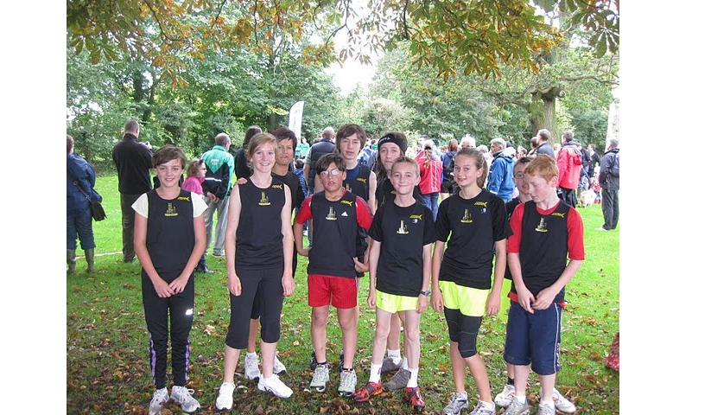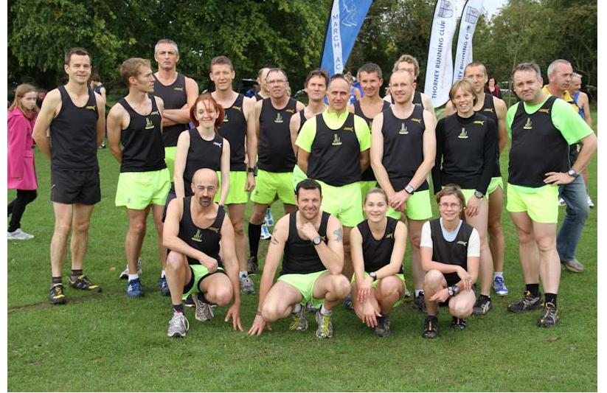

Fenland 10, Wisbech
Results: 3rd Craig Holgate 0:53:52 (PB, New Club SM Record) 12th John Manlow 0:59:08 18th Kieren Drane 0:59:58 (PB) 20th John Uff 1:00:14 (PB, 1st 10m, ran for 1st claim C&C) 25th Maurice Reed 1:01:44 66th Stephen Howard 1:06:52 203rd Stuart Baumber 1:21:11 244th Nick Dowdy 1:25:21 292nd Colin Doak 1:33:39 There were 341 finishers.

Snowdonia Marathon – Llanberis, Snowdonia, North Wales
Provisional Results (Official Results to follow): 9th Stephen Pettit 2:52:56 (2nd MV45) Miranda Paul 4:40 There were approximately 1300 starters.

East Coast 10k – Great Yarmouth, Suffolk
Official results: 9th Ian Day 35:15 (2nd MV40) 10th Stephen Pettit 35:27 (2nd MV45) There were over 550 finishers.

Cancer Research 10k, Cambridge
Results (unofficial watch times): 7th Kieren Drane 36:16 ?? Maurice Reed 37:?? 9thF Sarah Edwards 44:13 Kieren’s GPS measured the route slightly short at 6.05 miles.

Saxons 5m Race, Saxmundham, Suffolk
Official results: 15th Lionel Smith 36:50 19th Andy Nixon 38:27

Great Eastern Run, Half Marathon, Peterborough
Official results (chip times): 19th Alex Tate 1:12:28 (PB - ran for 1st claim Muddy Mucky Munkeys) 34th Stephen Pettit 1:16:46 (1st MV45, New Club MV45 Record) 58th John Manlow 1:19:32 70th Kieren Drane 1:20:57 (PB) 138th Adam Etches 1:25:51 233rd Tony Kirby-Cook 1:29:41 (PB) 273rd Mark Turner 1:31:34 289th Steve Barker 1:32:01 472nd David Mould 1:37:16 476th Andrew O’Hanlon 1:37:26 (PB) 641st Sarah Edwards 1:40:45 (PB) 685th Stuart Baumber 1:42:40 (PB) 1058th Rachel Roberts 1:48:18 1171st Miranda Paul 1:51:37 1317th Fraser Badcock 1:54:30 1334th Lisa Redman 1:55:18. The race was scrutinised by Ely Runners' Coach Alan Rutterford on behalf of the British Association of Road Races.

Forthcoming events

Cambridge Parkrun
This series is continuing to prove popular with members, with a further four races taking place in May. Cambridge 5k Park Runs are every Saturday at 0900. Entry is free but before your first race, register on-line by 1800 on Friday at www.parkrun.org.uk/cambridge/Home.aspx

Frostbite Friendly League 2010-2011
The first FFL venue on Sunday 3rd October has now reverted to the usual Priory Park at St Neots. It's an excellent course of parkland grass and woodland tracks. As such, it is suitable for spikes. As usual, the Junior race will start at 10:15 am and the Senior race at 11:00 am

Other FFL dates and venues are:
- 7 Nov Bushfield, Peterborough
- 12 Dec Hinchingbrooke Park, Huntingdon
- 16 Jan Ramsey
- 6 Feb Bourne Woods
- 6 Mar BRJ Huntingdon
This series of six races of 1.5m for Juniors and about 5-6m for Seniors is free to all members and provides enjoyable competition at all levels, plus all members running influence the result by competing against scoring members of other teams. No prior entry or numbers are required as club members are allocated PIN numbers and finishing position tags which are recorded by the club's Team Manager Eric Drury. Team scoring is Juniors 1st 5 (1 must be a girl) and Seniors 1st 10 (3 must be women) but all other runners effect the overall results.
Having won the Senior FFL twice since 2004, we slipped last season to 10th of 17 teams. Our talented Juniors, in their first full year in the FFL improved through the season to finish 9th of 13 teams but should gain places in 2010-11 because there are more members to ensure a full scoring teams for each race. Apart from providing enjoyable team and individual competition, these races provide a measure of progress and inspiration throughout the winter season.
SEAA Masters XC Championships
Sat 11th December, Old Warden, Biggleswade
Men 10k, Women (& V70M) 6k
Team entries via Charlie Barker captain@elyrunners.co.uk
Closing date 19th November

SEAA Indoor Track & Field Championships
Lee Valley Stadium, Edmonton, London
Sun 9th Jan (300m, 400m, 800m), Sat 15th Jan (sprints & hurdles), Sun 16th Jan (60m and 1500m)
All ages from -15 to seniors
Entries via Charlie Barker (seniors) and Leslie Wright (juniors) lesley@elyrunners.co.uk
Closing dates 14th December (1st meeting) and 4th January (2nd/3rd meetings)

SEAA XC Championships
Sat 29th January, Parliament Hill Fields, London - a famous and challenging course!
All ages from -13 to seniors. Distances according age group but SW run 8k and SM run 15k
Team Entries via Charlie Barker (seniors) and Leslie Wright (juniors)
Closing date 10th December

SEAA XC Relays
Sat 12th March 2011, Wormwood Scrubs, London
All ages from -13 to seniors. Distances (2k to 5k) and stages (3 or 4) according age group
Team Entries via Charlie Barker (seniors) and Leslie Wright (juniors)
Closing date 18th February

Full details of SEAA championship events at www.seaa.org.uk and they will also be put on the club's notice board at the Paradise Centre

ECCA National Cross-Country Championships, Alton Towers, Saturday 19th February 2011
All ages boys/girls and men/women from -13 to Seniors. Contact Charlie Barker captain@elyrunners.co.uk for Senior entries and Lesley Wright lesley@elyrunners.co.uk for -13/-15/-17/Junior entries. Full details on Notice Board.

Other Events

See following RACES & EVENTS GUIDE
Event photographs

Race/club event photographs should now be sent to Steve Tovey (sct36@cam.ac.uk) Ideally they should be resized to 800x600 pixels (ish) and preferably be less than 100k in size.

RACES & EVENTS GUIDE 2010-2011
November 2010
This includes local area and easily accessible races, club, county, regional and national championships, and a selection of UK/overseas events previously enjoyed by members.
Cambridge 5k Park Runs (at Milton) are every Saturday at 0900. Entry is free but before your first race, register on-line by 1800 on Friday www.parkrun.org.uk/cambridge/Home.aspx

November
06 (Sat) ECCA National XC Relays, Berry Hill Park, Mansfield, Notts
06 (at) Waddenhoe Quadrathlon, www.quadraracing.co.uk
07 Frostbite League, Jn 1015, Sn 1100, Bushfield, Peterborough (all Ely Runners can run)
Juniors to contact Alan Rutterford or Lesley Wright for arrangements
Seniors meet at 0900 at the Paradise Centre car park to share transport to Bushfield
07 Stevenage ½ Marathon including ARC Championships, www.fvspartans.org.uk
14 Stowmarket Striders Scenic 7m, 1102 start, http://www.stowmarketstriders.org.uk/scenic7.shtml
20 (Sat) Dirt Half Marathon Challenge (trail),1000 Cedars Upper School, Leighton Buzzard, £12,
www.dirtrunning.co.uk
21 Mucky Races 5k & 13k Guts & Glory (XC), Bures Pit, Colchester, www.muckyraces.co.uk
21 St Neots Riverside Half Marathon – race full
21 Hadleigh 10m Road Race, 1100 United FC, Duke St, Hadleigh, Suffolk, £11, EOD +£2
28 Hereward 4 Stage Relay (37.3m Peterborough to Ely), Ely Runners senior teams and marshals from
Little Downham to finish. (Alan Rutterford)
28 EAA XC Championships, Hillyfields, Colchester, -13GB, -15GB, -17MW, -20MW, SenM/W, VetM/W
28 Norwich ½ Marathon, 1100 Showground, £17, no EOD

December
03 (Fri) Ely Runner’s Christmas Buffet & Drinks, Cutter Inn, Ely
03 (Fri) Cambs AA AGM, 1930 Hemmingford Grey Conference Centre
05 Nene Valley 10m, 1030 The Cresset, Bretton, Peterborough, £8, www.nvh.orh
05 Luton Marathon & 3 stage Marathon Relay, 1000 Lea Manor Rec Gnd, £21, www.lutonmarathon.org.uk
05 Bunwell Santa 5k Fun Run, 1100 Village Hall, Bunwell, Norwich, £10, EOD +£2, www.bunwelstrollers.co.uk
11 (Sat) SEAA Masters & Southern Inter-County XC Championships, Shuttleworth College, Biggleswade
12 Frostbite League, Jn 1015, Sn 1100, Hinchingbrooke Park, Huntingdon (all Ely Runners can run)
12 Bedford Harriers ½ Marathon, 1000 Wootton Upper School, Beds, £15.50, no EOD, www.bedfordharriers.co.uk
19 Club Pre-Christmas training runs, Woodditton to Ely 18.5m, Woodditton to Reach 7.5m, Reach to Ely
11m. Meet 0800 Paradise car park for transport to starts. Contact JT to run. Lunch afterwards at the High
Flyer at 1300 - contact julie@elyrunners.co.uk to book
26 Boxing Day training, meet 0900 Paradise Centre car park
28 (Tue) Buntingford Year End 10m, 1030 Edwinstree Sch, £12, no EOD, www.roystonrunners.org.uk
31 (Fri) Ely New Year’s Eve 10k Road Race, Little Downham www.newyearseve10k.co.uk

January 2011
01 (Sat) Wymondham NYD10k, 1130 Ex-Servicemen’s Club, £8.50, EOD +£2, www.wymondhamac.org.uk
02 Ely Runners XC Championships (juniors, senior and vets) – provisional date
09 Cambs County XC Championships, Priory Park, St Neots (juniors, seniors and vets)
09 SEAA Indoor Championships, Lee Valley
15 (Sat) SEAA Indoor Championships (continued)
16 SEAA Indoor Championships, Lee Valley (concludes)
29 (Sat) SEAA XC Championships, Parliament Hill, London (all ages from -13 to seniors)
30 Reedham 10m, 1100 Reedham Village Hall, Norwich, £10, EOD +£2, www.gydac.org.uk

February
06 Frostbite League, Jn 1015, Sn 1100, Bourne Woods (all Ely Runners can run)
13 St Valentine’s 30k, 1100 Stamford, www.stamfordstriders.co.uk, early entry essential
07 (Mon) Ely Runners Annual General Meeting, 1930 Paradise Centre
19 (Sat) National Cross Country Championships, -13/-15 G/B, -17/Jn/Sn M/W, Alton Towers

March
05 CAU Inter County XC Championships, Cofton Park, Birmingham
05 Belvoir Challenge 15m/26m, 0900, Harby School, Harby, Leics, £15, www.belvoirchallenge.co.uk
06 Frostbite League, Jn 1015, Sn 1100, BRJ Huntingdon (all Ely Runners can run)
12 (Sat) SEAA XC Relays. Wormwood Scrubs, London W12 (all ages from-13 to seniors)
12 (Sat) BMAF XC Championships, Wigmore Valley Park, Luton
16-20 European Veterans Athletics Championships, Ghent
20 Turing Trail Relay (provisional)
27 Joe Cox ½ Marathon, Stowmarket

April

10 Bungay Marathon & ½ Marathon

17 London Marathon
22 Sudbury 5m Fun Run

May
05 Newmarket Heath 6k
08 Eye 10k
08 Frostbite Friendly League AGM
15 Woodbridge 10k
21 (Sat) BMAF Road Relays, Sutton Park
29 CAU Inter County Track & Field Championships, Bedford Stadium

June
09 (Thurs) Ely Runners 10k Club Handicap
19 BMAF 5k Championships, Horwich

July
6-17 July, World Masters Championships, Sacremento, California, USA
14 (Thurs) Ely Runners 1m Club Handicap
27 Bungay 10k

August
16-25, European Vets Championships, Stadia

September
11 Grunty Fen Half Marathon, Witchford, www.gruntyfen.co.uk

October
22 (Sat) Beachy Head Marathon

NOTES
Races and events are on Sunday unless otherwise mentioned.
Race entry fees are the ARC or UKA affiliated club fees
Many events also have a concurrent Fun Run – check race information for details.
Courses are usually on roads and/or hard footpaths/cycle ways unless otherwise mentioned.
Distances without units (m or k) are probably m = miles.
Frostbite League races are about 5-6 miles for seniors and 1.5m for juniors. Entry (league membership) is paid for by the club.
Further details of events from the Club notice board in the Paradise Centre foyer, running magazines, websites, or from John Turner secretary@elyrunners.co.uk who also has details of all RRC/TRA long distance road/TR/XC races and FRA fell races.
National, regional and county championship team entries are via Charlie Barker captain@elyrunners.co.uk but for -13,-15,-17 & juniors, first contact Lesley Wright lesley@elyrunners.co.uk
Ely Runners’ private club XC championships, 10k/1m handicaps, and TTR relay entries are via Steve Tovey membership@elyrunners.co.uk
Long distance team relay entries are via Alan Rutterford and paid for (if funds available) by the club.
Social events are via Julie Foreman julie@elyrunners.co.uk
Junior training details from Junior Representative/Club Coach Alan Rutterford alan@elyrunners.co.uk
Junior race details from Junior Secretary Lesley Wright lesley@elyrunners.co.uk
Club website: www.elyrunners.co.uk
Grunty Fen 1/2M website www.gruntyfen.co.uk
NYE10k website www.newyearseve10k.co.uk
Turing Trail Relay website www.turingrelay.co.uk
Association of Running Clubs www.runningclubs.org.uk

