Ely Runners Newsletter
May 2011



NEW MEMBERS

We warmly welcome the following new members who joined the club this month. Look forward to seeing you all at training and club social events!

Gareth Kavanagh-Dixon
Shaun Brown
Robin Webb

NEWS & NOTICES

Race Reports Now Updated!!
Some of you may have noticed there was a 6week spell without race reports being uploaded to the website.



Apologies to everyone – but thanks to the hard work of Stuart and Matt we’re now all back up to date.

As well as entertainment, race reports offer information on course conditions and competitor performance, organisational expertise and general ambience that help other ER members decide if they want to try the same event in the future. So please take the time so submit reports – and also to let us know about any new Personal Bests.

So it doesn’t matter if you take part in a graded UK athletics event or a local 5k, irrespective of distance or difficulty, other runners will want to hear about how you got on and what you thought of the event. Race reports should be sent to results@elyrunners.co.uk

Midsummer 10K handicap entry now open
The club's annual 10k Handicap returns on Thursday 9th June 2011 and is free to enter for both ER members and any of their friends, family or acquaintances who would like to turn up for a timed 10K on what is usually a lovely bright summer evening.

The winners are not those who run the course the fastest, but those who shave the most off their predicted time, so everybody is in with a chance, particularly improvers.

Entries to Matt Holmes matt@elyrunners.co.uk with a realistic forecast of likely time – recent race times or the calculator on the ER website can help here. Should your suggested time be considered optimistic or pessimistic, it will be adjusted in consultation with the Chairman, Secretary and Club Coaches based on recent race times!

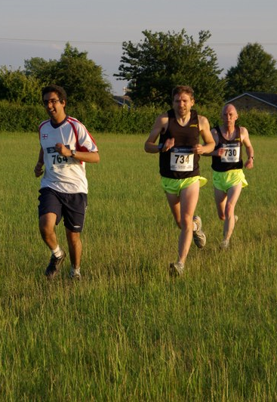
ER members and guests in the 2009 10K handicap

Round Norfolk Relay needs you
Club coach Alan Rutterford is now taking names for the 2011 RNR on 17/18th September, in which Ely Runners again have two teams. The 17 individual stages which make up the 195m course range from 5 to 20 miles, pass through some stunning rural and coastal scenery, and engender a great team spirit. More details can be found at www.roundnorfolkrelay.com
As well as 34 runners, Alan is also looking for 5 volunteers to marshall the changeover at Wissington, which is a condition of having a second team in the race. Anybody interested in running or helping out please email Alan (alanatrdsltd@aol.com) or see him at training.

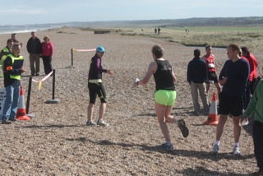
Ely Runners enjoying the scenery at the 2010 RNR

2011-2012 Frostbite Season
At the 2011 Frostbite AGM it was announced there would be two new venues – Bottisham hosted by C&C and March. Provisional dates and venues are as follows:

*October 2nd 2011 - Bottisham (C&C)
November 6th 2011 - Bushfield (Bushfield Joggers)
December 11th 2011 - Hinchingbrooke Country Park (Hunts AC)
*January 15th 2012 - March – (March AC)
February 5th 2012 - Bourne Woods (Bourne Town Harriers)
March 4th 201 - Huntingdon (BRJ)

* Provisional venues – should either C&C or March fail to host a race Riverside Runners will step in. The final race returns to the BRJ Huntingdon course after the club found an alternative venue to host the event after the closure of BRJ social club caused the cancellation of last year’s race.

Ladies Captain Heidi Uff welcomes new Ely Runners
Firstly, welcome! It's great you've chosen to join Ely Runners and we look forward to running with you. As you're new to the club, there may be lots you'd like to find out. I'll attempt to answer a few of the more frequent questions now:

How fast do I have to be to run with Ely Runners?
We welcome runners of all abilities, there's no pace you have to be able to run at. We do recommend that for participation in training, runners are able to jog for 30 minutes. If you don't think you're quite there yet, there are plenty of online training programs which can help you get there. 'Couch to 5k' is a good one and has helped many people achieve their fitness goals: http://www.coolrunning.com/engine/2/2_3/181.shtml

I'm not sure about racing. Do I have to do it?
Of course not, but you'd be missing out on a lot of fun if you don't try it. A gentle, friendly introduction can be found by taking part in club only events. As well as a cross country event in January, we have a 10k handicap in June and a 1 mile handicap in July.
In addition, members are able to take part in the Frostbite Friendly League. This is a series of races around 5 miles in length, which run each month from October to March. Entry is free to all members and the events provide a wonderful, friendly introduction to racing.
Alternatively, you could try taking part in Cambridge parkrun. This is a free, weekly event which takes place every Saturday morning. Just check out this website for more information: http://www.parkrun.org.uk/cambridge/home
I'm really keen to race! What opportunities are there?
Lots! Just check out our Races and Events Guide. This is kept updated and includes the vast majority of local events. It also includes some not-so-local events which nevertheless prove popular with members of the club. Speaking with club members at training will be a great way of familiarising yourself with various events - we've runners who enjoy shorter distances, right up to our ultra-running contingent.

Do you organise team events?
Yes. You'll have the opportunity to take part in a number of relay events, which include the well-known Round Norfolk Relay and the club's own Turing Trail Relay. We also try, where possible, to put teams together for various cross country and track based events. We will let you know when these events are coming up.

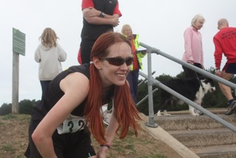
Ladies Captain Heidi Uff at the 2010 RNR

What does the club expect from me?
Well, we'd hope that you'd consider helping out at some of our events. As well as a number of smaller club races, our main events are Grunty Fen Half Marathon in September and New Year's Eve 10k in December. Marshals and helpers are vital for the successful continuation of these races, so if you could assist we would be very grateful. Also, all members have the opportunity to attend our AGM. Participation is encouraged as the meeting is of great importance to the running of the club.

Do you meet up socially?
Sure. We meet up for drinks each first Thursday of the month, so please join us. For further information on social events, speak to Julie Foreman as she kindly organises social activities.
If ever you’ve anything you’d like to suggest about the club or comments you’d like to make, you can email me: captain@elyrunners.co.uk

Contributions to the Newsletter
If any members have any short articles about their running experiences which other members may find useful, interesting or just entertaining, please send them with a suitable picture (800x600, portrait) to newsletter@elyrunners.co.uk

SOCIAL EVENTS

After training drinks
After training drinks are usually held on the first Thursday of each calendar month, with all members more than welcome to attend. The next opportunity to see what your training partners look like with their clothes on will be Thursday 9th June at the Prince Albert in Ely directly after the Midsummer 10K handicap. Further information is available from Julie Foreman (Julie@elyrunners.co.uk).

SELECTED RESULTS ROUND-UP – March/April/May

Oakley 20
Plenty of PB’s and a club record at this popular pre-London warm up race.

Official Chip times:
17th Kieren Drane 2:09:03 (PB)
53rd Graham Chapman 2:16:18
28th Stephen Tovey 2:16:50 (PB)
96th Jose Perez 2:23:26 (PB)
344th Nicola Bramley 2:49:20 (FV50 Club Record)
495th Miranda Paul 3:02:14 (PB)
657th Emily Knight 3:20:00 (PB)

Thorney 10k
A PB for the ever improving Lionel Smith.

Official Results:
9th John Uff 36:05 (PB)
55th Lionel Smith 43:51 (PB)
72nd Heidi Uff 45:13 (10th Lady)

Cambourne 10k
Matt Holmes was looking for a considerable improvement on his PB at the Cambourne 10k, but hadn't done his homework finding that the race was mostly off-road. Rather than flying off at the start and paying for it later on as he normally does, Matt wisely decided to stick with fellow Ely Runners Peter Harris and Andrew O'Hanlon, finishing the race with a 40 second PB.
Official Chip times:
11th John Uff 37:18 (2nd Claim)
87th Peter Harris 43:14 (1st MV60)
88th Matt Holmes 43:17 (PB)
91st Andrew O'Hanlon 43:30
121st Ray Harding 44:59
130th Heidi Uff 45:28
288th Steve Starr 50:54 (PB)

Virgin London Marathon
Fifteen Ely Runners completed the London Marathon on an unseasonably hot day this year. Race day conditions were hot and sunny without a cloud to be seen. The temperature rose steadily as the day went on, with the section through the Isle of Dogs and Canary Wharf being particularly unforgiving. As ever there were massive crowds and incredible support all the way round – but particularly at Tower Bridge and along the Embankment. There were plenty of PB’s and also a club record. To read the full story of the race in the eyes of several ER visit the club website and go to race reports.

Official Results:
158th Stephen Pettit 2:39:59 (8th MV45, PB by 4:11, MV45 Club Record)
575th John Manlow 2:52:34
681st Kieren Drane 2:54:51 (PB by 18:29)
1262nd Graham Chapman 3:03:14
1507th Steve Tovey 3:06:47 (PB by 23:42)
1782nd Clare Durrant 3:09:58
2205th John Crisp 3:14:30
2582nd Mark Turner 3:18:13 (PB)
3479th Jose Perez 3:26:42 (PB, 1st Marathon)
6708th Melanie Fisher 3:48:07 (ran for 2nd Claim Claremont Road Runners)
7094th Nicola Bramley 3:50:12
7366th Linden Smith 3:51:39
10300th Steven Hardwick 4:04:38
12987th Hannah Shiell 4:16:40 (PB by 4:26)
16187th Emily Knight 4:29:18 (PB by 20s)
16487th Fraser Badcock 4:30:19
18014th Ian Blatchford 4:36:38

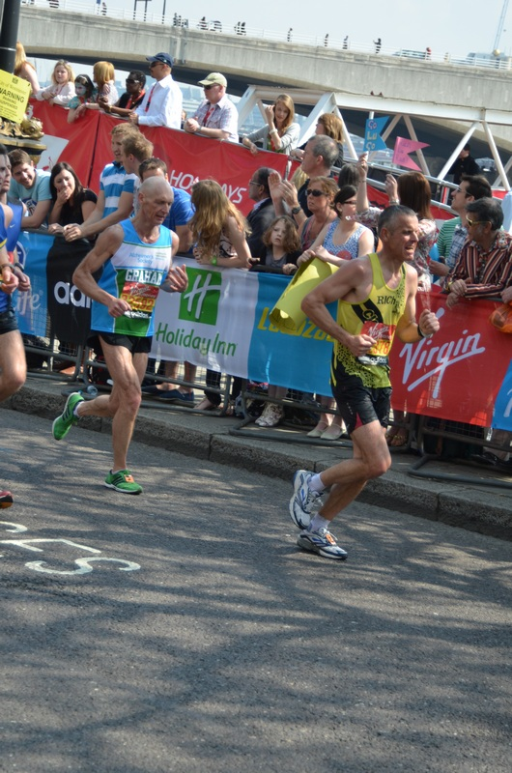

Graham Chapman in the closing stages of the marathon

Congratulations also to the month’s other Marathon runners:

Cindy Mills (Brighton) 2743rd in 4:15:33 (PB)
David Mould (Bungay) 85th in 3:33:15
Miranda Paul (Bungay) 115th in3:53:37 (PB)
David Mould (Bletchley Enigma) 15th in 4:05:18

GEAR 10k King’s Lynn
The 6th Grand East Anglian run was held at Kings Lynn with warm weather and a record turnout.

Official results (Chip Times):
13th Craig Holgate 34.33,
17th Stephen Pettitt 34.58
20th Alex Tate (2nd Claim) 35.28 31st Maurice Reed 36.49
190th Ray Harding 44.13
192nd Lionel Smith 44.24
227th Zoe Shackleton 45.14
273rd Trevor Dowling 46.37
314th Jason Pattison 47.15 (PB) 336th Sarah Edwards 47.30
349th Robert Shortland 47.55
376th Miranda Paul 48.14
426th Lisa Redman 49.24 (PB)
555th Andy Nixon 51.32
573rd Gareth Kavanagh-Dixon 51:41
599th Adrian Scaites-Stokes 52.11
651st Stephen Starr 53.11
907th Claire Van L 56.56.
The race was won by Aaron Scott of Notts AC in 31.25. There were 1478 finishers and over 300 in the 1.2 mile Fun Run.

Milton Park Run, April
Congratulations to Graham Chapman achieved a new 5k PB and MV50 club record on 9th April. Graham ran 18:41, achieving a WAVA of 81:41%. Ian Day (below) bagged a new parkrun course PB on 16th April running the 5K course in 17:26.
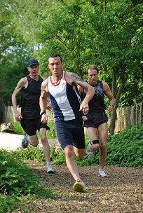
Well done to David Mould’s son, Luke, who took part in his first parkrun this month, and broke 30 minutes with relative ease.
On Saturday 30 April, Ely Runner Emma Greaves and her family arrived to take part in a special event supported by the Lucozade YES team. To celebrate the launch of Lucozade’s Orange Lite, runners were asked to wear orange to be in with a chance of winning goodies. As you can tell from the photo below, the Greaves family certainly embraced the colour theme!
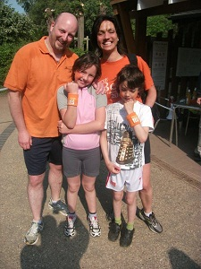
Event photographs
Race/club event photographs should now be sent to Charlie Barker: (charlie@elyrunners.co.uk) Ideally they should be resized to 800x600 pixels (ish) and preferably be less than 100k in size.

FORTHCOMING EVENTS

EVENTS GUIDE

Other Events

See the following RACES & EVENTS GUIDE starting on page 5.

RACES & EVENTS GUIDE 2011
This includes local area and easily accessible races, club, county, regional and national championships, and a selection of UK/overseas events previously enjoyed by members.
Cambridge 5k Park Runs (at Milton) are every Saturday at 0900. Entry is free but before your first race, register on-line by 1800 on Friday, www.parkrun.org.uk/cambridge/Home.aspx
May
01 Bespak Grand East Anglia Run (GEAR) 10k/1.2m FR, King's Lynn, www.grandeastangliarun.co.uk
01 Glastonbury Road Run 3k/5k/10k/FR, www.glastonburyroadrun.info
01 Suffolk Heritage Coast Run/Walk, Thorpeness
01 Titchmarsh 10k, Kettering, www.titchmarshplayingfield.org.uk/events/10k.php
02 (Mon) Ashdon 10k & 3k, Ashdon, Saffron Walden, ashdon.handycandy.co.uk/
02 (Mon) Breckland 10k, Croxton, www.thetford-ac.co.uk
02 (Mon) Great Weston 5m, Towcester, www.greatweston5.co.uk
02 (Mon) Impington 5k, Histon & Impington, http://www.friendsoftherec.co.uk/
02 (Mon) Watford 10k & FR, www.watford10k.org.uk
04 (Wed) EVAC Track & Field, Match 1
04 (Wed) Great Yarmouth 5m Series (Race 2), www.gyrr.co.uk
04 (Wed) Silverstone Grand Prix 10k, Silverstone Race Circuit, www.silsonjoggers.org.uk
05 (Thu) Newmarket Heath 6k, newmarketjoggers.co.uk/?page_id=1221
07 (Sat) Fen Drayton 10k & FR, www.fendrayton10k.org.uk/
08 Birchanger 10k, Birchanger nr Bishop's Stortford, www.birchanger.essex.sch.uk/
08 Bluebell 5m, Benfleet, users.aber.ac.uk/aiv/bluebell5.htm
08 Colchester Trinity Rotary Charity 10k, Colchester, www.colchestercharityraces.org
08 Eye 10k & 3k FR, Eye, www.eye10k.co.uk
08 Frinton & Walton Half-Marathon, Frinton-on-Sea, www.ttc.uk.net
08 Frostbite Friendly League AGM
08 Halstead & Esse Marathon, Halstead, www.halsteadandessexmarathon.co.uk
08 Rotary Shakespeare Marathon and Half-Marathon, Stratford-upon-Avon, www.shakespearemarathon.org.uk
08 Saffron Crocus Trail 10, Saffron Walden, www.saffroncrocustrail.co.uk
08 St Albans 10k, www.stalbansstriders.com/10k.html
10 (Tue) Ladies 5k series, Harlow, www.thehrc.org.uk
13 (Fri) Blisworth Friday 5, Northampton, www.woottonroadrunners.co.uk
13-15 European Road Races & Walks, Thionville, France
14 (Sat) Cambs AAA Track & Field Championships, Wilberforce Road, www.cambsathletics.org.uk
14 (Sat) Frostbite Presentation Evening, www.frostbiteleague.org.uk/Presentation/Presentation
14 (Sat) St Thomas More 5k & 3k FR, Saffron Walden
14 (Sat) Stanwick Ultra 45k, Stanwick, Northants, www.ultramarathon.org.uk
15 Aviator 10k, Sywell Aerodrome nr Northampton, www.onyourmarksevents.org
15 Deepings Rotary 10k & 3k FR, Deeping St. James,
15 Dereham 10m, www.derehamrunners.co.uk/
15 Lactic Rush 8, Brentwood, Essex, www.adventureraceessex.co.uk
15 Ross Peers Half-Marathon, Soham, www.rosspeers-sportscentre.co.uk/
15 Sawston Fun Run 4.8m, Sawston, www.sawstonfunrun.co.uk
15 Shuttleworth 5m Trail Race, Shuttleworth College, www.dirtrunning.co.uk
15 Stevington 12k, Stevington, Bedford, stevington12k.website.orange.co.uk
15 Woodbridge 10k, www.woodbridgeshufflers.org.uk/
18 (Wed) Great Yarmouth 5m Series (Race 3), www.gyrr.co.uk
20 (Fri) Ipswich Jaffa Friday 5, Ipswich, www.ipswichjaffa.org.uk
21 (Sat) BMAF Road Relays, Sutton Coldfield, www.bmaf.org.uk
22 Great Baddow Charity Race 10m, Chelmsford, www.baddowraces.org.uk
22 Henham 10k, Bishop's Stortford, www.henham10k.co.uk
22 Magog Down 5m, Stapleford, Cambridge
28 (Sat) Eastern AA Track & Field Championships, Cambridge University Track
29 Alex Moore Memorial Relay, Skeyton (Nr Norwich), www.norfolkgazelles.co.uk/
29 Bupa London 10k, www.london10000.co.uk/
29 CAU Inter County Track & Field Championships, Bedford Stadium
29 Woodland Half-Marathon, Bourne Woods, Lincs, www.fat-feet.co.uk
30 (Mon) Hatfield Broad Oak 10k, Bishop's Stortford, www.hbo-10k.org.uk
June
01 (Wed) EVAC Track & Field, Match 2
04 (Sat) Moulton Race Walks 5m, 1k (10+) & 500m (-10)
05 BMAF Track 10k Champs, Oxford
05 Harewood House Chase 10k (Near Leeds), www.bingleyharriers.org.uk/html/harewood/hwood.htm
08 (Wed) Peterborough 5k series Race 1, Ferry Meadows, Peterborough
09 (Thu) Ely Runners 10k Club Handicap (Private Event)
11 (Sat) South Downs Marathon & Marathon relay, Petersfield www.209events.com/uk-events-lists.php
12 Abbey 10k & 3k FR, Ramsey, www.ramseyroadrunners.org.uk
12 Chilford 10k, Chilford Hall, Linton, www.losc.co.uk/
12 The Heroes Half-Marathon, ATR Brassingham, Royston, www.endurorunning.com
17 (Fri) Marston Forest 5k, www.MarstonForest5K.org.uk
17 (Fri) Summer Solstice 10k, Grantham, www.granthamrc.btinternet.co.uk/solstice_10k
18 (Sat) Trionium Picnic Marathon/Half-Marathon, Box Hill, Surrey, www.trionium.com
19 North Downs 30k, Gravesend, www.isteadandifield.org.uk/
19 BMAF 5k Road Champs, Horwich
19 Huntingdon 10k charity run, Huntingdon, www.huntingdon10kcharityrun.co.uk
22 (Wed) Peterborough 5k series Race 2, Eye, Peterborough
25 (Sat) Greensand Ridge Relay (6 stages/33m) Leighton Buzzard to Bedford, www.smoc.info/GSRR/
26 Humpty Dumpty 10k, Great Yarmouth, www.gydac.org.uk/roadrunning
26 Sutton Feast Beast, 7m, Sutton
26-27 BMAF Track & Field Champs, Birmingham
July
06 (Wed) EVAC Track & Field League, Match 3
06 (Wed) Peterborough 5k series Race 3, Ferry Meadows, Peterborough
06-17 World Masters T & F Champs, Sacremento, California, USA
10 Bushy 10k, Bushfield, Peterborough, www.bushfieldjoggers.co.uk/
14 (Thurs) Ely Runners 1m Club Handicap (Private Event)
17 NSPCC Milton Keynes Half Marathon, http://www.nspcc.org.uk/
17 St. Ives 10k & 3k FR, www.huntsac.org.uk
20 (Wed) Peterborough 5k series Race 4, Stamford
24 Littleport 10k, www.littleport10k.co.uk
24 Luton 10k
24 Spartan Race 5k with obstacles, ATR Bassibgbourn, Royston, www.spartanrace.com/
27 Bungay 10k
29-31 (Fri-Sun) Montane Lakleand 100m, www.lakeland100.com
30/31 (Sat/Sun) Montane Lakeland 50m, www.lakeland100.com
31 EVAC Track & Field Champs, Kings Lynn
August
03 (Wed) EVAC Track & Field League, Match 4
03 (Wed) Peterborough 5k series Race 5, Werrington, Peterborough
07 Veterans Inter Area Competition, Solihull
11 (Thu) Eye 5m Charity Race, Eye, www.eyerunners.co.uk
14 Great Yarmouth Half-Marathon, www.gyrr.co.uk
14 Thorney 5m, outa-stock.co.uk/trc/raceinfo.htm
16-25 European Vets Championships, Stadia
20 (Sat) Race the Train 14m XC, Tywyn, Wales, www.racethetrain.co.uk
21 BMAF Half-Marathon Champs, Leek
21 Camille's Appeal 5m, Wherstead nr Ipswich, www.enter4.co.uk/camillesappeal/home
21 Monster Racing Middle Triathlon, Ely, www.monsterracing.net
September
04 BMAF 10m Road Champs, Hexham
04 Budapest Half-Marathon, www.budapestmarathon.com
04 Ely sprint triathlon & Aquathlon, Ely, www.entrycentral.com
04 Wissey Half-Marathon, www.rystonrunners.org.uk/
11 EVAC Track & Field League Final, Bedford
11 Grunty Fen Half Marathon, Witchford, www.gruntyfen.co.uk
17/18 (Sat/Sun) Round Norfolk Relay, www.roundnorfolkrelay.com
21-24(Wed-Sat) Great Barrow Challenge, Suffolk, www.greatbarrowchallenge.co.uk
October
02 BMAF 10k Championships, Exmouth
02 Budapest Marathon, www.budapestmarathon.com
02 Royal Parks Half-Marathon, London, http://royalparkshalf.com/
22 (Sat) Beachy Head Marathon, www.beachyheadmarathon.org.uk/events/BeachyHeadMarathon.aspx
23 Ampthill Trophy XC, www.AmpthillTrophy.org.uk
23 East Coast 10k, Great Yarmouth, www.gyrr.co.uk
23 Trionium Greensand Marathon, Dorking, www.trionium.com
30 Fenland 10, Wisbech, www.fenlandrunners.org.uk/
November
06 Adnams Great Eastern Run, www.bungayblackdogrunningclub.co.uk
20 St Neots Half-Marathon, www.riversiderunnersraces.co.uk
27 Bath hilly Half-Marathon, Bath, www.trionium.com
27 (prov date) Hereward Relay, www.marchathleticclub.co.uk
December
02 (Fri) Ely Runner's Christmas Buffet & Drinks, (Private Event) Cutter Inn, Ely (Prov)
11 Bedford Harriers Half-Marathon, www.bedfordharriers.co.uk/
18 Club Pre-Christmas training runs, (Private Event) Woodditton/Ely 18.5m, Woodditton/Reach 7.5m, Reach/Ely 11m. Lunch afterwards at the High Flyer
31 (Sat) Ely New Year’s Eve 10k Road Race, 1100 Little Downham, www.newyearseve10k.co.uk

NOTES
Races and events are on Sunday unless otherwise mentioned.
Many events also have a concurrent Fun Run. These can provide valuable racing experience for junior members and beginners. Check the main race information for details.
Courses are usually on roads and/or hard footpaths/cycle ways unless otherwise mentioned.
Distances without units (m or k) are probably m = miles.
Frostbite League races are about 5-6 miles for seniors and 1.5m for juniors. Entry (league membership) is paid for by the club.
Further details of events from the Club notice board in the Paradise Centre foyer, running magazines, websites, or from Steve Tovey, secretary@elyrunners.co.uk who also has details of all RRC/TRA long distance road/TR/XC races and FRA fell races.
National, regional and county championship team entries are via Heidi Uff, captain@elyrunners.co.uk but for -13,-15,-17 & juniors, first contact Lesley Wright, lesley@elyrunners.co.uk.
Ely Runners’ private club XC championships, 10k/1m handicaps, and TTR relay entries are via Matthew Holmes, (matt@elyrunners.co.uk).Long distance team relay entries are via Alan Rutterford, alan@elyrunners.co.uk and paid for (if funds available) by the club.
Social events are via Julie Foreman, julie@elyrunners.co.uk
Junior training details from Junior Representative/Club Coach Alan Rutterford, alan@elyrunners.co.uk
Junior race details from Junior Secretary Lesley Wright, lesley@elyrunners.co.uk
Club website: www.elyrunners.co.uk
Grunty Fen 1/2M website: www.gruntyfen.co.uk
NYE10k website: www.newyearseve10k.co.uk
Turing Trail Relay website: www.turingrelay.co.uk
Association of Running Clubs website: www.runningclubs.org.uk
Last Updated 24/04/2011

