Ely Runners Newsletter

May 2010



NEW MEMBERS
This month we welcome the following new members to the club:

Tanya Shenton, Ashley Blackmore, and Robert Shortland

Birthday Celebrations

Presentations of engraved pewter tankards were made by Stephen Howard to Peter Harris who has just celebrated his 60th birthday and to Tony Hall who
celebrated his 75thbirthday last year.

As can be seen from the photographs taken at The Prince Albert, no one can argue with the fact that running fights off ageing.

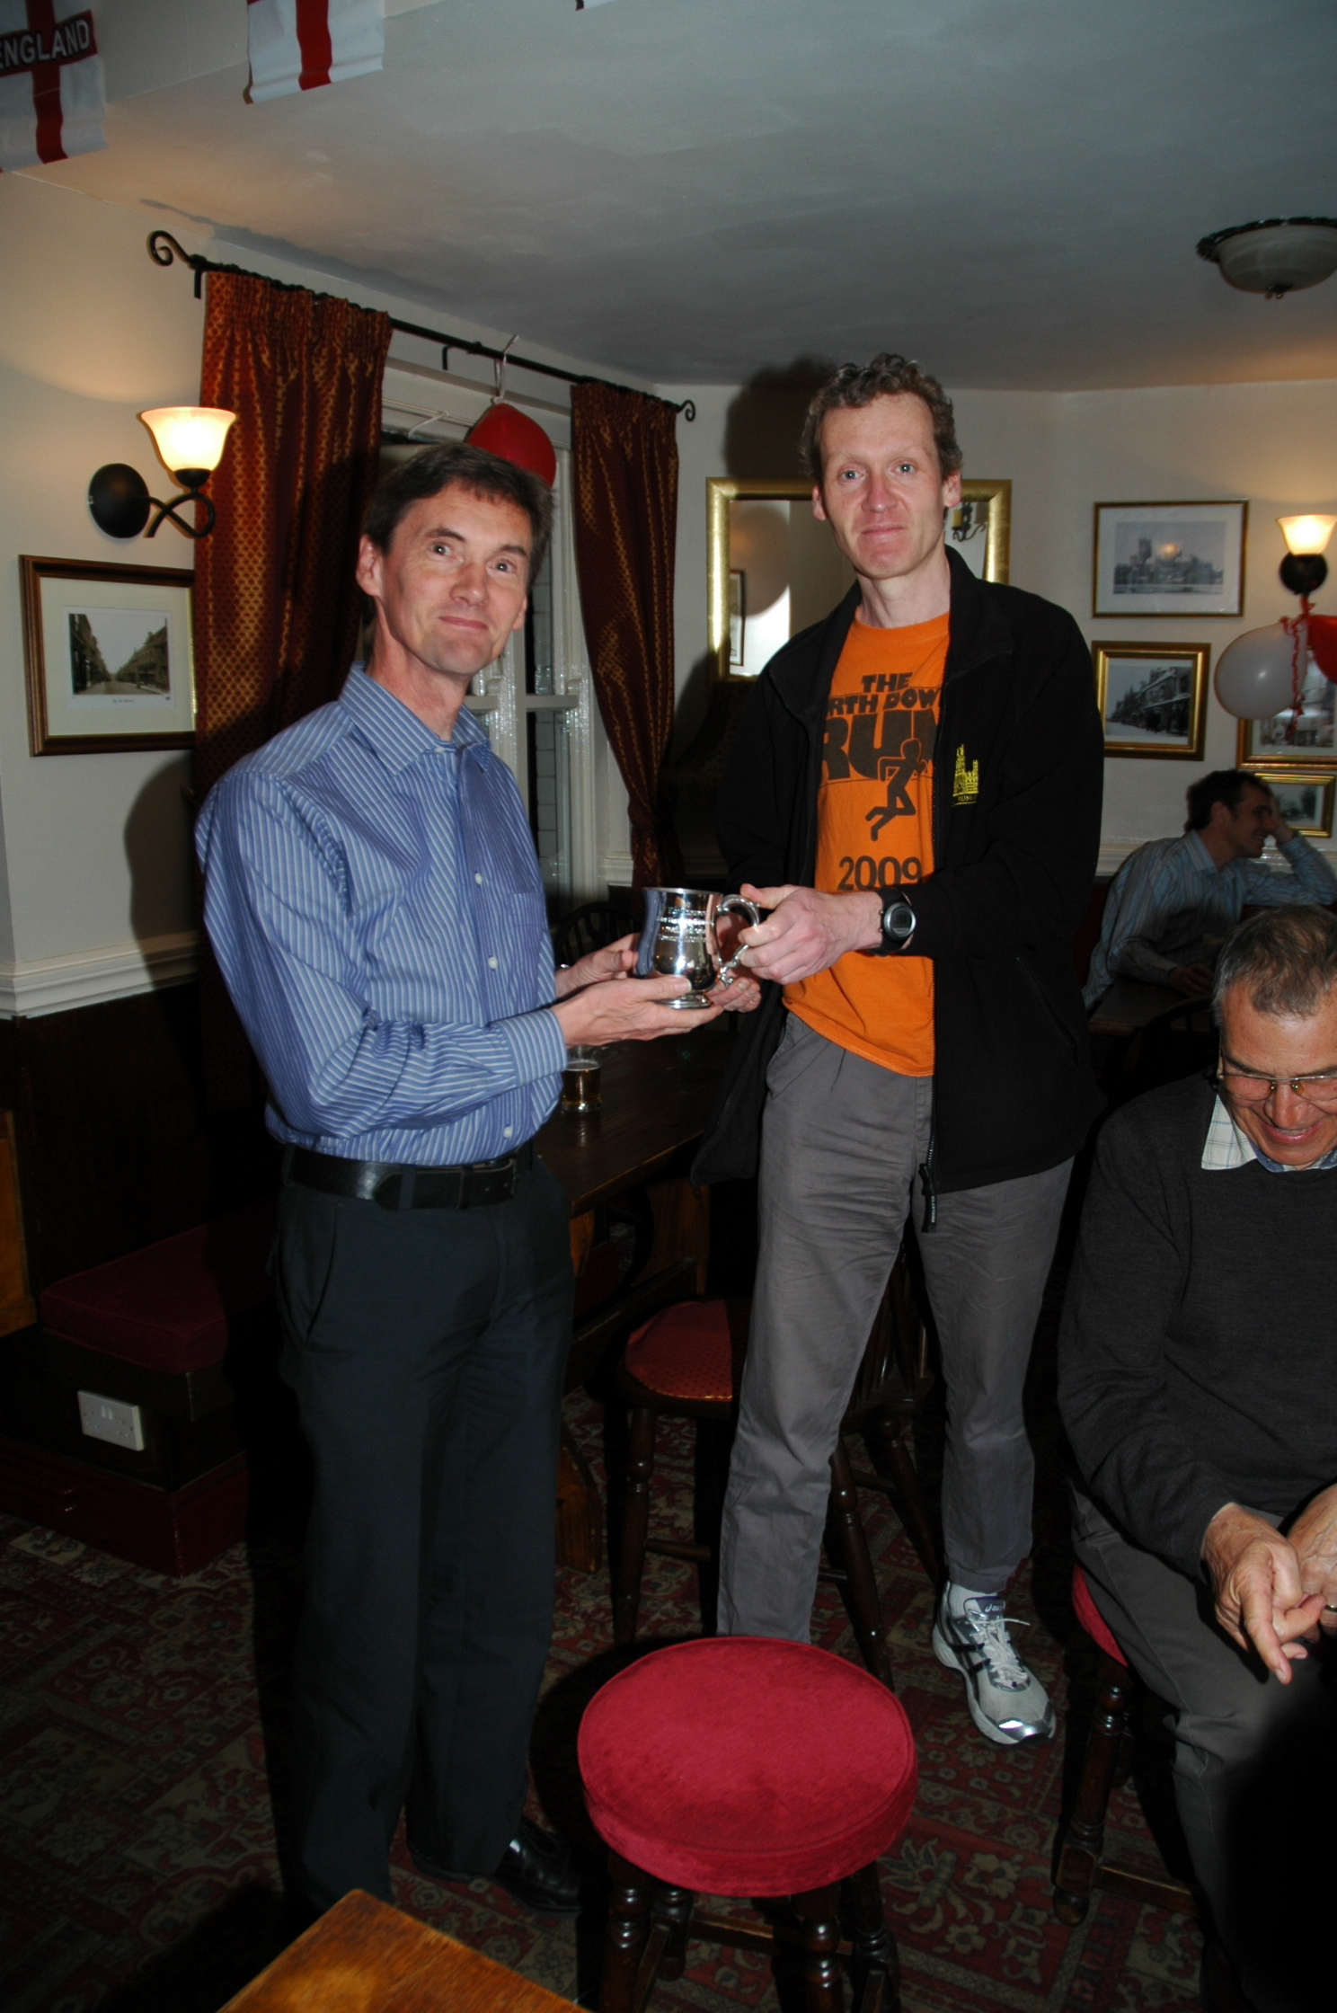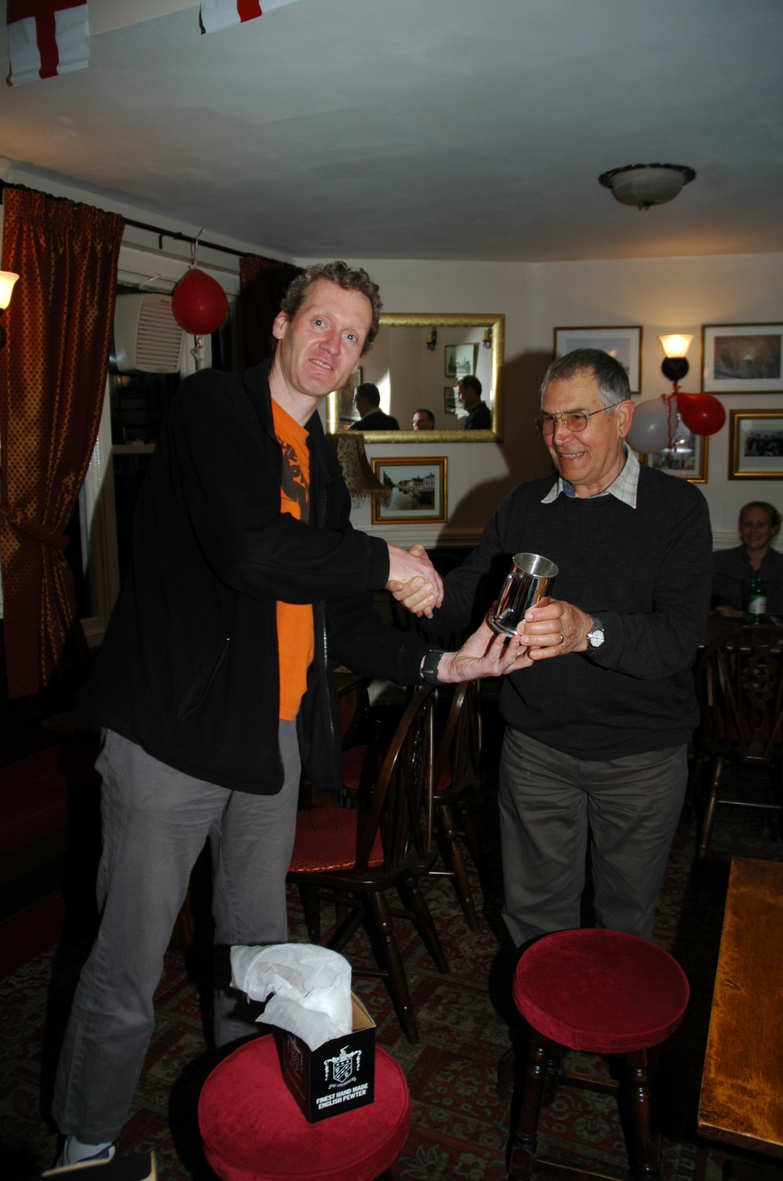

Wedding Celebrations

Congratulations to members Heidi Fochtmann and John Uff on their recent wedding.

Distant Members
News from Ture Neilsen
I ran the Chris Hoy half Marathon in Edinburgh on the 18th of April. It was a typical Scottish day in April 6 degrees rain and into a 10mph wind for the first 10miles. Despite this and the ash cloud from Iceland, the field, this year increased to 3,092 runners. I had a fair run despite this was only meant to be a warm up for the next half marathon the 15th of May I finished in 1.30.46 with the last 5k in just below 20 min. You can find the official time on
http://www.winningtimeuk.com/index.php?page=results and either look for my bib “42” or search for the club…see one of the pictures taken at the event where you can see that Ely colours were representing the club. Regards, Ture.

Beachy Head Marathon, Saturday 23rd October 2010
Entries are now open (see http://www.visiteastbourne.com/marathon.asp) for this very popular off-road and hilly marathon over the South Downs from Eastbourne. Lots of members have taken part for many years in this inspiring run at an ideal time of year over some of the finest scenery in the SE.

UK Athletics
UK Athletics sponsor (since 1999) Aviva have launched a new Athletics website at www.aviva.co.uk/athletics. This is an extensive hub where athletes and athletics enthusiasts can get closer to the sport and witness the exciting interactive and innovative content.

Round Norfolk Relay Sat/Sun 18th/19th September 2010
We have teams entered in both the OPEN and CLUB classes and the club’s i/c Long Distance Relays, Alan Rutterford, would like to hear from members who’d like to run or help in this event. He says this 194 mile 17 stage relay is again the chance to show the rest of East Anglia clubs what a strong team we have. Having come 2nd and 44th out of 55 teams last year, and being in the top 3 for the last few years, he considers it is a great chance to pit our wits against some strong teams.

Alan will be coordinating our Open Team (No.54) and Simon Jackson will be coordinating the Club Team (No.29). We will need a driver, timekeeper, recovery driver and assistant each. The Open class has 22 teams this year and the Club class has 24 teams. There are 3 new teams, one being the Australian Defence Force Athletic Club who could be strong contenders for the overall prize.

We are also responsible for setting up and marshalling the changeover at Wissington from about 5-6 am on Sunday 19th Sept. It is a condition of having 2 teams in the event that we marshal this changeover, so it is important that to have volunteers for this role. We will need about 4 marshals and Alan will provide more details nearer the time.

For now Alan will be taking names of those interested, and nearer the time will join up with Simon to pick the teams etc. Please look at the web site www.roundnorfolkrelay.com as there are changes to stages 3,4,5,10 and 11. Basically we need 34 runners, 2 reserve runners, 4 marshals and 6 additional support crew.

Contact Alan Rutterford on alan@elyrunners.co.uk or 07821988959

SUBSCRIPTIONS and REGISTRATION

MEMBERSHIP RENEWALS - The committee would like to remind members that membership renewal subs (£10 adults; £5 juniors) are due by January 1st
each year. Members who haven't renewed by this time are reminded by e-mail (January and March) and also at the cub AGM. Those members who have failed to renew by the end of March will be removed from the membership list. In a change to club policy members who allow their membership to elapse will be allowed to rejoin the club for £20 (see link on website) rather than having to pay the full £35 required from new members.
Benefits of membership include:

- £2 affiliated discount on open race entries
- club affiliations to ARC, ABAC, UKA, EA, TRA, FRA & CAA
- free registration (£5) with EAuntil31stMarch2011(on request via JohnTurner)
- free changing and showers at the Paradise Centre
- free training and coaching advice
- free high-visibility bib for night-time training
- £12 subsidy on club fleeces
- 10-20% discount at most specialist running kit shops
- free entry to the club’s Cross-Country Championships, Turing Trail Relay, 10k Handicap, and One Mile Handicap
- free entry to the six Frostbite League races
- free club team entry to county, regional and national championships and for club relay entries
• entry into the draw (if a member’s ballot entry is rejected) for the club’s guaranteed London Marathon places
• free snacks at club social events
• shared transport to races

England Athletics Registration
Members who requested Registration with EA have now received confirmation of registration from John Turner.

To take part in UKA National and SEAA championships, members need to be registered with England Athletics (EA). Also, a few open events still require EA registration to claim affiliated entry fees. However, most events (especially locally) either have ARC permits or, if they have UKA permits, require only membership of an EA affiliated club, like Ely Runners. Please contact John Turner secretary@elyrunners.co.uk if you need to be registered. As per the AGM, the club will pay the £5 registration fee.

SOCIAL EVENTS
After Training Drinks
After training drinks are usually held on Thursdays. All members are welcome to attend. Further information is available from Julie Foreman (Julie@elyrunners.co.uk).

Cambridge 5k Parkrun
This series got underway in February with a further four races being run this month. Cambridge 5k Park Runs are every Saturday at 0900. Entry is free but before your first race, register on-line by 1800 on Friday at www.parkrun.org.uk/cambridge/Home.aspx

RESULTS ROUND-UP

Stephen Pettit has carried on adding to his collection of club MV45 records with a 10 mile time of 58:54 achieved at the Maidenhead Easter Ten. He followed this by running the Flitwick 10k in a new club MV45 time of 37:27.
Tony Kirby-Cook, Heidi Uff and Samantha Collins-Shirley all achieved PBs at the Cambourne 10k.
Graham Chapman was 1st MV 50 and recorded another PB at the Friskney Half Marathon in a time of 1:24:02.

Forthcoming events
See ‘Races & Events Guide’ below.
The next club event is the popular 10k Handicap on Thursday evening 10th June at Little Downham. If you’d like to invite a guest to run, please contact Steve Tovey at membership@elyrunners.co.uk

Event photographs
Race/club event photographs should be sent to Steve Tovey membership@elyrunners.co.uk

Ideally they should be resized to 800x600 pixels (ish) and preferably be less than 100k in size.

CONTRIBUTIONS TO THE NEWSLETTER
As ever, please send your contributions to the newsletter to newsletter@elyrunners.co.uk. Many thanks!

Charlie Barker (Editor)

RACES & EVENTS GUIDE 2010
This includes local area and easily accessible races, club, county, regional and national championships, and a selection of UK/overseas events previously enjoyed by members.
Cambridge 5k Park Runs are every Saturday at 0900. Entry is free but before your first race, register on-line by 1800 on Friday at www.parkrun.org.uk/cambridge/Home.aspx

May
02 GEAR 10k, 1030 King’s Lynn, £16 (EA reg no), entries closed, www.grandeastangliarun.co.uk
02 Bartlow Challenge 9m, 1000 Three Hills pub, Bartlow, Cambs, £9, EOD +£1
02 Thurston 10.5k/3.5k FR, 1100 Thurston, Bury St Edmunds, £6/£4, EOD +£2
02 Cambridge Duathlon, Bottisham, 7.5k/40k/7.5k
02 Kesgrave KMF 5k, 1000 Bell Inn, Main Rd, Kesgrave, Suffolk, £4, EOD OK
02 Heritage Coast Runs 26m/13m/6m, Thorpeness Playing Field, £15/£10/£10, EOD + £5
03 Breckland 10k, 1100 Croxton Village Hall, Thetford, £10, no EOD, www.thetford-ac.co.uk
03 (Mon) Ashdon 10k/3k MT, 1030/1035 Ashdon Primary School, Saffron Walden, £7/£5-£3 (-16), EOD +£2
03 I(Mon) Impington 5k, 1045 Histon & Impington Rec Ground, £3 EOD only
05 (Wed) EVAC T&F League Meeting, Bedford/Peterborough/Chelmsford
06 (Thu) Newmarket Heath 6kTR, 1930 Newmarket Heath, £8, EOD +£2
08 Cambs AA Track & Field Championships, St Ives, entries captain@elyrunners.co.uk
09 Eye 10k & 3k FR, 1100 Eye nr Peterborough, £7.50, EOD +£1, www.eye10k.co.uk
09 Halstead & Essex Marathon, Essex, £26 EOD, www.halsteadandessexmarathon.co.uk
09 Frinton & Walton ½ Marathon, 1030 Tendring Tech Co, Frinton, £10, EOD +£1, www.ttc.uk.net,TCA link
09 Sawston 4.8m Fun Run, 1030 Sawston College, www.sawstonfunrun.co.uk
09 River Cam Run 4.67m trail, 0930 Pavilion, Rec Ground, Fen Ditton, £7.50, EOD +£2.50
09 The Gauntlet 10k (v muddy XC), 1100 Bures Pit, Parsonage Hill, Bures, £20
09 Colchester Charity 10k, 1030 Abbey Fields, £8, EOD +£2, www.colchestercharityraces.org
09 Alton Water 10k, 1000 Alton Reservoir, Stutton, Suffolk, www.altonwaterrun.co.uk
12 (Wed) Promenade 5m (Race 3), 1915 Marine Centre, Gt Yarmouth, £5.50, www.gyrr.co.uk
15 (Sat) BMAF Open Masters Road Relay Championships, Sutton Park, www.bmaf.org.uk
16 Ross Peers East Cambs ½ Marathon, 1115 St Andrews Primary, Soham, £10, EOD +£2
16 Dereham 10m, 1100 Neatherd High School, Norwich Rd, Dereham, £7, EOD +£2
16 Stevington 12k, 1100 Village Hall, Stevington, Beds, £8, EOD OK
16 Newmarket Triathlon, 300m/22k/4k, 0800 Leisure Centre, £30, no EOD, contact: nigellb@aol.com
23 Race Walking Master Class, 1000-1300 Newmarket Leisure Centre, £5, randjwallwork@btinternet.com
23 March 5m Spud Run, 1100 Elm Rd Sports Field, March, £tba
23 Great Baddow 10m (& 2m FR), 1100 Rec Ground, Baddow Rd, Chelmsford, www.baddowraces.org.uk
23 BMAF Road Relay Champs, Birmingham
23 BMAF Open 10k Track Run & Walk Championships, Oxford
23 Felsted 6m & 13m trail runs/walks, from 0930 Felsted School, Essex, £3 EOD only
23 Gt Daffodil Dash 10k, Lelmarsh Hall, Northants, £16, EOD +£8, www.mariecurie.org.uk/running
23 Edinburgh Marathon, www.edinburgh-marathon.com
26 (Wed) Cambs AA T&F Development Meeting, St Ives (+ 3000m Championships), www.cambsaa.org.uk
28 (Fri) Ipswich Jaffa Friday 5, 1930 St Joseph’s College, Ipswich, £6, EOD +£2
29/30 (Sat/Sun) SEAA U15/U17 SEAA T&F Champs, Ashford, Kent
30 Woodland ½ Marathon, 0900 Bourne Woods, Bourne, Lincs, www.fat-feet.co.uk
31 (Mon) Brandon Forest ½ Marathon, 1030 Mayday Field, B1106, £8, no EOD, www.bfh.org.uk
31 (Mon) Hatfield Broad Oak 10k, 1100 Village Hall, £12.50, No EOD, www.hbo-10k.org.uk

June
02 (Wed) EVAC T&F League Meeting, Cambridge/King’s Lynn/Lee Valley
04 (Fri) Kirton Friday 5, Recreation Ground, Kirton, Felixstowe, contact: farny@talk21.com
06 Hanworth ½ Marathon, 1030 Hanworth Common, £7, EOD OK, www.hanworthcommon.org.uk
06 SCVAC T&F Champs, Ashford
09 (Wed) Peterborough Grand Prix 5k, 1930 Ferry Meadows, Watersports Centre, £4, EOD only
10 (Thurs) Ely Runners 10k Club Handicap, 1900 registration at Little Downham Cricket Pavilion for 1930
first start by Skoda Garage in Main Street. Members (in race kit) and nominated guests only. Awards,
sandwiches and chips from 2115 in The Prince Albert garden, Silver Street, Ely
12 (Sat) Moulton 5m walk. Also Junior 400m and 1500m walks. Ron Wallwark
randjwallwork@btinternet.com
12 (Sat) Kedington 5k, 1100 Community Centre, Kedington, Haverhill, contact: Kedington5k@aol.com
12/13 (Sat/Sun) SEAA U20/Senior T&F Champs, Crystal Place, London
13 Stortford 10k & 10m, 1000 Rugby Club, Bishop’s Stortford, £10, www.bsrc.org.uk
17 (Thu) Eye 5m Charity Race, Eye, Peterborough
19 West Highland Way Race 95m
19-20 (Sat-Sun) BMAF T&F Champs, Alexander Stadium, Birmingham (prov date & venue)
20 BMAF 5k Road Championships, Horwich (tbc)
20 North Downs 30k, 1030 Cascades Leisure Centre, Gravesend, £17, www.isteadandifield.org.uk
20 Rotary Charity 10k, MT, 1000 Huntingdon Race Course, £11
20 Chilford 10k (MT), 1100 Chilford Hall Vinyard, Balsham Road, Linton, £7, EOD +£3
27 Humpty Dumpty 10k, 1030 Reedham Village Hall, Norfolk, £8, EOD +£2, www.gydac.org.uk
27 N Devon Marathon & 1/2 Mar, 1000 Woolacombe, £20/£18 www.northdevonmarathon.co.uk

July
03-04 (Sat-Sun) BMAF T&F Championships, Cardiff
04 March AC 5m Spud Run, 1100 Elm Road Sports Field, March, £7, EOD+£2
07 (Wed) EVAC T&F League Meeting, Biggleswade/King’s Lynn/Chelmsford
08 (Thurs) Ely Runners 1m Club Handicap, Amherst sports field by railway station. Meet promptly 1900 at
the Paradise for issue of numbers prior to running to start. Members only and in race kit. Awards,
sandwiches and chips from 2030 in The Prince Albert garden, Silver Street, Ely
13 St Albans ½ Marathon (+5k,1½FR), 1000 Verulamium Pk, £18, www.stalbanshalfmarathon.co.uk
15-24 European Masters T&F Champs, Nyiregyhaza, Hungary
18 St Ives Dairy Crest 10k
18 Forces Help Marathon, Bury St Edmunds, http://www.bsemarathonandchallenges.com/
21 (Wed) Cambs AA T & F Development Meeting, St Ives (+ Steeplechase & 1 Mile
Championships), www.cambsaa.org.uk
23 (Fri) Brantham 5m & FR – details to follow
24/25 (Sat/Sun) SEAA Combined T&F Events (all age groups), Barnet Copthall
25 Exmoor Sea View 17m, Lynton to Minehead coast path, £6, www.mineheadrunningclub.co.uk

August
04 (Wed) EVAC T&F League Meeting, Milton Keynes/King’s Lynn/Lee Valley
06 (Fri) Wibbly Wobbly Log Jog, 1930 Mayday Field, B1106 Brandon, www.bfh.org.uk
08 BMAF ½ Marathon Championships, Burnham Beeches, Slough
15 Thorney 5m
15 Cambridge Triathlon, Mepal, Cambs, 1.5k/40k/10k
21 (Sat) Race the Train 14m TR, Tywyn, Mid-Wales, www.racethetrain.co.uk
22 BMAF Half Marathon, Burnham Beeches, Slough, www.bmaf.org.uk
28 (Sat) U15/U20 SEAA Inter-Counties T&F Champs, Barnet Copthall

September
05 The Beast (13m multi-terrain), Corfe Castle, Dorset, www.poole.ac.co.uk
05 EVAC T&F League – Final (full match), Bedford
10-17 European Masters Games, Lignano, Italy
12 Ely Standard 20th Grunty Fen Half Marathon, Witchford, www.gruntyfen.co.uk
12 BMAF 10k Road Championships, Goodrich, Wolverhampton
18/19 (Sat/Sun) Round Norfolk Relay, 194 miles in 17 stages, www.roundnorfolkrelay.com
25 (Sat) SEAA 6/4 Stage Road Relays (senior men & vets), Rushmoor Arena, Aldershot
26 SEAA 6/4 Stage Road Relays (women & young athletes), Rushmoor Arena, Aldershot

October
03 SEAA 10k Road Race Champs, Crystal Palace, London
03 BMAF 10m Championships, Oldbury Power Station, Bristol
10 Great Eastern Run ½ Marathon & 4k Fun Run, 1010 Peterborough
17 EVAC XC Championships, Ampthill Trophy Meeting, Bedford (tbc)
23 (Sat) Beachy Head Marathon, South Downs, 0900 Eastbourne, http://www.visiteastbourne.com/marathon.asp
24 Exmoor Stagger, Minehead, 15.1m & 3,627’ ascent, £10, EOD +£2 www.mineheadrunningclub.co.uk

November
21 St Neot’s Riverside ½ Marathon
28 Hereward 4 Stage Relay (37.73m Peterborough to Ely), club teams

December
02 (Thu) Ely Runner’s Christmas Buffet & Drinks, 2030 Cutter Inn, Ely
19 Club Pre-Christmas training runs, Woodditton to Ely 18.5m, Woodditton to Reach 7.5m, Reach to Ely 11m. Meet 0800 Paradise car park for transport to starts. Contact JT to run. Lunch afterwards at the High Flyer at 1300 - contact julie@elyrunners.co.uk to book
26 Boxing Day training, meet 0900 Paradise Centre car park
31 (Fri) Ely New Year’s Eve 10k Road Race, Little Downham www.newyearseve10k.co.uk

NOTES
Races and events are on Sunday unless otherwise mentioned.
Race entry fees are the ARC or UKA affiliated club fees
Many events also have a concurrent Fun Run – check race information for details.
Courses are usually on roads and/or hard footpaths/cycle ways unless otherwise mentioned.
Distances without units (m or k) are probably m = miles.
Frostbite League races are 5-6 miles and entry (league membership) is paid for by the club.
Further details of events from the Club notice board in the Paradise Centre foyer, running magazines, websites, or from John Turner secretary@elyrunners.co.uk who also has details of all RRC/TRA long distance road/TR/XC races and FRA fell races.
National, regional and county championship team entries are via Charlie Barker (captain@elyrunners.co.uk).
Ely Runners’ private club XC championships, 10k/1m handicaps, and TTR relay entries are via Steve Tovey (membership@elyrunners.co.uk).
Long distance team relay entries are via Alan Rutterford and paid for (if funds available) by the club.
Social Events are via Julie Foreman julie@elyrunners.co.uk
Club website: www.elyrunners.co.uk
Grunty Fen 1/2M website www.gruntyfen.co.uk
NYE10k website www.newyearseve10k.co.uk
Turing Trail Relay website www.turingrelay.co.uk (private club event for 2010)
Association of Running Clubs www.runningclubs.org.uk
Last Updated JT 28.04.2010

