Ely Runners Newsletter

MAY 2009


April is always a month of transitions in running. It sees the culmination of many months of hard training for those who’ve been targeting spring marathons. Meanwhile, those of us who prefer the shorter stuff are starting to pick up the pace ready for a summer of 5k- and 10k-racing. Lighter evenings mean we can now head out of town on our mid-week training runs and also enjoy the benefits of Alan Rutterford’s coaching expertise at his Tuesday evening grass track sessions. (Click on “ER Training Programme“ on the homepage of the club’s website for further details of these sessions.)

NEW MEMBERS
This month we welcome the following new members of the club:

Rachel Toms
Rachel is originally from Dorset but moved up to East Anglia 12 years ago to go to University in Norwich, and has been here ever since. She is an Occupational Therapist, working in mental health services based in Bury St Edmunds, and moved to Soham (from Thetford) just a few weeks ago. Rachel has done a lot of swimming in the past and last year decided to look into doing some triathlons for a bit of fun and a challenge! So she has joined Ely Runners to try to improve the running side of things.

Rachel Levitt
Rachel says: “I’m married with two teenage boys, and live in Burwell. My 15 year old son has recently started at the Kick Boxing Club at the Paradise Centre at 7pm on Tuesday night and I saw you all starting out the first week that I took him. I’m a keen runner but not necessarily very disciplined so training with a group would be ideal to spur me on and push me a bit further. I’ve done two 5k and two 10k charity races over the last two years and would like to do more.”

Paul Collings
Jason Mann
Fiona Bainbridge

COACHING NEWS
Congratulations to Melanie Fisher, who has just successfully completed her UKA Level 1 Athletics Coaching qualification. Melanie has been assisting club coach Alan Rutterford with his sessions for juniors at the new East Cambs AC.

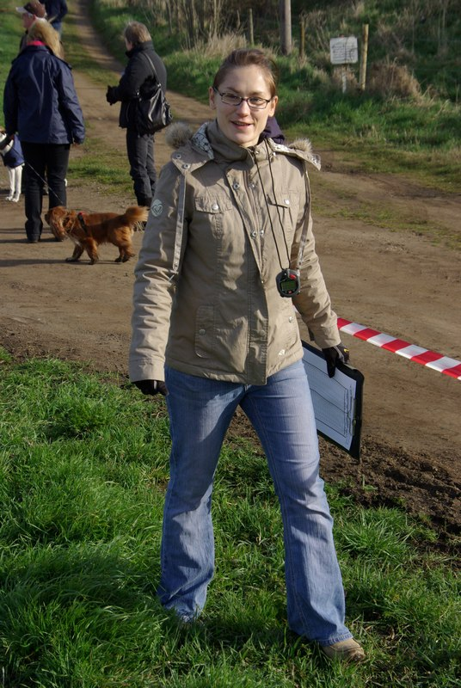
Mel Fisher

EAST CAMBS AC
Alan reports that the East Cambs AC is thriving and that he is keen to foster links between it and Ely Runners, to provide continuity for promising junior endurance athletes wishing to join ER at a later date. On that note, some of the juniors may be invited to join us for the annual Straight Mile Handicap Race, to be held on Quanea Drove on Thursday 9 July. He’s pleased to see Mick Butler’s children attending the junior sessions regularly, getting ready to follow in their dad’s footsteps.

RACE NUMBERS
If you have entered a race and then find you are unable to run, please ensure that the race organisers have been informed, if you arrange for someone else to take over your number. Some races offer an official number transfer service. Others will allow you to transfer your number, as long as they have details of the runner taking your place. See the event’s website or contact the organisers for further information.

FORTHCOMING EVENTS

Magog Down Training Session
The date of the Magog Down training session has been switched to Thursday 4 June. (The run to Little Downham planned for that evening will now take place on 28 May instead.) Members are invited to go back to the David Lloyd Club (Next Generation) in Cambridge after the session, from 8.30pm to 9.00pm, as guests of Sweatshop, where they will be able to use the changing facilities and have a swim. Sweatshop will also be open at that time and members will be offered a special 15% discount. Meet Paradise at 6:15 pm or go direct (meet Magog car park) for 7:00 pm start.

Ely Runners’ Midsummer 10k Handicap
The club’s annual 10k handicap race will be taking place on Thursday, 11 June, starting from the Cricket Club in Little Downham at 7.30pm (or maybe a little later, if you’re particularly speedy!). As usual, there will be refreshments and prize presentations afterwards in the Prince Albert in Ely.
If you would like to take part, email Steve Tovey (stevetovey@elyrunners.co.uk) with a recent race time (10k if available, but Steve can calculate your handicap time from any recent race performance).
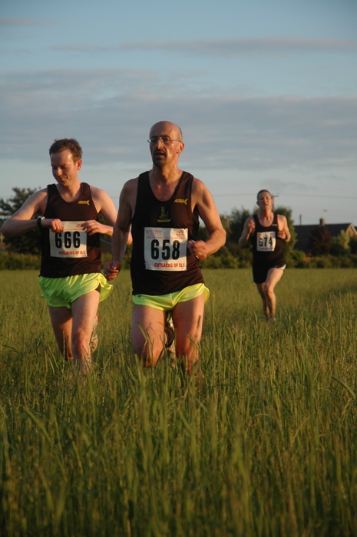
Stephen Hardwick, Adrian Stokes and Steve Tovey battle it out
at the end of last year’s 10k handicap

Round Norfolk Relay
Just a reminder that we have entered two teams into the 2009 Round Norfolk Relay this year (the weekend of 19/20th September). If you'd like to run, please contact Alan Rutterford (alan@elyrunners.co.uk).

FITNESS CLOTHING SALE
Natalle Etches is selling a selection of running, cycling, fitness and triathlon clothing, from brand names including Craft, Gore Bike Wear, Pearl Izumi, and Sugoi, that she purchased from a local Internet company that closed down. Prices will be as low as half price to club members. Natalle will be bringing her stock to the following training sessions in May:
Tuesday 5 May
Tuesday 12 May
Tuesday 19 May
If you have any questions in the meantime, please contact Natalle (natalle@elyrunners.co.uk).

HELP TO RUN YOUR CLUB!
John Turner is still looking for volunteers to help with the club’s administration, in particular any of the following responsibilities:
- Secretary
- Training (programme, taking training, and Club Coaches Working Group)
- Open Events (TTR, GF & NYE10k) & Sponsorship
Please contact John Turner (secretary@elyrunners.co.uk ) if you feel you can help with any of these duties.

RESULTS ROUND-UP
This month has seen the final stages of arduous marathon training for quite a few of the club’s members. Highlights have included Emily Knight showing excellent form in the build-up to the London Marathon with PBs at half-marathon (Joe Cox Half-Marathon), 20m (Oakley 20m race) and the marathon itself, all within the last month. Graham Chapman had to go one better, setting two half-marathon PBs this month, alongside new best marks for 20m and the marathon!

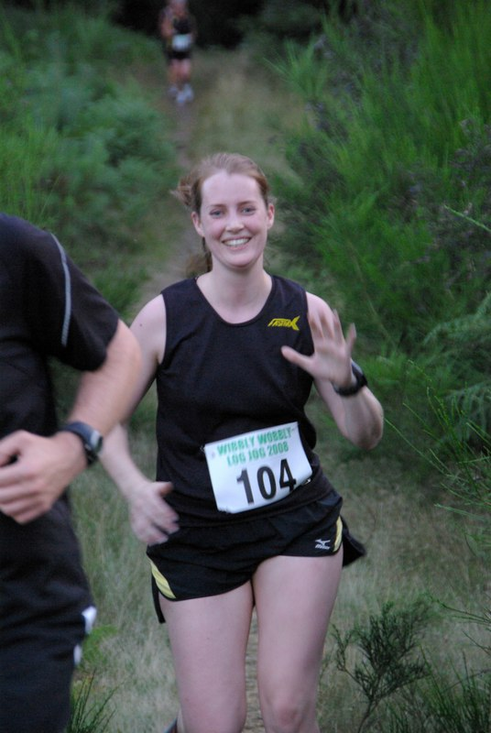
Emily Knight

The London Marathon saw 17 Ely Runners taking part, 10 of whom managed to set new PBs in unfavourable conditions for marathon-running. Special mention must go to Craig Holgate and Stephen Pettit for qualifying for the elite start next year and for setting new club records in the process.

Also setting a new marathon PB this month was Simon Jackson, who coped well with the heat in Paris to run a perfectly-paced race and knock 5 minutes off his previous PB.

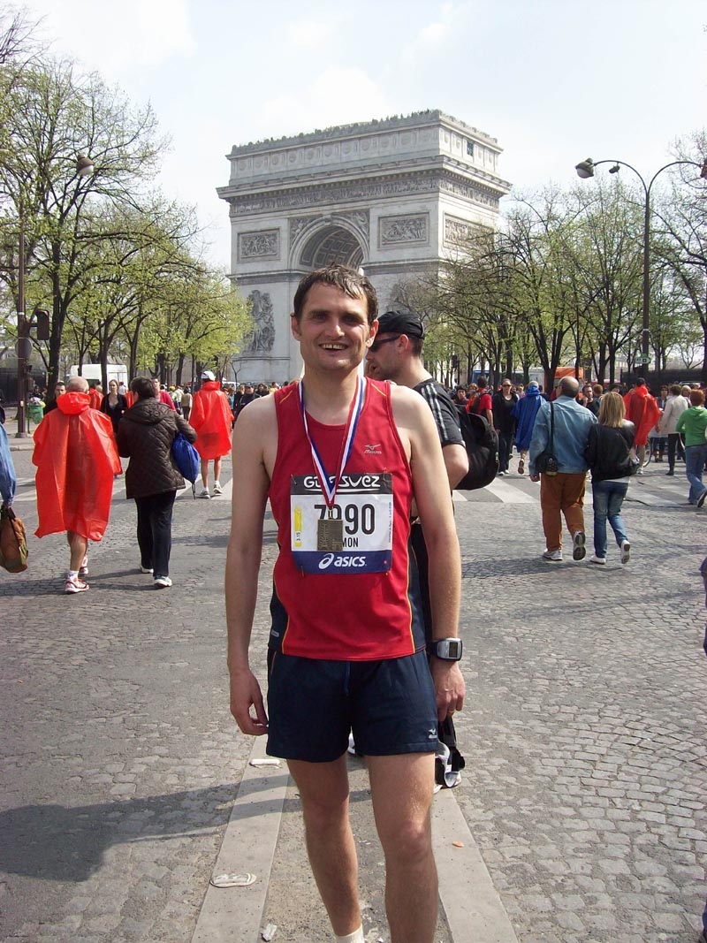
A proud Simon Jackson following his triumph in Paris

Meanwhile, Natalle Etches followed up on her impressive pre-marathon results by placing 3rd in the Bungay Marathon.
At the inaugural Cambridge and Cambourne 10k, Daisy Glover was first lady (13th overall) in a new PB and club record time, over 2 minutes ahead of the second-placed lady and her dad, John Glover, took a massive 3 minutes off his PB in the same race.

Ian Day demonstrated his strength and versatility by finishing 2nd in the tough Coombe Gibbet to Overton 16m cross-country race only 4 days before setting a new PB and club record in the Maidenhead 10 road race.

To see all the results and the race reports, visit: http://www.elyrunners.co.uk > RESULTS > Latest Results.

TONY HALL RECALLS A HAIRY MOMENT AT THE TURING TRAIL RELAY
“On the day,” Tony writes, “I was positioned at the finishing funnel with Rod's camera ready to snap the finishers when I was approached by a lady in a motorised wheelchair, complete with dark glasses and a dog to help blind people.

“She then asked if it was possible for her to make use of the several canes in the finishing funnel. I think there must have been about 30. She explained that at the dog training sessions there were only 2 canes to practise with the dog weaving in and out of canes, and our long finishing funnel would be absolutely lovely to practise with.

“At this stage the lead runner was about 10 minutes away, and I thought, well you can’t really refuse a blind lady. I then prayed that the lead runner was at least 10 minutes away, and then put my foot in it by saying that could she please hurry, but keep a lookout for the first runners. Anyhow she completed the course, and I avoided being kicked out of the club!”

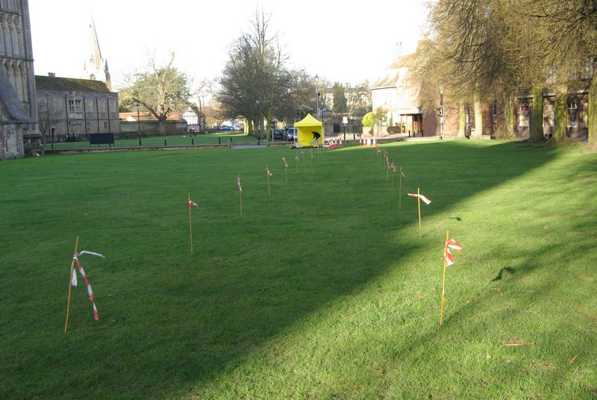
The multi-tasking finish funnel at the TTR

CONTRIBUTIONS TO THE NEWSLETTER
Finally, a reminder that I’d welcome contributions to the newsletter from all of you! For example, if you’re planning to take part in an unusual event, training for your first marathon, raising money for charity, or trying out a triathlon or two, I’m interested. If you have anything you’d like to share with the rest of the club, including news from those of you whom we don’t see regularly at training, please email me (Rachel Roberts) on: newsletter@elyrunners.co.uk.

RR
April, 2009
newsletter@elyrunners.co.uk
USEFUL INFORMATION

Data Protection
Email circulations by the club to members are done by the Bcc (confidential) option so that member’s email addresses are not circulated and also these do not take up most of the first page of emails.
See www.elyrunners.co.uk > CLUB INFO > administration for the club’s policy on data protection and use of photos and videos on the club’s website.

Membership
Subscription renewals (£10) were due from 1st January 2009. Members who joined after 15th November 2008 are covered for 2009.

To renew online:
Go to www.elyrunners.co.uk > CLUB INFO > Membership
OR
Send a cheque, payable to ‘Ely Runners’, to Club Secretary: John Turner, 22 Cromwell Road, Ely, Cambs, CB6 1AS.

If you did not renew your membership by the end of March 2009, you will be removed from the membership list and will no longer be entitled to attend training, represent the club in races, take part in club championships, claim affiliated entry fees, or wear club colours.

Benefits of membership include:
- £2 affiliated discount on open race entries
- club affiliations to ARC, ABAC, UKA, EA, TRA, FRA & CAA
- free registration (£5) with EA until 31st March 2010 (on request via John Turner)
- free changing and showers at the Paradise Centre
- free training and coaching advice
- free high-visibility bib for night-time training
- £12 subsidy on club fleeces
- 10-20% discount at most specialist running kit shops
- free entry to the club’s Cross-Country Championships, 10k Handicap and Straight Mile Handicap
- free entry to the six Frostbite League races
- free club team entry to county, regional and national championships and for club relay entries
- entry into the draw (if a member’s ballot entry is rejected) for the club’s guaranteed London Marathon places
- free snacks at club social events
- shared transport to races

Supporting the Club and its Events
Ely Runners hold three popular open races each year (Turing Trail Relay, Grunty Fen Half Marathon, and Ely New Year’s Eve 10k Road Race) that contribute considerably to the club’s reputation and financial stability. This enables the club to provide the many benefits listed above. In return, members are expected to show commitment to the club by helping with these events and taking their share of responsibility. Please don’t just rely on the usual loyal helpers and think of the club only as a convenient way to promote fitness and enter races. We’re all busy these days but commitment is realising the mutual benefits of putting something back into the club and sport we enjoy.

Training
For details of club training sessions at 7pm on Tuesday (intervals/hills) and Thursday (steady 5-8m runs) evenings, please see the homepage of the club’s website. Details of 9am Sunday morning training runs are usually circulated by email a few days in advance.

When meeting at the Paradise Centre for training on Tuesdays and Thursdays, please assemble either in the balcony/bar area upstairs or outside, around the corner by the side of the building. Please do NOT assemble in the foyer or outside the main entrance.

The meeting place for Sunday morning runs is the Paradise car park. The car park toilets are open by 9:00 am and the Paradise Centre is open for showers afterwards.

Please ensure that new members, some of whom are new to running, feel part of the club and are not left alone on training runs.

Club training sessions are intended to cater for a wide range of abilities and racing objectives. If you require specific coaching advice, please ask Club Coach Alan Rutterford to help.

To measure the distance of a route before or after running, see Google Earth > Ruler (toolbar symbol) > Path. Provided measurement is done carefully, the distance should be of similar accuracy as GPS.

Club Noticeboard
This is in the foyer of the Paradise Centre, to the right of the main entrance. It includes details of club events, training sessions, route maps, local races and other events of interest to members. There are usually several copies of race entry forms on the board but please leave the last copy or ask staff at reception to photocopy (Ely Runners' account) a few more copies.

Club Website
Webmaster, Rod Baron, maintains the Ely Runners’ website (www.elyrunners.co.uk) to provide an up-to-date record of the club's activities and a myriad of useful information. The website is frequently updated and well worth regular visits. For member’s general comments, there is a Message Board on the website’s home page and the recently upgraded photo and video section contains a huge selection of members in races. Rod also maintains the club’s websites for the Grunty Fen Half Marathon, New Year’s Eve 10k, and Turing Trail Relay.

Club Library
Grade 2 coach Max d'Ayala has selected a range of books on running and injuries for use by club members. Please see http://www.dayala.co.uk/elyrunners/booklist.htm for details: they have been chosen to provide a combination of interest, information, advice and stimulation for all standards of runners. The books are stored in the club's locker (authenticate membership and ask for key at Reception) at the Paradise Centre staff room. Please record which books you have borrowed in the notebook in the club's locker.

John Turner has the latest (2009) Fell Runners Association Fixtures Calendar & Handbook. Members interested in running a fell race can borrow this booklet. Most fell races are ‘up north’, though there are also many in Wales and other hilly areas of the UK. There is a huge choice throughout the year, including many evening races in the summer, some not too far away in areas like the Peak District. Alternatively, if on holiday in such areas, you can often find a local fell race. They provide an enjoyable, challenging and worthwhile experience, even for Fenland-based runners.

A recent addition to the club’s library includes ‘Feet in the Clouds – A Tale of Fell Running and Obsession’ by Richard Askwith.

Racing
Some open races are very popular and reach the entry limit before the race day. Many races no longer accept entries on the day (marked ‘no EOD’ in the Races & Events Guide). If you are thinking of entering a race on the day, check with the organisers or on the race website before setting out that a place is still available – turning up does not guarantee that the organisers will allow you to run!

Wearing Club Kit
Members wear their Ely Runners’ colours with pride in races far and wide (see www.elyrunners.co.uk > RESULTS) and are encouraged to do so whenever appropriate. Guidelines to wearing Ely Runners' colours (minimum club vest) in all events entered as an individual or team member of Ely Runners are as follows:
1. Obligatory requirement of governing athletic organisations in leagues entered by the club, relays entered for or by the club, all championships and events incorporating championships. Exceptions are members running for county, regional or national teams when they will be given the appropriate team kit to wear.
2. Necessary to avoid disqualification as a team member in open races.
3. Members normally wear their club kit in open races but there are recognised exceptions such as representing a charity, necessary kit change in an ultra run, spur of the moment race entry, non-availability of kit for whatever reason etc.
4. Not wearing club kit also makes it harder for other runners, race officials, and photographers to distinguish club runners, especially in relays.
5. Our distinctive race kit defines us as ambassadors of a well-respected running club.

Race Results
When you send your race results to Stephen Howard (results@elyrunners.co.uk), please advise if you have achieved a PB (including in vet categories), so that it can be included in press reports and to update PB information on the website. If possible, please send Stephen any information you have (including links to race results) by noon on Monday to avoid the extra work involved in updating press reports. Please email any photographs or links to event photographs (with your race number) to Rod Baron at webmaster1@elyrunners.co.uk.

Several members have put themselves on www.athleticsdata.com. This is a statistical website showing:

- UK year rankings
- All-time rankings
- Comprehensive results service
- Athletes’ profiles

This website will enable you to check your form relative to rival runners and allow them to do the same. It’s also useful for the prediction of race results for both runners and organisers.

Payment of club entries into championships, relays and leagues will be funded by the club provided they are team entries made by the club. The club will not pay for individual entries into open races that have an incorporated championship.

To take part in UKA National and SEAA championships, members need to be registered with England Athletics (EA). Also, a few open events still require EA registration to claim affiliated entry fees. However, most events (especially locally) either have ARC permits or, if they have UKA permits, require only membership of an EA affiliated club, like Ely Runners. Please could members who would like to be registered from 1st April 2009 with EA for 2009-10 please contact John Turner secretary@elyrunners.co.uk. It was agreed at the recent AGM that the club will pay the £5 registration fee. Registration number confirmation and cards will be supplied when received from EA.

To enter a County (eg Cambs AA) or Regional (eg SEAA) Championship, members must have been born in the county/region or had 9 months of continuous residency. If you qualify by birth and residency for different counties, you may only run for one county/region during each competition year from October to September.

Club vets who are not members of EVAC may run as guests of the club’s EVAC members in EVAC Championships. EVAC events are included in the Races and Events Guide and can be entered by sending an email to eastvetm75@ntlworld.com. Subject to the availability of funds, the club will pay for club team entries to EVAC and BMAF Championships. EVAC website: www.evac.org.uk
BMAF (vets) events are too numerous to include all of them but they have been circulated to EVAC members via regional and national veteran magazines or see www.bmaf.org.uk/fix/fix.asp

Running Kit
Mary Gates oversees the club’s kit supplies. The club’s joining fee of £33 includes a free club race vest and shorts. Please contact Mary on 01353 861379 or mary@elyrunners.co.uk to order. See www.elyrunners.co.uk for full details of club kit.

New club vests now have the Ely Runners’ cathedral logo top centre on the front. Any members with older vests who would like to have the logo added will need to give their vest to Mary to send. The cost (£1.20 for the transfer + 25p for application) will be covered from club funds. Race vests will continue to have ELY RUNNERS on the back.
Club fleeces are available from Mary Gates at the subsidised price of £10 to members only. This price is for one fleece per member. Subsequent fleeces will be at the cost price of £22.
.

Discounts on Kit Purchases
If you buy running kit from Advance Performance at Cambridge or Peterborough, please show them your membership certificate and the club will receive 10% towards vouchers that we use for prizes for our Christmas charity raffle. Advance Performance do not otherwise give discounts. Other running shop suppliers such as Sweatshop in Cambridge (who sponsor our three open races: New Years Eve 10k, Turing Trail Relay, and Grunty Fen Half Marathon) will usually provide a 10% discount to members on production of a valid membership certificate.

Natalle Etches has purchased a wide variety of fitness stock from a local Internet fitness company that closed down. She is re-selling the stock as low as half price to club members. The stock includes cycling, running, fitness and triathlon wear from brand names including Craft, Gore Bike Wear, Pearl Izumi, and Sugoi. If you’re interested, speak to Natalle at one of the training sessions or contact her on natalle@elyrunners.co.uk.

Social Events
Julie Foreman organises the club’s After Training Drinks on the first Thursday of the month. The next will be after training on Thursday 2nd April.

RACES & EVENTS GUIDE 2009

This includes local area/easily accessible races, club, county, regional and national championships, and a selection of UK/overseas events previously enjoyed by members.

May
03 Heritage Coast Run 26m/13m/6m, 1000/1015/1020 Saxmundham, £12/£7/£7
03 Grand East Anglia 10k Run (GEAR), King’s Lynn, £13 on-line, www.grandeastangliarun.co.uk
03 The Betty Willett Memorial 10k, 1030 Stockwood Park, Luton, £8 (+£2 EOD)
04 (Mon) Ashdon 10k, Ashdon, Essex, www.ashdon.ik.org
07 (Thu) ER after training drinks, julie@elyrunners.co.uk
08 (Fri) Blisworth 5k, 1930 Blisworth Football Club, Northants, £6 or £11 for series, www.woottonroadrunners.co.uk
09 (Sat) Cambridgeshire AA Track & Field Champs, University Track, www.cambsaa.org.uk
10 Eye 10k (CRRL), 1100 Primary School, Eyebury Rd, £7.50, EOD +£1, www.eye10k.co.uk
10 Great Daffodil 15m/10k Runs, Kelmarsh Hall, Northants, www.mariecurie.co.uk/running
16 (Sat) Nat Open Masters Road Relay Champs, Sutton Park, team entries to Charlie Barker
17 Dereham 10m, 1100 Neatherd High School, Norwich Road, Dereham, £7 (+£2 EOD)
19 (Tues) Bedford 6, 1945 Bedford International Athletics Stadium, Bedford, £5 (+£2 EOD)
24 Copenhagen Marathon, www.copenhagenmarathon.com
23/24 (Sat/Sun) SEAA –15 and –17 T&F Champs – venue tba
25 (Mon) Brandon Forest Half Marathon (TR), 1030 B1106, £8, no EOD, www.bfh.org.uk
25 (Mon) BUPA London 10k
27 (Wed) Cambs Open Graded T&F Meeting, 800m & 3000m, 1900, St Ivo Centre, St Ives, £2 per event, www.cambsaa.org.uk
31 Rotary 5m (run/walk), 1030 Bourne Woods, £8.50 by 1015, paul@rossifa.wanadoo.co.uk

June
04 (Thu) ER after training drinks, julie@elyrunners.co.uk
07 EVAC 5-Mile Road Championships, 1100 Reach, Cambs
10 (Wed) Cambs Open Graded T&F Meeting, 800m & 1500m, 1900, St Ivo Centre, St Ives, £2 per event, www.cambsaa.org.uk
11 (Thu) Ely Runners’ Midsummer 10k Handicap (private club event), Cricket Club, 1930
Lt Downham, FOC members & guests. Presentation afterwards in the Prince Albert, Ely
13 (Sat) Eurofoule 10k, Andrezieux-Boutheon, France, by invitation
14 Abbey 10k (CRRL), 1100 Leisure Centre, Hollow Road, Ramsey, £9, EOD +£2
14 North Downs 30k, 1030 Cascades Leisure Centre, Thong Lane, Gravesend, £13, no EOD
14 St Albans Half-marathon, 1000 Verulamium Park, St Albans, £17, no EOD, www.stalbanshalfmarathon.co.uk
19 (Fri) Marston Forest 5k, 1930 Marston Moretaine, Beds, www.MarstonForest5K.org.uk
20/21 (Sat/Sun) SEAA U20 and Senior T&F Champs, Woodside Stadium, Watford
28 Stortford “10” (10k or 10m options), 1000 Bishop’s Stortford Rugby Club, £8 (+£2 EOD)

July
02 (Thu) ER after training drinks, julie@elyrunners.co.uk
03 (Fri) Cranfield 5m, 1930 Cranfield, Beds (more details to follow)
05 EAA T&F Championships (incl. 800m, 1500m & 3000m), 1000 Cambridge University Track, £6 per event
08 (Wed) Mike Groves Run 5.85k Multi-terrain, 1930 Coltishall Football Ground, Norfolk, £6 (+£2 EOD)
09 (Thu) training at 1900 will include Ely Runners’ Straight Mile Handicap on Quanea
Drove. Perpetual Shields for Handicap 1st M/F, Fastest M/F, and Age Related 1st M/F will
be presented afterwards in The Prince Albert, Ely
12 Bushfield 10k (CRRL),
19 Fairlands Valley 12/18/26.2m Challenges, Bedwell, Stevenage, www.races.fvspartans.org.uk
22 (Wed) Cambs Open Graded T&F Meeting, 1 mile, 1900, St Ivo Centre, St Ives, £2 per event, www.cambsaa.org.uk
26 March 5m Spud Run, 1100 Elm Rd Sports Field, March, £7 (+£1 EOD)
26 NSPCC Milton Keynes Half-Marathon, 1000 Bury Lawn School, Stantonbury, £18 (+£7 EOD), http://www.mkhalfmarathon.org.uk/

August
02 Wellingborough 5m, 1030 Old Grammarians Sports Field, Wellingborough, £8, WWW.familysupportlink.co.uk
07 (Fri) Wibbly Wobbly Log Jog (5m TR), 1930 Brandon Forest, £tba, no EOD, www.bfh.org.uk
07 (Fri) Blisworth 5m, 1930 Blisworth Football Club, Northants, £6 or £11 for series, www.woottonroadrunners.co.uk

16 Thorney 5m (CRRL)
16 Reepham Summer Sunday Run 10k (multi-terrain), 1000 Reepham, Norfolk, £8 (+£2 EOD)
19 (Wed) Nene Valley Harriers 5k (Cambs County Championship & CRRL) (prov date)

September
06 Wissey Valley ½ Marathon (EVAC & Norfolk Champs), 1030 Oxborough Village Hall, www.rystonrunners.org.uk
06 Budapest Half-Marathon, Budapest, www.budapestmarathon.com
06 Littleport Leisure 10k Run, 1045 Leisure Centre, £8, www.littleport10k.co.uk
13 Grunty Fen ½ Marathon (Cambs County Championship & CRRL), 1030 Witchford Village
College, Ely, www.gruntyfen.co.uk
13 The Jubilee 5, 1100 The Marriotts School, Telford Ave, Stevenage, £9.50 (no EOD), http://www.fvspartans.org.uk
19/20 (Sat/Sun) Round Norfolk Relay, www.roundnorfolkrelay.com
19/20 (Sat/Sun) Isle of Wight Fell Running Series, 3 races over 2 days, www.rydeharriers.co.uk

October
04 SEAA 10k Road Running Championships, Crystal Palace, London
04 Budapest Marathon, Budapest, www.budapestmarathon.com
10 (Sat) Peddars Way Trail Run (more details to follow)
11 Great Eastern Run ½ Marathon (more details to follow)
18 Ampthill Trophy XC, Ampthill, Beds, www.AmpthillTrophy.org.uk (more details to follow)
25 Fenland 10m (CRRL)
24 (Sat) Beachy Head Marathon (3,500’ climb), 0900 Eastbourne, depart Paradise 0500

November
04 Loch Ness Marathon (&10k/5k), www.lochnessmarathon.com
15 St Neot’s ½ Marathon, 1000 St Neot’s Recreation Centre, http://www.half.riverside-runners.com/
22 Hereward 4 Stage Relay (39.1m Peterborough to Ely), club teams, provisional date

December
20 Long/medium/short club pre-Christmas trail training runs, Woodditton to Ely 18.5m,

Woodditton to Chalk Pit 12m, Reach to Ely 11m, Woodditton to Reach 7.5m, meet 0800

Paradise for transport to starts
26 (Sat) Boxing Day training, meet 0900 Paradise Centre car park
31 (Thu) The 10th Ely New Year's Eve 10k Road Race, 1100 Lt Downham, entries on-line
only, no EOD, www.newyearseve10k.co.uk

NOTES

Races and events are on Sunday unless otherwise mentioned.

Race entry fees are the affiliated (ARC/UKA or just UKA registered) fees

Courses are roads and/or hard footpaths/cycle ways unless otherwise mentioned.
Distances without units (m or k) are probably m = miles.
Frostbite League races are 5-6 miles and entry (league membership) is paid for by the club.
Further details of events from the Club notice board in the Paradise Centre foyer, running magazines, websites, or from John Turner secretary@elyrunners.co.uk) who also has details of all RRC/TRA long distance road/TR/XC races and FRA fell races.

National, regional and county championship team entries are via Charlie Barker (captain@elyrunners.co.uk).

Club championship & club handicap entries are via Steve Tovey

Long distance team relay entries are via Alan Rutterford and paid for (if funds available) by the club.

Club website www.elyrunners.co.uk
Grunty Fen 1/2M website www.gruntyfen.co.uk
NYE10k website www.newyearseve10k.co.uk
Turing Trail Relay website www.turingrelay.co.uk
Association of Running Clubs www.runningclubs.org.uk

Rachel Roberts
April 2009
newsletter@elyrunners.co.uk

