Ely Runners Newsletter
March 2011



NEW MEMBERS

We warmly welcome the following new members who joined the club this month. Look forward to seeing you all at training and club social events!

Aiden Merry

NEWS & NOTICES

A legend takes a bow
After almost 25 years at the helm of Ely Runners, John Turner has now handed over most of his duties to other committee members, with Stephen Howard elected to Chairman and Race Director Open Events & Sponsorship and Steve Tovey to Secretary, at the club AGM in February. We would like to sincerely thank John for his long years of dedication, organisation and support for club during his tenure and wish him well for the future.

John was presented with something to remember us by before he eventually heads off (vouchers for a steam train journey) and sent the following letter of appreciation:

I'd like to thank you and the Committee for the extraordinarily kind gift presented to me at the AGM last night. We will certainly enjoy one of the express steam locomotive hauled trains available.

After the near habitual involvement in the evolution of the club for so long, it was sad for me to reach the point where other priorities dictate that yesterday marked the start of handing over my routine and familiar roles. Although this will take a while, I am comfortable that these are being taken on by

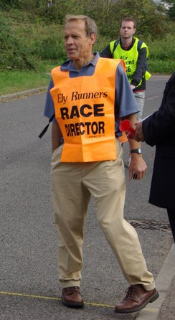
John Turner: a hard act to follow

competent and enthusiastic members who will develop their responsibilities in harmony with the club's continued development.

My strong belief is that the future development of Ely Runners will ultimately depend on becoming track based as the population in the Ely area grows with an increasing need for such a community facility. I would very much like to have seen this through to fulfilment but will continue to do what I can within the time available. Concurrent with and integral to pursuing a track based objective, I also believe that the growing Junior Section needs every ounce of support the club can give because they represent the future of our club and sport, with all the fulfilment, enjoyment, health and worthwhile values they provide.

John Turner

Ely Runners AGM Awards
The following Ely Runners were presented with awards at the club AGM in recognition of their personal achievements in 2010:

Most Improved Member (new member) – Sarah Edwards
Most Improved Male Runner – Kieren Drane
Most Improved Female Runner – Nicola Bramley
Best Marathon – Craig Holgate
Best HM – Stuart Baumber
Best 10K – Ian Day

Special achievement awards went to members showing ongoing commitment to the club’s organisation and events:
Charlie Barker, Stephen Howard, Steve Tovey, Mary Gates, Heidi Uff, Emily Knight, Simon Jackson
Diana Gipp
We sadly report that on Thursday 17th February 2011, former member Diana Gipp, wife of ex-Chairman Peter and mother to Hannah, died peacefully at the Arthur Rank Hospice, Cambridge after a long fight against cancer. Following her diagnosis in 2009, Peter and Diana enjoyed as much time together as possible, including several walking holidays in the Lake District and Devon. Resolute as ever, for most of this period, Diana continued her work with STRADA stroke patients and to exercise at the Paradise Centre.

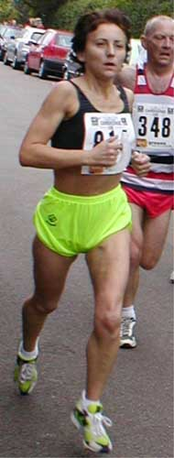 Diana Gipp (more photos on page 4)

Diana was an extraordinary and determined athlete whose long Sunday runs were as legendary as were her numerous race achievements. In 2001 she ran the Seven Sisters/Beachy Head Marathon in an impressive 4:00 and then, whilst an FV44-46, she was outright Cambs Road Race League women's champion for three successive years between 2000 and 2002. Diana was also first woman in three Frostbite League races from 2003 to 2004 and still holds eleven club veteran records with age-grading of 78-83% including 3:12 for the 2004 London Marathon.

Our thoughts and sympathy go to Peter and Hannah as they cherish the life of Diana.

Molly Butler wins Grunty Fen HM T-shirt competition
Congratulations to junior member Molly Butler whose brilliant artwork (below) will be printed on the front of the T-shirts given out to finishers in this year’s Grunty Fen half marathon. Well done to Molly and all the other juniors who sent in designs, all so good it was hard to pick a winner!

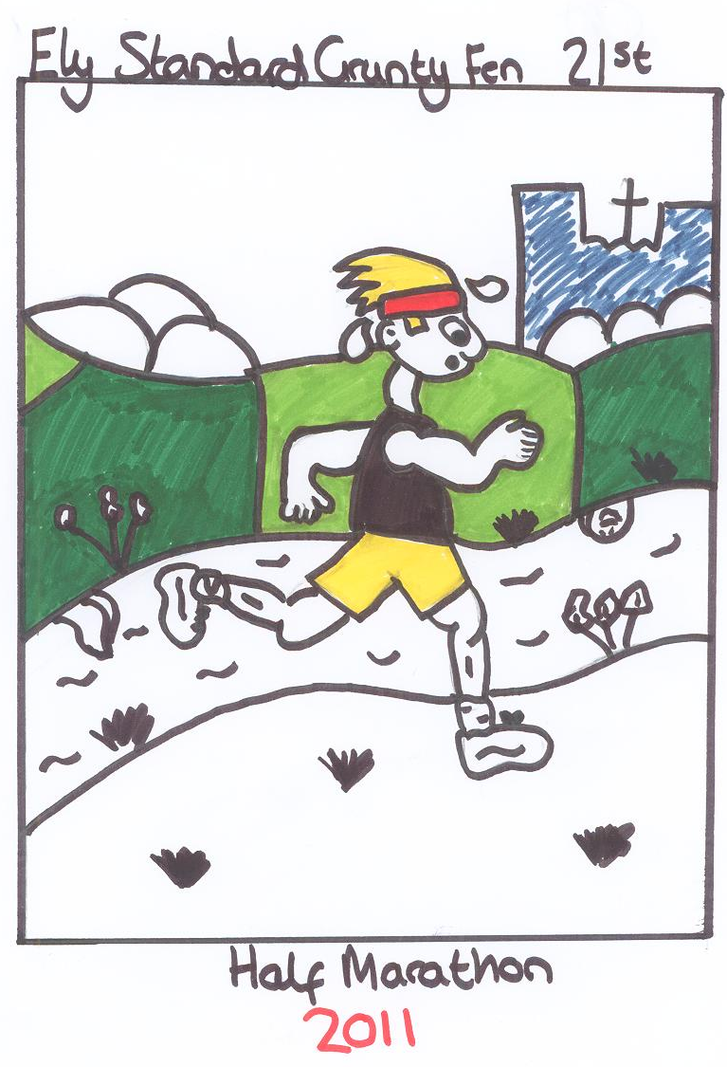

Molly Butler’s winning design

Contributions to the Newsletter
If any members have any short articles about their running experiences which other members may find useful, interesting or just entertaining, please send them with a suitable picture (800x600, portrait) to newsletter@elyrunners.co.uk

Continued success for ER juniors
Esme Wright and Fraser Crossman won club Most Improved Junior Runners awards for 2010. Ashley Pettit and Robyn Seabright have also been called up to the Schools Cross Country Nationals Championships on Saturday 19th March at Wollaton Park Nottingham after successful runs in the County and Anglian Schools Championships at Corby. Ashley should be one of the top runners in his category, whilst Robyn is a reserve in the girl’s team.

CLUB EVENTS

Frostbite goes to Hinchingbroke Park, round 2
The last Frostbite races of the 2010/2011 series returns to Hinchingbroke Park on March 6th. As usual, the juniors start at 10:15 am and the main race is at 11.00am. The junior team are currently 6th out of 13 teams and the senior team are currently 8th out of 17 teams. In order to improve our position in the league an excellent turnout from club members is essential. Scoring is based on the finish position of each team’s first 3 women and 7 men (first 1 girl and 4 boys), but all runners influence the team’s overall result. All runners of all abilities are strongly encouraged to take part.
The scenic course at Hinchingbrooke Park consists of grass, dirt tracks, woodland paths and some tarmac sections. Trail shoes would be ideal if you have them, though road shoes will be adequate. The course is not suitable for spikes given the tarmac. Seniors to meet at the Paradise at 9:15 to share transport. Details can be found here: http://www.frostbiteleague.org.uk/. Any questions, please email team captain Heidi Uff at: captain@elyrunners.co.uk
The club has paid for Ely Runners’ entry to the League and there is no charge to members for taking part in any of the 6 races (1 each month October to March) in the series. It is not necessary to wear a number, as each member will have been allocated an individual PIN. Club kit is required (vest essential) and at the end of the race, you will be handed a finish position number. Please give this to our Team Manager Alan Rutterford at the finish.

SOCIAL EVENTS

After training drinks
After training drinks are usually held on the first Thursday of each calendar month, with all members more than welcome to attend. That said (and providing this newsletter reaches you on time), the next opportunity to see what your training partners look like with their clothes on will be Thursday 3rd March at the West End pub from around 8:30pm onwards. Further information is available from Julie Foreman (Julie@elyrunners.co.uk).

Ely Runners in this year’s London Marathon
To our knowledge there are 16 Ely Runners taking part in this year’s London Marathon, some of whom are seeking sponsorship. Good luck to you all!

Emily Knight
Fraser Badcock
Hannah Shiell
Ian Blatchford
John Manlow
Jon Pennington http://uk.virginmoneygiving.com/JonPennington
Jose Perez
Kieren Drane
Melanie Fisher
Stephen Petitt
Stephen Tovey (WRVS) - http://uk.virginmoneygiving.com/StephenTovey
Steven Hardwick
William Wilson
Graham Chapman
Ian Day

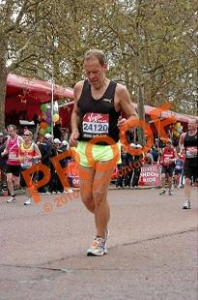
John Turner finishing the 2010 London Marathon

If other members running can let Steve Tovey know and for which charity, we’ll update the list in the next newsletter.

SELECTED RESULTS ROUND-UP – February
Sleaford Half Marathon – Sleaford, Lincolnshire
Official Results 347th Jason Pattinson 1:53:32 (PB) 363rd Jon Pennington 1:55:39 (PB) (1st Half Marathon) 476th Colin Doak 2:07:56

Stamford Striders Valentines 30k - Stamford, Lincolnshire
Official Results Results (chip times) 25th Stephen Pettit 1:58:33 (3rd MV 45) 87th Steve Tovey 2:11:06 (PB) 267th Ian Blatchford 2:29:04 (PB) 270th Mel Fisher 2:29:03 (1st 30k)(PB) 379th Nicola Bramley 2:42:18 413th Rob Comley 2:46:34 589th Cynthia Mills 3:20:06 (PB)

Frostbite Friendly League Junior Race 5 – Bourne Woods
Official Results: 19th Robyn Seabright 12:00 21st Michael Ford 12:05 31st James Holland 12:41 39th Esme Wright 12:57 40th Alex Ellwood 13:05 45th Adrian Chalmers 13:19 49th Molly Butler 13:26 59th Nathan Pennington 13:45 62nd Fraser Crossman 13:47 There were 115 finishers

Frostbite Friendly League Senior Race 5 – Bourne Woods
Official Results: 13th John Uff 29:52 (ran for 1st claim C&C) 20th Max d’Ayala 30:31 37th Steve Tovey 32:18 71st Stephen Howard 33:54 119th Matt Holmes 35:55 122nd Alex Seabright 35:59 123rd Adam Etches 36:02 159th Heidi Uff 37:40 179th Lionel Smith 38:30 241st Jon Pennington 41:52 (PB) 265th Martin Courtney 43:26 270th John Turner 43:36 321st Claire Van Leersum 47:17

Anglian Schools Cross Country Championships, Northamptonshire
Official Results (Minor Boys, 2.5k, 65 runners): 55th Charlie Staaf 12:16.
Official Results (Intermediate Boys, 5k, 58 runners): 6th Ashley Pettit 21:40 (PB)(MJ Club Record) Official Results (Junior Girls, 3k, 68 runners): 38th Robyn Seabright 13:27 (PB)(Girl Club Record)

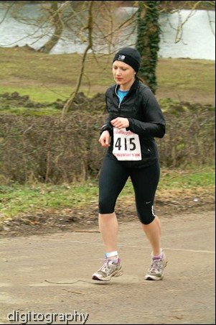
Cynthia Mills racing in the Valentines 30K

FORTHCOMING EVENTS

Cambridge Athletic Association Road League - where the Frostbite League stops, the road league starts
The first race of this year’s Cambridge Athletic Association road league will be the Thorney 10k on 27th March. (Runner’s World entry link here: http://www.runnersworld.co.uk/events/viewevent.asp?ugn=5226). All the races have a fun, friendly atmosphere and welcome runners of all abilities. ER were third overall in last year’s and twelfth overall in the women’s teams (last year’s results: http://www.cambsaa.org.uk/road.asp), so it would be great if we can get as many Ely Runners out as possible to go one better.

Frostbite Friendly League 2010-2011
Remaining FFL dates and venues are:
- 6 Mar Hinchingbroke Park
This series of six races of 1.5m for Juniors and about 5-6m for Seniors is free to all members and provides enjoyable competition at all levels, plus all members running influence the result by competing against scoring members of other teams. No prior entry or numbers are required as club members are allocated PIN numbers and finishing position tags which are recorded by the club's Team Manager Eric Drury. Team scoring is Juniors 1st 5 (1 must be a girl) and Seniors 1st 10 (3 must be women) but all other runners effect the overall result.
Having won the Senior FFL twice since 2004, we slipped last season to 10th of 17 teams. Our talented Juniors, in their first full year in the FFL improved through the season to finish 9th of 13 teams but should gain places in 2010-11 because there are more members to ensure a full scoring teams for each race. Apart from providing enjoyable team and individual competition, these races provide a measure of progress and inspiration throughout the winter season.

EVENTS GUIDE
Event photographs
Race/club event photographs should now be sent to Charlie Barker - (charlie@elyrunners.co.uk) Ideally they should be resized to 800x600 pixels (ish) and preferably be less than 100k in size.

Other Events

See the following RACES & EVENTS GUIDE starting on page 5
Diana Gipp, 1956 - 2011

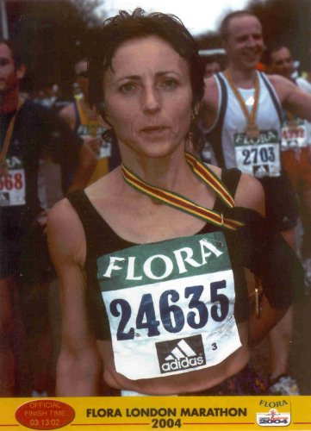

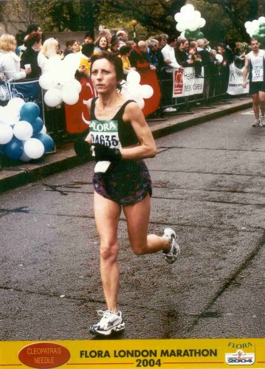

RACES & EVENTS GUIDE 2011
March 2011
This includes local area and easily accessible races, club, county, regional and national championships, and a selection of UK/overseas events previously enjoyed by members.
Cambridge 5k Park Runs (at Milton) are every Saturday at 0900. Entry is free but before your first race, register on-line by 1800 on Friday www.parkrun.org.uk/cambridge/Home.aspx

March
05 CAU Inter County XC Championships, Cofton Park, Birmingham
05 Belvoir Challenge 15m/26m, Harby, Leics, www.belvoirchallenge.co.uk
06 Frostbite League, Hinchingbrooke Park, Huntingdon
06 Wymondham 20, www.wymondhamac.org.uk
06 Leighton 10k, Leighton Buzzard, £tba, www.leightonfunrunners.org.uk
06 Steyning Stinger Marathon, www.steyningac.co.uk
06 BHF North Downs Way Challenge (8.6m/14.4m/20m), www.bhf.org.uk
12 (Sat) SEAA XC Relays. Wormwood Scrubs, London W12
12 (Sat) BMAF Open XC Championships, Birmingham
12/13 (Sat/Sun), EAA Indoor Championships, Lee Valley Stadium
13 Bedford Clanger Marathon, sites.google.com/site/bedfordclanger/
13 Norwich ½ Marathon, www.cityofnorwichhalfmarathon.com
13 Lactic Rush 8m XC/obstacles, Essex, www.adventureracesessex.co.uk
13 ABAC AGM, TVH Athletics Centre, Eton
13 Chilly Willy 5k, Peterborough, www.action4menshealth.co.uk
13 AAA AGM, Alexander Stadium, Birmingham
16-20 European Veterans Athletics Championships, Ghent
20 Turing Trail Relay (Ely Runners 3 stages private club event)
20 NiceTri Hurden 9, Offord, Cambs, www.nicetri.co.uk
20 Muddy Marvel 5, Lode, Cambs, www.newmarketcyclingtriathlon.co.uk
20 Radar Challenge 10k, Crowland, Lincs
20 Mud & Mayhem Thetford 10k, www.gobeyondultra.co.uk
20 (Mon) True Grit 5k, Wisbech, www.arch.org.uk/true-Grit.asp
27 Joe Cox ½ Marathon, Stowmarket, www.stowmarketstriders.org.uk
27 Thorney 10k, www.thorneyrunningclub.co.uk
27 Colchester ½ Marathon, www.colchesterhalfmarathon.co.uk
27 Bedford Harriers Oakley 20, www.bedfordharriers.co.uk
27 Ryston 6.5k XC & junior races, Shouldham Warren, www.rystonrunners.org.uk
27 Monster Racing Duathlon, Littleport, www.monsterracing.net
27 Resolution 5k, Nowton Park, Bury St Edmunds, www.strokeorg.co.uk
27 Spring 10k, Frettenham, Norfolk, www.runnersworld.co.uk
27 SEAA Road Relay Championships, Milton Keynes, www.mkac.org.uk

April
03 Lincoln 10k, 1100 Lincoln, www.lincoln10k.co.uk
03 Cambridge Cambourne 10k, www.cambridgefestivalofrunning.com

03 Sandy 10, www.sandy10.org.uk
03 Broadland ½ Marathon, www.nrr.org.uk

10 Bungay Marathon & ½ Marathon, www.bungayblackdogrunningclub.co.uk

17 London Marathon, www.virginlondonmarathon.com
19 (Tue) Eastern Athletic Assoc AGM, Cambridge
20 (Wed) Great Yarmouth 5m Series (Race 1), www.gyrr.co.uk
22 (Fri) Sudbury 5m Fun Run
24 Monster Racing Duathlon, Littleport, www.monsterracing.net
30 (Sat) 3 Peaks Race, www.threepeaksrace.org.uk

May
01 Grand East Anglia Run 10k/1.2m FR, King's Lynn, www.grandeastangliarun.co.uk
02 (Mon) Breckland 10k, Croxton, www.thetford-ac.co.uk
02 (Mon) Ashdon, Cambs, 10k & 3k, http://ashdon.handycandy.co.uk/
04 (Wed) Great Yarmouth 5m Series (Race 2), www.gyrr.co.uk
05 Newmarket Heath 6k, www.newmarketjoggers.co.uk
08 Eye 10k & 3k FR, Eye, Peterborough, www.eye10k.co.uk
08 Frostbite Friendly League AGM
14 (Sat) Frostbite Presentation Evening, www.frostbiteleague.org.uk
15 Deepings Rotary 10k & 3k FR, Deeping St. James,
15 Dereham 10m, Neatherd High School, www.derehamrunners.co.uk
15 Shuttleworth 5m Trail Race, Shuttleworth College
18 (Wed) Great Yarmouth 5m Series (Race 3), www.gyrr.co.uk
21 (Sat) BMAF Road Relays, Sutton Coldfield, www.bmaf.org.uk
28 (Sat) Eastern AA Track & Field Championships, Cambridge University Track
29 CAU Inter County Track & Field Championships, Bedford Stadium

June
04 (Sat) Moulton Race Walks 5m, 1k (10+) & 500m (-10)
09 (Thurs) Ely Runners 10k Club Handicap (private event)
17 Marston Forest 5k, www.MarstonForest5K.org.uk
19 BMAF 5k Championships, Horwich
25 (Sat) Greensand Ridge Relay (6 stages/33m) Leighton Buzzard, www.smoc.info/GSRR/

July
6-17 July, World Masters Championships, Sacremento, California, USA
14 (Thurs) Ely Runners 1m Club Handicap (private event)
24 Spartan Race 5k, ATR Bassingbourn, Royston, www.spartanrace.com
27 Bungay 10k
29-31 (Fri-Sun) Montane Lakleand 100m, www.lakeland100.com
30/31 (Sat/Sun) Montane Lakeland 50m, www.lakeland100.com

August
14 Great Yarmouth ½ Marathon, www.gyrr.co.uk
16-25, European Vets Championships, Stadia
21 Monster Racing Middle Triathlon, Ely, www.monsterracing.net

September
04 Budapest ½ Marathon, www.budapestmarathon.com
11 Grunty Fen Half Marathon, Witchford, www.gruntyfen.co.uk
17/18 (Sat/Sun) Round Norfolk Relay, www.roundnorfolkrelay.com
21-24 (Wed-Sat) Great Barrow Challenge, Suffolk, www.greatbarrowchallenge.co.uk

October
02 BMAF 10k Championships, Exmouth
02 Budapest Marathon, www.budapestmarathon.com
22 (Sat) Beachy Head Marathon
23 Ampthill Trophy XC, www.AmpthillTrophy.org.uk
23 East Coast 10k, Great Yarmouth, www.gyrr.co.uk

November
06 Adnams Great Eastern Run, www.bungayblackdogrunningclub.co.uk
20 St Neots ½ Marathon, www.riversiderunnersraces.co.uk
27 (prov date) Hereward Relay, www.marchathelticclub.co.uk

December
02 (Fri) Ely Runner’s Christmas Buffet & Drinks (private event), Cutter Inn, Ely (prov)
18 Club Pre-Christmas training runs (private event), Woodditton/Ely 18.5m,
Woodditton/Reach 7.5m, Reach/Ely 11m. Lunch afterwards at the High Flyer
31 (Sat) Ely New Year’s Eve 10k, Little Downham, www.newyearseve10k.co.uk

NOTES

Races and events are on Sunday unless otherwise mentioned.
Many events also have a concurrent Fun Run. These can provide valuable racing experience for junior members and beginners. Check the main race information for details.
Courses are usually on roads and/or hard footpaths/cycle ways unless otherwise mentioned.
Distances without units (m or k) are probably m = miles.
Frostbite League races are about 5-6 miles for seniors and 1.5m for juniors. Entry (league membership) is paid by the club.
Further details of events from the Club notice board in the Paradise Centre foyer, running magazines, websites, or from Steve Tovey, secretary@elyrunners.co.uk
National, regional and county championship team entries are via Charlie Barker captain@elyrunners.co.uk but for -13,-15,-17 & juniors, first contact Lesley Wright lesley@elyrunners.co.uk
Ely Runners’ private club XC championships, 10k/1m handicaps, and TTR relay entries are via Matthew Holmes, matt@elyrunners.co.uk
Long distance team relay entries are via Alan Rutterford, alan@elyrunners.co.uk and paid for (if funds available) by the club.
Social events are via Julie Foreman, julie@elyrunners.co.uk
Junior training details from Junior Representative/Club Coach Alan Rutterford alan@elyrunners.co.uk
Junior race details from Junior Secretary Lesley Wright, lesley@elyrunners.co.uk
Club website: www.elyrunners.co.uk
Grunty Fen 1/2M website: www.gruntyfen.co.uk
NYE10k website: www.newyearseve10k.co.uk
Turing Trail Relay website: www.turingrelay.co.uk
Association of Running Clubs website: www.runningclubs.org.uk

