Ely Runners Newsletter

JUNE 2009



NEW MEMBERS
This month we welcome the following new members of the club:

Peter Woods
Peter says, “I’ve been a road runner for very many years, looking to build back some fitness after a lapse in regular training. I’ve enjoyed road races of various distances over the years (I’ve run the London Marathon 3 times, way back when) but nowadays 10k usually seems far enough. My knees and I increasingly favour off-road running, for example over Easter I was in Northumberland for a big orienteering event. Mind you, one of the races there was street orienteering in the centre of Newcastle so I can’t avoid pavement pounding altogether. I’ve started a new job just outside Ely, so I’m hoping I’ll be able to come along at least once a week and I’m looking forward to running and training with a group once again.”

HAPPY 75TH BIRTHDAY TO TONY HALL
This month, Tony Hall will celebrate his 75th birthday (on 11 June). Tony is the only founder member still involved in the club. A hugely experienced runner, Tony has previously held the posts of Chairman and Treasurer within the club. From the late 1980s through to about 1994, Tony took the club’s Tuesday and Thursday training sessions. Nowadays, Tony is to be found loyally supporting the club at events such as the Frostbite League races, the club handicaps and the Woodditton to Ely pre-Christmas run.

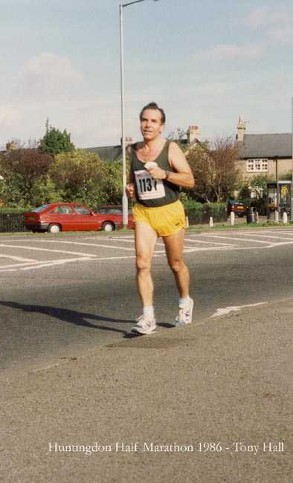 Tony Hall competing in the Huntingdon Half-Marathon in 1986
FORTHCOMING EVENTS

Magog Down Training Session
This will take place on Thursday 4 June. Members should meet at the Paradise Centre at 6.15pm to share lifts or at the Magog Down car park ready to start running at 7.00pm. Following the training runs, Sweatshop has invited members to go back to the David Lloyd Club (Next Generation) in Cambridge, where they will be able to use the changing facilities and have a swim from 8.30pm to 9.00pm. Sweatshop will also be open at that time and members will be offered a special 15% discount.

Ely Runners’ Midsummer 10k Handicap
The club’s annual 10k handicap race will be taking place on Thursday, 11 June, starting from the Cricket Club in Little Downham at 7.30pm. As usual, there will be refreshments and prize presentations afterwards in the Prince Albert in Ely.
If you would like to take part, email Steve Tovey (stevetovey@elyrunners.co.uk) with a recent race time (10k if available, but Steve can calculate your handicap time from any recent race performance).

EVAC (Eastern Veterans A.C.) News
Unfortunately, the EVAC 5-mile road race championships, scheduled to be held at Reach on Sunday 7 June, have been cancelled.

The Luton 10k on Sunday 26th July will incorporate the EVAC 10k championships. Members interested in taking part in these championships should enter the race in the normal way.

The Half-Marathon championships are likely to be incorporated in the Fairland Valley Spartans’ Stevenage Half-Marathon, which is on 1st November (and which is also incorporating the BMAF and ARC championships this year).

ARC Championships
The ARC Half-Marathon Championship will be incorporated into Fairlands Valley Spartans’ Stevenage Half Marathon on 1st November 2009.

The 10-mile Championships will be incorporated into Thornbury Running Club’s Oldbury Power Station 10-mile Race on Sunday 4th October 2009.

There will also be a Postal Marathon (details on the ARC website) and a Long Distance Multi-Terrain Relay at the Round Norfolk Relay over the weekend of 19th and 20th September 2009.

Round Norfolk Relay
Just a reminder that we have entered two teams into the 2009 Round Norfolk Relay this year (the weekend of 19/20th September). If you'd like to run, please contact Alan Rutterford (alan@elyrunners.co.uk).

POWER OF 10 NATIONAL RANKINGS
This is the athletics performance rankings system run by UK Athletics, with the aim of driving up standards in the run-up to the 2012 Olympics. Any athlete reaching a pre-determined standard in a standard event will feature in the rankings. See http://www.thepowerof10.info/rankings/ for details of these standards and to see if you are currently ranked – you may be pleasantly surprised! Daisy Glover recently discovered that she is currently ranked 6th in the 10k rankings for under 20 women.

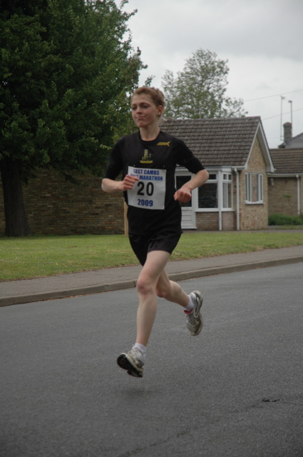
Daisy Glover, on her way to winning the Soham Half-Marathon on 17 May (her debut at this distance)

WEBSITE RACE REPORTS FAQs
There have been a number of queries recently about the website race reports. Stephen Howard, the club’s Press Liaison Officer, has produced these FAQs to tell you everything you ever wanted to know about the race reports but were afraid to ask!

Q1: Who writes the reports?
- Hopefully the members themselves, by email to results@elyrunners.co.uk. The Committee ‘Press Liaison’ officer is Stephen Howard, who splices together reports from members and adds more general event details if appropriate.

Q2: What are the reports for?
- They provide a historic archive of club activity going back to the start of the club.
- They offer a useful resource for members considering which races to enter in future.
- They provide motivation and support - a chance for runners to bask in past glories or achievements.
- They form the basis of press reports sent to the Cambridge Evening News and Ely Standard.

Q3: What information should I provide?
- Details of the race itself, course terrain, views, weather conditions, information about PBs or prizes.
- Your race position, name, and time - if possible for all Ely Runners who ran, please!
- Anything you think is relevant to you, or you think members would be interested in knowing.
- Anything you think would help to support the answers to Q2 above.

Q4: What information should I not provide?
- Anything that is not suitable to be published on the public internet!

Q5: Are the race reports only for elite or prizewinning performances?
- Emphatically not! The race reports are a club-wide resource and reports from all members are treated respectfully and are spliced into the final report.

Q6: I had a bad run – should I tell you about it?
- Yes, please. Of course it is easier to report a good performance but please do ensure all results are recorded. If a run was disappointing or affected by illness or injury then either say so or just give the result. You’ll certainly find club members supportive and many have been through similar bad patches themselves. It is part of running.

Q7: There are race reports and race results. How do they fit together?
- They are overlapping but complementary. The eventual end state is that reports will explain and embellish the results, but that more formally structured results will allow for PBs, Club Records and the like to be determined automatically, and race stats to be produced. In the meantime please continue to mention PBs, course and category records in your reports upfront. The reports may be updated or amended later with this information too.

Q8: Maintaining the Reports/Results must take a lot of effort. I have the time, how can I ease the burden?
- Try to write the report yourself as you think it should read. Write about yourself in the 3rd person, i.e. instead of “I ran the BHM on Saturday”, write “Ely Runner Stephen Howard ran the BHM on Saturday”.
- When giving the race results, format the line exactly like this: POSITION FORENAME SURNAME HH:MM:SS (PBs, category place)
99th Stephen Howard 29:59 (PB, 5th MV45)

Q9: When do race results appear?
- Usually a day or two after the race itself. There is usually a once-a-week email reminder to members to go to read them.

Q10: A report contains something wrong or inappropriate, what should I do?
- Email results@elyrunners.co.uk and we will try to correct the inaccuracy or reword the inappropriate phrase. Don’t ever worry about being pedantic – we are grateful for feedback and corrections to errors however small!

RESULTS ROUND-UP
This month, club members have competed in a wide variety of events, ranging from the Newmarket Heath 6k, through a selection of 10k races, to the Brathay Windermere Marathon. The following performances have been amongst the highlights:

Peter Harris is a regular at the Newmarket Heath 6k, this year finishing first M55. Hot on the heels of this success, he ran his best 10-mile time for 7 years in the Dereham 10m race, finishing 47th overall.

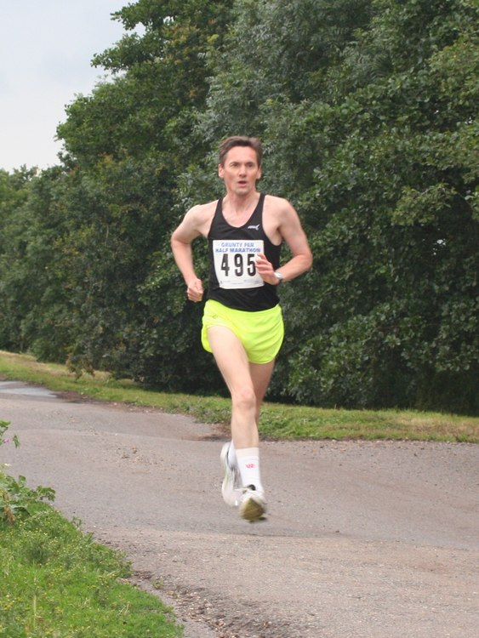 Peter Harris

In a welcome return to racing after a quiet winter, John Crisp has quickly returned to form, with three top-ten finishes this month – 6th in the Newmarket Heath 6k, 2nd in the Newport 10k and 5th in the Soham Half-Marathon.

Following a winter of solid training and improvements in PBs at 5m and 10k, Mel Fisher translated her good form to an impressive PB at the off-road Brandon Half-Marathon on Bank Holiday Monday.

Special mention must go to the club’s 4 competitors in the Brathay Windermere Marathon – Chris Bower, Steve Barker, Mark Turner and Hayley Tooke. Chris and Steve both achieved PBs, whilst Mark and Hayley posted similar times to those they achieved in the London Marathon 3 weeks previously on what was a much tougher course.

Chris Bower 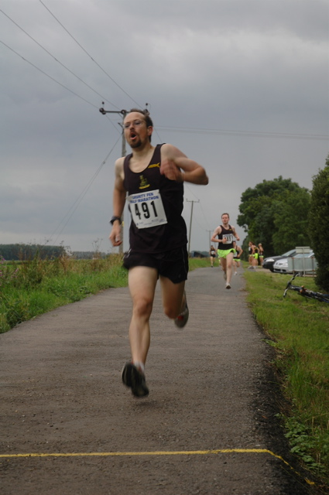

CONTRIBUTIONS TO THE NEWSLETTER
As ever, please send your contributions to the newsletter to me (Rachel Roberts) at: newsletter@elyrunners.co.uk. Many thanks!

RR
May, 2009
newsletter@elyrunners.co.uk
USEFUL INFORMATION

Data Protection
Email circulations by the club to members are done by the Bcc (confidential) option so that member’s email addresses are not circulated and also these do not take up most of the first page of emails.
See www.elyrunners.co.uk > CLUB INFO > administration for the club’s policy on data protection and use of photos and videos on the club’s website.

Membership
Subscription renewals (£10) were due from 1st January 2009. Members who joined after 15th November 2008 are covered for 2009.

To renew online:
Go to www.elyrunners.co.uk > CLUB INFO > Membership
OR
Send a cheque, payable to ‘Ely Runners’, to Club Secretary: John Turner, 22 Cromwell Road, Ely, Cambs, CB6 1AS.

If you did not renew your membership by the end of March 2009, you will be removed from the membership list and will no longer be entitled to attend training, represent the club in races, take part in club championships, claim affiliated entry fees, or wear club colours.

Benefits of membership include:
- £2 affiliated discount on open race entries
- club affiliations to ARC, ABAC, UKA, EA, TRA, FRA & CAA
- free registration (£5) with EA until 31st March 2010 (on request via John Turner)
- free changing and showers at the Paradise Centre
- free training and coaching advice
- free high-visibility bib for night-time training
- £12 subsidy on club fleeces
- 10-20% discount at most specialist running kit shops
- free entry to the club’s Cross-Country Championships, 10k Handicap and Straight Mile Handicap
- free entry to the six Frostbite League races
- free club team entry to county, regional and national championships and for club relay entries
- entry into the draw (if a member’s ballot entry is rejected) for the club’s guaranteed London Marathon places
- free snacks at club social events
- shared transport to races

Supporting the Club and its Events
Ely Runners hold three popular open races each year (Turing Trail Relay, Grunty Fen Half Marathon, and Ely New Year’s Eve 10k Road Race) that contribute considerably to the club’s reputation and financial stability. This enables the club to provide the many benefits listed above. In return, members are expected to show commitment to the club by helping with these events and taking their share of responsibility. Please don’t just rely on the usual loyal helpers and think of the club only as a convenient way to promote fitness and enter races. We’re all busy these days but commitment is realising the mutual benefits of putting something back into the club and sport we enjoy.

Training
For details of club training sessions at 7pm on Tuesday (intervals/hills) and Thursday (steady 5-8m runs) evenings, please see the homepage of the club’s website. Details of 9am Sunday morning training runs are usually circulated by email a few days in advance.

When meeting at the Paradise Centre for training on Tuesdays and Thursdays, please assemble either in the balcony/bar area upstairs or outside, around the corner by the side of the building. Please do NOT assemble in the foyer or outside the main entrance.

The meeting place for Sunday morning runs is the Paradise car park. The car park toilets are open by 9:00 am and the Paradise Centre is open for showers afterwards.

Please ensure that new members, some of whom are new to running, feel part of the club and are not left alone on training runs.

Club training sessions are intended to cater for a wide range of abilities and racing objectives. If you require specific coaching advice, please ask Club Coach Alan Rutterford to help.

To measure the distance of a route before or after running, see Google Earth > Ruler (toolbar symbol) > Path. Provided measurement is done carefully, the distance should be of similar accuracy as GPS.

Club Noticeboard
This is in the foyer of the Paradise Centre, to the right of the main entrance. It includes details of club events, training sessions, route maps, local races and other events of interest to members. There are usually several copies of race entry forms on the board but please leave the last copy or ask staff at reception to photocopy (Ely Runners' account) a few more copies.

Club Website
Webmaster, Rod Baron, maintains the Ely Runners’ website (www.elyrunners.co.uk) to provide an up-to-date record of the club's activities and a myriad of useful information. The website is frequently updated and well worth regular visits. For member’s general comments, there is a Message Board on the website’s home page and the recently upgraded photo and video section contains a huge selection of members in races. Rod also maintains the club’s websites for the Grunty Fen Half Marathon, New Year’s Eve 10k, and Turing Trail Relay.

Club Library
Grade 2 coach Max d'Ayala has selected a range of books on running and injuries for use by club members. Please see http://www.dayala.co.uk/elyrunners/booklist.htm for details: they have been chosen to provide a combination of interest, information, advice and stimulation for all standards of runners. The books are stored in the club's locker (authenticate membership and ask for key at Reception) at the Paradise Centre staff room. Please record which books you have borrowed in the notebook in the club's locker.

John Turner has the latest (2009) Fell Runners Association Fixtures Calendar & Handbook. Members interested in running a fell race can borrow this booklet. Most fell races are ‘up north’, though there are also many in Wales and other hilly areas of the UK. There is a huge choice throughout the year, including many evening races in the summer, some not too far away in areas like the Peak District. Alternatively, if on holiday in such areas, you can often find a local fell race. They provide an enjoyable, challenging and worthwhile experience, even for Fenland-based runners.

A recent addition to the club’s library includes ‘Feet in the Clouds – A Tale of Fell Running and Obsession’ by Richard Askwith.

Racing
Some open races are very popular and reach the entry limit before the race day. Many races no longer accept entries on the day (marked ‘no EOD’ in the Races & Events Guide). If you are thinking of entering a race on the day, check with the organisers or on the race website before setting out that a place is still available – turning up does not guarantee that the organisers will allow you to run!

Wearing Club Kit
Members wear their Ely Runners’ colours with pride in races far and wide (see www.elyrunners.co.uk > RESULTS) and are encouraged to do so whenever appropriate. Guidelines to wearing Ely Runners' colours (minimum club vest) in all events entered as an individual or team member of Ely Runners are as follows:
1. Obligatory requirement of governing athletic organisations in leagues entered by the club, relays entered for or by the club, all championships and events incorporating championships. Exceptions are members running for county, regional or national teams when they will be given the appropriate team kit to wear.
2. Necessary to avoid disqualification as a team member in open races.
3. Members normally wear their club kit in open races but there are recognised exceptions such as representing a charity, necessary kit change in an ultra run, spur of the moment race entry, non-availability of kit for whatever reason etc.
4. Not wearing club kit also makes it harder for other runners, race officials, and photographers to distinguish club runners, especially in relays.
5. Our distinctive race kit defines us as ambassadors of a well-respected running club.

Race Results
When you send your race results to Stephen Howard (results@elyrunners.co.uk), please advise if you have achieved a PB (including in vet categories), so that it can be included in press reports and to update PB information on the website. If possible, please send Stephen any information you have (including links to race results) by noon on Monday to avoid the extra work involved in updating press reports. Please email any photographs or links to event photographs (with your race number) to Rod Baron at webmaster1@elyrunners.co.uk.

Several members have put themselves on www.athleticsdata.com. This is a statistical website showing:

- UK year rankings
- All-time rankings
- Comprehensive results service
- Athletes’ profiles

This website will enable you to check your form relative to rival runners and allow them to do the same. It’s also useful for the prediction of race results for both runners and organisers.

Payment of club entries into championships, relays and leagues will be funded by the club provided they are team entries made by the club. The club will not pay for individual entries into open races that have an incorporated championship.

To take part in UKA National and SEAA championships, members need to be registered with England Athletics (EA). Also, a few open events still require EA registration to claim affiliated entry fees. However, most events (especially locally) either have ARC permits or, if they have UKA permits, require only membership of an EA affiliated club, like Ely Runners. Please could members who would like to be registered from 1st April 2009 with EA for 2009-10 please contact John Turner secretary@elyrunners.co.uk. It was agreed at the recent AGM that the club will pay the £5 registration fee. Registration number confirmation and cards will be supplied when received from EA.

To enter a County (eg Cambs AA) or Regional (eg SEAA) Championship, members must have been born in the county/region or had 9 months of continuous residency. If you qualify by birth and residency for different counties, you may only run for one county/region during each competition year from October to September.

Club vets who are not members of EVAC may run as guests of the club’s EVAC members in EVAC Championships. EVAC events are included in the Races and Events Guide and can be entered by sending an email to eastvetm75@ntlworld.com. Subject to the availability of funds, the club will pay for club team entries to EVAC and BMAF Championships. EVAC website: www.evac.org.uk
BMAF (vets) events are too numerous to include all of them but they have been circulated to EVAC members via regional and national veteran magazines or see www.bmaf.org.uk/fix/fix.asp

Running Kit
Mary Gates oversees the club’s kit supplies. The club’s joining fee of £33 includes a free club race vest and shorts. Please contact Mary on 01353 861379 or mary@elyrunners.co.uk to order. See www.elyrunners.co.uk for full details of club kit.

New club vests now have the Ely Runners’ cathedral logo top centre on the front. Any members with older vests who would like to have the logo added will need to give their vest to Mary to send. The cost (£1.20 for the transfer + 25p for application) will be covered from club funds. Race vests will continue to have ELY RUNNERS on the back.
Club fleeces are available from Mary Gates at the subsidised price of £10 to members only. This price is for one fleece per member. Subsequent fleeces will be at the cost price of £22.
.

Discounts on Kit Purchases
If you buy running kit from Advance Performance at Cambridge or Peterborough, please show them your membership certificate and the club will receive 10% towards vouchers that we use for prizes for our Christmas charity raffle. Advance Performance do not otherwise give discounts. Other running shop suppliers such as Sweatshop in Cambridge (who sponsor our three open races: New Years Eve 10k, Turing Trail Relay, and Grunty Fen Half Marathon) will usually provide a 10% discount to members on production of a valid membership certificate.

Natalle Etches has purchased a wide variety of fitness stock from a local Internet fitness company that closed down. She is re-selling the stock as low as half price to club members. The stock includes cycling, running, fitness and triathlon wear from brand names including Craft, Gore Bike Wear, Pearl Izumi, and Sugoi. If you’re interested, speak to Natalle at one of the training sessions or contact her on natalle@elyrunners.co.uk.

Social Events
Julie Foreman organises the club’s After Training Drinks on the first Thursday of the month. The next will be after training on Thursday 2nd April.

RACES & EVENTS GUIDE 2009

This includes local area/easily accessible races, club, county, regional and national championships, and a selection of UK/overseas events previously enjoyed by members.

June
02 (Tues) Harlow Ladies 5k series (women only), 1930 Mark Hall School, Harlow, £3 per race/£9 series (+£1/£3 EOD), http://www.thehrc. org.uk/ladies5ks eries.htm
04 (Thu) ER after training drinks, julie@elyrunners.co.uk
07 Suffolk Orienteering Club Introductory Event, 1030 Nowton Park, Bury St Edmunds, £4, http://www.pdl.demon.co.uk/events/nowton.htm
10 (Wed) Cambs Open Graded T&F Meeting, 800m & 1500m, 1900, St Ivo Centre, St Ives, £2 per event, www.cambsaa.org.uk
11 (Thu) Ely Runners’ Midsummer 10k Handicap (private club event), Cricket Club, 1930
Lt Downham, FOC members & guests. Presentation afterwards in the Prince Albert, Ely
11 (Thu) Cambridge Tri Club 5k, 1900 Chivers Farm, Impington, £4 (no EOD), http://www.howesplace.com/ctc/ctc_entry.php
13 (Sat) Eurofoule 10k, Andrezieux-Boutheon, France, by invitation
13 (Sat) Kedington 5k, 1100 Community Centre, Arms Lane, Kedington, £5
14 Abbey 10k (CRRL), 1100 Leisure Centre, Hollow Road, Ramsey, £9, EOD +£2
14 North Downs 30k, 1030 Cascades Leisure Centre, Thong Lane, Gravesend, £13, no EOD
14 St Albans Half-marathon, 1000 Verulamium Park, St Albans, £17, no EOD, www.stalbanshalfmarathon.co.uk
19 (Fri) Marston Forest 5k, 1930 Marston Moretaine, Beds, www.MarstonForest5K.org.uk
20 (Sat) PACTRAC 5k, 1400 Oundle, Northants, £3, www.oundlecarnival.co.uk
20/21 (Sat/Sun) SEAA U20 and Senior T&F Champs, Woodside Stadium, Watford
21 Haddenham Fun Run c. 5k, 1030 Fairchilds Meadow, Chewells Lane, Haddenham
27 (Sat) Hampton Fun Run c. 7.5k, 1115 Hampton Vale Primary School, Peterborough, £3
28 Stortford “10” (10k or 10m options), 1000 Bishop’s Stortford Rugby Club, £8 (+£2 EOD)

July
01 (Wed) Sudbury Joggers 5m, 1930 Sudbury Football Club, £5 (+£2 EOD), http://www.sudburyjoggers.org.uk/clubraces.html
02 (Thu) ER after training drinks, julie@elyrunners.co.uk
03 (Fri) Cranfield 5m, 1930 Cranfield, Beds (more details to follow)
05 EAA T&F Championships (incl. 800m, 1500m & 3000m), 1000 Cambridge University Track, £6 per event
05 Newmarket 10k, 1100 Ellesmere Centre, Stetchworth, £8 (+£2 EOD), http://newmarketjoggers.org.uk/wp-content/uploads/2009/05/newmarket10kentryform2009.pdf
08 (Wed) Mike Groves Run 5.85k Multi-terrain, 1930 Coltishall Football Ground, Norfolk, £6 (+£2 EOD)
09 (Thu) training at 1900 will include Ely Runners’ Straight Mile Handicap on Quanea
Drove. Perpetual Shields for Handicap 1st M/F, Fastest M/F, and Age Related 1st M/F will
be presented afterwards in The Prince Albert, Ely
12 Bushfield 10k (CRRL),
17 (Fri) Thetford Forest Challenge (Run-Bike event), 1900 May Day Events Field, Thetford Forest, £25 per pair (+£5 EOD), www.runbikeevents.com
19 Fairlands Valley 12/18/26.2m Challenges, Bedwell, Stevenage, www.races.fvspartans.org.uk
22 (Wed) Cambs Open Graded T&F Meeting, 1 mile, 1900, St Ivo Centre, St Ives, £2 per event, www.cambsaa.org.uk
26 March 5m Spud Run, 1100 Elm Rd Sports Field, March, £7 (+£1 EOD)
26 NSPCC Milton Keynes Half-Marathon, 1000 Bury Lawn School, Stantonbury, £18 (+£7 EOD), http://www.mkhalfmarathon.org.uk/

August
02 Wellingborough 5m, 1030 Old Grammarians Sports Field, Wellingborough, £8, WWW.familysupportlink.co.uk
07 (Fri) Wibbly Wobbly Log Jog (5m TR), 1930 Brandon Forest, £6, no EOD, www.bfh.org.uk
07 (Fri) Blisworth 5m, 1930 Blisworth Football Club, Northants, £6 or £11 for series, www.woottonroadrunners.co.uk

09 Wandlebury 5m XC, 1030 Wandlebury Woods, Shelford, £7 (+£2 EOD)

16 Thorney 5m (CRRL)
16 Reepham Summer Sunday Run 10k (multi-terrain), 1000 Reepham, Norfolk, £8 (+£2 EOD)
19 (Wed) Nene Valley Harriers 5k (Cambs County Championship & CRRL) (prov date)

September
06 Wissey Valley ½ Marathon (EVAC & Norfolk Champs), 1030 Oxborough Village Hall, www.rystonrunners.org.uk
06 Budapest Half-Marathon, Budapest, www.budapestmarathon.com
06 Littleport Leisure 10k Run, 1045 Leisure Centre, £8, www.littleport10k.co.uk
13 Grunty Fen ½ Marathon (Cambs County Championship & CRRL), 1030 Witchford Village
College, Ely, www.gruntyfen.co.uk
13 The Jubilee 5, 1100 The Marriotts School, Telford Ave, Stevenage, £9.50 (no EOD), http://www.fvspartans.org.uk
13 Bourn to Run 10k, 1030 Bourn Recreation Ground, Bourn (Cambs), £10, http://www.bournschool.co.uk/
19/20 (Sat/Sun) Round Norfolk Relay, www.roundnorfolkrelay.com
19/20 (Sat/Sun) Isle of Wight Fell Running Series, 3 races over 2 days, www.rydeharriers.co.uk

October
04 SEAA 10k Road Running Championships, Crystal Palace, London
04 Budapest Marathon, Budapest, www.budapestmarathon.com
04 New Balance English Half-Marathon, 0900 Centre Park Warrington, £27 (no EOD), http://www.english-half.co.uk/
10 (Sat) Peddars Way Trail Run (more details to follow)
11 Great Eastern Run ½ Marathon, 1100 Laxton Square, Peterborough, £18 (no EOD)
18 Ampthill Trophy XC, Ampthill, Beds, www.AmpthillTrophy.org.uk (more details to follow)
25 Fenland 10m (CRRL)
24 (Sat) Beachy Head Marathon (3,500’ climb), 0900 Eastbourne, depart Paradise 0500

November
04 Loch Ness Marathon (&10k/5k), www.lochnessmarathon.com
15 St Neot’s ½ Marathon, 1000 St Neot’s Recreation Centre, http://www.half.riverside-runners.com/
22 Hereward 4 Stage Relay (39.1m Peterborough to Ely), club teams, provisional date

December
20 Long/medium/short club pre-Christmas trail training runs, Woodditton to Ely 18.5m,

Woodditton to Chalk Pit 12m, Reach to Ely 11m, Woodditton to Reach 7.5m, meet 0800

Paradise for transport to starts
26 (Sat) Boxing Day training, meet 0900 Paradise Centre car park
31 (Thu) The 10th Ely New Year's Eve 10k Road Race, 1100 Lt Downham, entries on-line
only, no EOD, www.newyearseve10k.co.uk

NOTES

Races and events are on Sunday unless otherwise mentioned.

Race entry fees are the affiliated (ARC/UKA or just UKA registered) fees

Courses are roads and/or hard footpaths/cycle ways unless otherwise mentioned.
Distances without units (m or k) are probably m = miles.
Frostbite League races are 5-6 miles and entry (league membership) is paid for by the club.
Further details of events from the Club notice board in the Paradise Centre foyer, running magazines, websites, or from John Turner secretary@elyrunners.co.uk) who also has details of all RRC/TRA long distance road/TR/XC races and FRA fell races.

National, regional and county championship team entries are via Charlie Barker (captain@elyrunners.co.uk).

Club championship & club handicap entries are via Steve Tovey

Long distance team relay entries are via Alan Rutterford and paid for (if funds available) by the club.

Club website www.elyrunners.co.uk
Grunty Fen 1/2M website www.gruntyfen.co.uk
NYE10k website www.newyearseve10k.co.uk
Turing Trail Relay website www.turingrelay.co.uk
Association of Running Clubs www.runningclubs.org.uk

Rachel Roberts
April 2009
newsletter@elyrunners.co.uk

