NEW MEMBERS  We warmly welcome the following new members who joined the club this month. We look forward to seeing you all at training and club social events!  Simon Law  Gareth Lewis  Milly Day  Harry Brown  Fletcher Collins-Shirley  December Highlights  - Record NYE 10k  - Juniors in impressive Frostbite performance  - Munkeys quick in Bedford  - Big turnout at NVH  It is the club AGM at 7:30 on Monday February 6th – All members are welcome.  If anyone has any proposals for the AGM or any nominations for the committee they should contact Steve Tovey: secretary@elyrunners.co.uk | NYE 10k  Thank you to all members who volunteered their time on Saturday at what proved to be a hugely successful running of the NYE 10k. A full report follows on page 5 but special mention must go to Ashley Pettit who put in a particularly impressive time of 35:06 and with it was the 1st Junior Male home in a new Junior Club Record, not bad at 17 years old!  Global Running by ER  Longstanding Cambridge based member Alfredo Verna, whose work provides projects in many countries, reports that in 2011, he ran in South Korea, Germany, Czech Republic, Colombia, Hungary, Cuba (3 journeys), Italy, USA (Maine), Spain, South Africa and UK (only 20 days) including Scotland - must be a club record!  Cambs AA XC  Riverside Runners will be hosting the Cambs AA XC Championships on 8th January 2012 (the weekend before the March AC Frostbite) at Priory Park in St Neots. There will be 9 races throughout the morning for all age groups. http://www.cambsathletics.org.uk/page4.htm  If you are attending or know someone who is Adrian Jarvis would be grateful of any help on the day – please contact Adrian adrian.jarvis@virgin.net if you can help.
Club Colours at Parkrun – a message from national Parkrun organisers
“We love the fact that Parkrun is fully representative of the whole society. We have loads of folks who are serious runners and a load more that are not. We have folks who just want a jog or even those who start out walking with the goal to eventually run the whole distance. But, we believe that for those who want to better their running then the club structure is the best place to find this help. This is why we signpost all clubs by adding a link to each clubs website in the results plus we recommend that club runners represent themselves by wearing club kit at our events. I am aware that there are many folks who have finished ahead of a fellow parkrunner wearing club kit and have realised as a result that perhaps joining a club is a possibility for them.”
Club Membership and EA Affiliation
Membership subs (£10 seniors; £5 Juniors) are due by 1st January 2012 – to facilitate payment Steve Tovey has updated the ‘membership renewal’ page on the club website (Club Info>>Membership). Please can you try and renew ahead of the deadline so that Steve doesn’t have to chase you. If you prefer to use cash/cheque rather than Paypal then please give your payment to Club Treasurer Peter Harris. Equally, if you know you don’t intend to renew your membership in 2012 then can you please let Steve know.
EA Affiliation: As reported in the last newsletter members who wish to retain/obtain an individual affiliation to EA are required to pay their own fee from next year onwards. To facilitate this we’ve added an ‘EA affiliation’ payment item (£5) to the membership renewal page - although EA renewals are not due until 31/3/2012 it may be convenient for members to be able to pay for this when they renew their membership. The club will then make one payment to EA in March.
Christmas Drinks: Many thanks to seniors and juniors alike for raising £257 for East Anglia’s Children’s Hospices at their various Xmas events. The club matched the amount raised, making the final donation £514.

Ely Runners Juniors - Bowling night - Friday 8th December 2011
On Friday 8th December junior members of the Ely Runners club were invited to a Christmas bowling night at Strikes in Ely. The members were all paid for by the club which we were all very grateful for. We were all asked to pair up with one person that we wanted to be in our team. Pairs were then put together to make a team of four and then the fun and games began. After all the games had finished we were treated to a meal at strikes. Everyone was awarded with a Christmas selection pack from the club. Finally the prizes were given out. In 5th place was Adrian Chalmers who said “I’d like to say thank you to Rhys and James for going easy on me!” In 4th place was Rhys Gwynn who was very surprised that he’d made it into the top five bowlers. Robyn Seabright came in 3rd place and was in a hurry to see what her prize bag had to offer! Esme Wright came runner up and said in her speech “Thank you so much for this wonderful gift”. The highest scorer was Molly Butler, finishing in 1st place. Molly’s prize was a rucksack, some stylish shorts and a drinks bottle. Every one thoroughly enjoyed the evening and we wouldn’t have been able to have this night without the volunteers who gave up their time to be with us at strikes, so a big thank you goes to them, and as Ely Runners kindly paid for us all to attend we would like to give them a big “thank you” too.
By Megan Gwynn
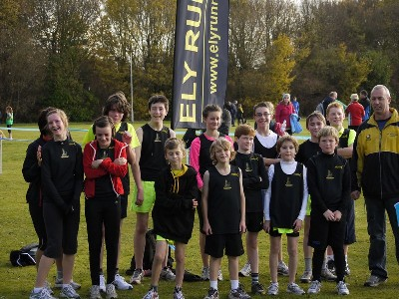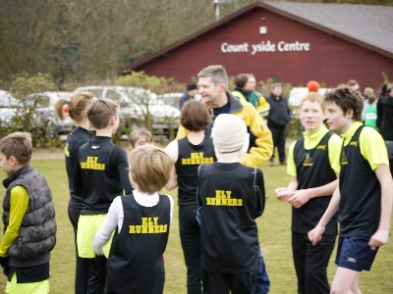

Santa’s converge on East Cambs
On Sunday 18th December several members took part in the annual pre-Christmas training run from Woodditton to Ely. Runners were able to run a range of distances from 6 to 18 miles with some running even further. This popular event brings out the more eccentric side of our normally reserved members as the photos will confirm. Many thanks to John Turner for organising the event and to Tony Hall and Alan Rutterford for providing both transportation and refreshments.

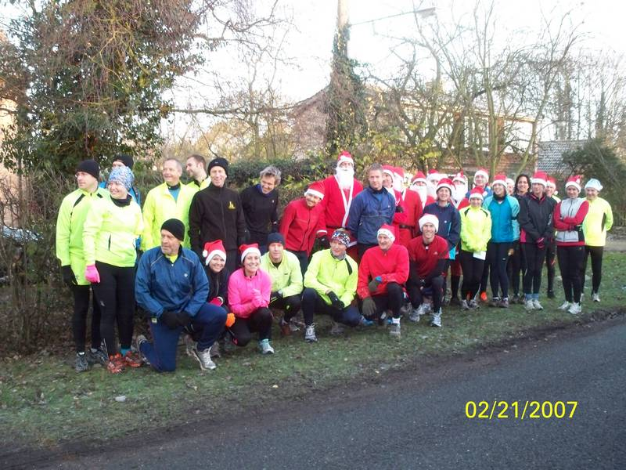
Ely Runners at the start in Woodditton

FORTHCOMING EVENTS: Full fixture list on page 6

Frostbite Friendly League
The fourth race in the of six race series takes place on Sunday 15 January at Whitemoor Prison. It’s FREE to take part! All you need to do is turn up on the day in your Ely Runners race kit.
The junior race gets underway at 10:15 and the seniors start at 11am. It is a challenging off-road course – it’s certainly muddy in places, so trail shoes would be ideal if you have them.
The first 10 Ely Runners to cross the finish line score for the club; three of these runners must be female. This series of races places great emphasis on friendly rivalry between clubs and the enjoyment of all runners and helpers. Women are especially encouraged to take part.
Please don’t be discouraged from taking part if you don’t think you’ll make the scoring team – the success of the club depends on a good turnout from runners of all abilities so please do join us! If seniors would like to share transport then meet at the Paradise centre at 9AM . www.frostbiteleague.org.uk

Any junior members (aged 9-15) wishing to run should contact Alan Rutterford in training or (alan@elyrunners.co.uk / 07821 988959).

FIXTURES:
15 January 12 Whitemoor Prison, March (March AC)
5 February 12 Bourne Woods
4 March 12 TBA (BRJ)

Ely Runners’ 2011-2012 club cross-country championships

The annual club XC race will be held on Sunday January 29th 2011.

The race will be held over 4 laps on the new ~ 5m course starting and finishing on Ely common at the top of Waterboard Hill.

Alan Rutterford will be organising a one-lap race (plus an additional circuit of the meadow) for juniors – entries to either Alan or Lesley Wright (alan@elyrunners.co.uk or lesley@elyrunners.co.uk). We would also like to encourage parents to join their children in the Junior race, many juniors would like the opportunity to race against their parents

Meet at the Paradise car park at 9:30am for a 10:00 am start on Ely common.

Entry is free of charge to members and their invited guests. This is a club event so please wear club colours. The course is suitable for trail shoes or (just about) spikes. Road shoes are also suitable but not ideal in wet conditions.

There are perpetual 12” tudor shields for the following award categories (members only): ·
1st Male (2010-11 Rob Campbell) ·
1st Female (2009-10 Heidi Uff) ·
1st Age Graded Male (2009-10 Rob Campbell)·
1st Age Graded Female (2009-10 Heidi Uff)

Afterwards Chairman Stephen Howard will present the trophies in the upstairs bar at the paradise centre at 11:30 am.

If you would like to run or alternatively are available to help on the day as a marshal then please let me know. matt@elyrunners.co.uk

p.s any offers of homemade cake for after race refreshments would be gratefully accepted.

SOCIAL EVENTS
After training drinks are usually held on the first Thursday of each calendar month, with the next opportunity happening on Thursday, January, 5th at the High Flyer in Ely. Further information is available from Julie Foreman Julie@elyrunners.co.uk

2011 Statto’s Corner (up to 23 December)
A selection of interesting(?) and some might say pointless facts:

Most PB’s
Steve Starr 12
Lewis Leonard 8
Miranda Paul 8

Most Club Records
Graham Chapman 8
Luke Crisp 5
Stephen Pettit 5

Most Races
David Mould 43
Stephen Pettit 39
John Manlow 32
Lionel Smith 32

New Physio in Ely
There is a new Physio in town! Julia Anderson will be based at the Atrium club and she is happy to offer a £10 discount on treatment to all Ely Runners. Her charges are £40 for an Initial Assessment and treatment and £30 follow up appointments so it would be £30/£20 for ER members.

Julia also teaches one-one pilates in which she specialises in rehabilitation and muscle imbalances of runners. These sessions could be useful to anyone who will be increasing their training very shortly in preparation for marathon season!

Julia can be contacted via the Atrium Club or on via her website www.pivotalphysiotherapy.co.uk or on 07903284040

Ely Runners can also benefit from a £10 discount at The Sports Injury Clinic in Fordham www.thesportsinjuryclinic.org

RESULTS

Frostbite Senior League Race 3 – Hinchingbrooke Country Park, Huntingdon 5m(XC)

Twelve members made the short journey to Huntingdon to represent ER in the third Frostbite race of the series held at Hinchingbrooke Country Park. The 5m Cross-Country course is made up of a mixture of muddy trails and gravel paths with only a short half-mile section on tarmac. Conditions on the day were cool with a slight breeze, with a brief shower during the race adding to the wintry feel. The course was wet and muddy in places but not too demanding considering the time of year. Continuing his fine recent form Gary Wilberforce was first home for Ely in 10th place recording a time of 29:13. Further down the field there were fine PB performances from Linden Smith, Steve Starr, Emma Greaves, Sharon Leonard and Anita Lewis on a day when the ladies very much outshone the men. Many thanks to Heidi Uff and Andy Nixon for being stand-in team managers on the day.

10th Gary Wilberforce 29:13 (Scoring Team –M)
14th Ian Day 30:17 (2nd Claim; ran for HuntsAC)
22nd John Uff 30:55 (2nd Claim; ran for C&C)
35th Steve Tovey 31:32 (Scoring Team –M)
184th Lionel Smith 38:18 (Scoring Team –M)
200th Linden Smith 39:22 (PB)(Scoring Team –F)
207th Steve Starr 39:39 (PB,1st 5m)(Scoring Team –M)
213th Melanie Fisher 39:46 (Scoring Team –F)
214th Emma Greaves 39:47 (PB)(Scoring Team –F)
215th Sharon Leonard 39:48 (PB)
219th John Turner 40:01 (Scoring Team –M)
224th Tom Russell 40:19 (Scoring Team –M)
285th Jon Pennington 45:06 (Scoring Team –M)
340th Anita Lewis 50:59 (PB)

The senior race was won by Aaron Scott (NVH) in 26:29. There were 370 finishers.
The seniors finished 15th on the day with 1791 running points.
10th Ely 22

Frostbite Junior League Race 3 – Hinchingbrooke Country Park, Huntingdon 1.5m(XC)

A healthy contingent of ER juniors attended the 3rd Frostbite race of the series at Hinchingbrooke Country Park in Huntingdon. The course is a single 1.5m loop through woodland starting and finishing near the park’s visitor centre. First home for Ely was Robyn Seabright in an impressive 10:27, the scoring team was completed by Lewis Leonard, Alexander Ellwood, Gareth Lewis and James Holland. The juniors finished 4th on the day, consolidating their overall 4th position in the league standings. Many thanks to Brent Crossman for acting as team manager on the day – and to Jon Pennington for photography and taking charge of the ER sail-flag!!

21st Robyn Seabright 10:27
25th Lewis Leonard 10:39
31st Alexander Ellwood 10:56
34th Gareth Lewis 11:01
37th James Holland 11:04
44th Michael Ford 11:17
53rd Fraser Crossman 11:34
83rd Molly Butler 12:20
101st Milly Day 12:50
114th Nathan Pennington 13:26
122nd Jamie Rendall-Read 14:13

The junior race was won by Thomas Heylen (C&C) in 8:53. There were 153 finishers.
The juniors finished 4th on the day with 148 running points.
4th Ely 31

Tom & Alex in Mucky Times
Several runners took the short journey to Bedford to take part in the Bedford Half. The course consists of 2 miles flat - hill - 1 mile flat - then 5 miles uphill and four back down to the finish. This year it was windy for the first time in a few years and it was runners’ faces for the uphill elements. Tom Bracegirdle and Alex Tate (both running for 1st claim Muddy Mucky Munkeys) put in impressive times finishing close together in 6th and 8th respectively. In John Manlow’s view it was one race too far particularly after his exertions at the Nene Valley 10 the previous week. The Bedford Half is a great race - good organisation, a challenging course, a good memento (water resistant jacket this year), flawless bus transfer, excellent marshals. John started off ok sharing the workload with another runner. However at 9 miles they got to the downhill section and John felt his calf start to tighten , he decided to ignore it for a mile or 2 but at 12 miles he started to slow and at 13 was forced to hobble to the line. Stephen Howard ran well with Jason Mann not far behind him, unfortunately neither of them or Colin Doak, who also ran, were available for comment.
Official Results:
6th Tom Bracegirdle 01:13:07 (PB) (2nd claim)
8th Alex Tate 01:13:30 (2nd MV35) (2nd Claim)
36th John Manlow 01:19:02
123rd Stephen Howard 01:27:26
137th Jason Mann 01:28:19 (PB)
1293rd Colin Doak 02:06:43
There were 1523 finishers and Paul Martelleti won for the second time in 1:08:48

ER out in force at NVH 10
15 members made the short trip to Peterborough for the NVH 10m. The race is run over a twisty but flat course through Bretton in the suburbs of Peterborough. The race is mainly run on cycle paths and road, with the only perils coming from the odd flight of steps and bollards found in the middle of the cycleways at disconcerting regularity. The cool conditions were ideal for running and the course is pretty sheltered negating the effects of the westerly wind. There were some fine performances from ER on the day with 6 PB’s and two ER registering their first times for 10m. John Manlow ran a first PB for a while, Ian Day was running in green for first claim Hunts AC; Kieren Drane is back running well after NYC and Steve Tovey was pleased with his new PB. Gary Wilberforce ran with Tom Russell pacing them both to PB times. Miranda Paul’s running continues to improve and she was very happy with her new PB. David Mould exceeded his own expectations in beating his PB by nearly 90 seconds. David was very pleased with 70:18 after running consistent splits with the first five miles complete in just over 35 minutes. Members were pleased to see John and Fran Crawford again, unfortunately Colin Doak was unavailable for comment.
Full Results:
15th John Manlow 58:28 (PB)
28th Stephen Pettit 1:00:40
30th Ian Day 1:00:55 (2nd Claim)
31st Kieren Drane 1:01:03
42nd Stephen Tovey 1:03:15 (PB)
56th Stephen Howard 1:05:26
107th David Mould 1:10:18 (PB)
162nd Miranda Paul 1:16:03 (PB)
177th Melanie Fisher 1:17:37 (PB)
195th Tom Russell 1:19:15 (PB)(1st 10m)
196th Gary Wilberforce 1:19:16 (PB)(1st 10m)
221st Stephen Starr 1:22:53 (PB)
233rd John Crawford 1:24:38
269th Colin Doak 1:32:00
278th Fran Crawford 1:35:07
There were 309 finishers. The winner was Alex Hains of Cardiff AC in 49:35 with the 1st lady, also from Cardiff AC, being Ava Hutchinson finishing in 58:08.

For a full list of results and event reports see the club website.

Event photographs
Please send any race/club event photographs to Charlie Barker - (charlie@elyrunners.co.uk) Ideally they should be resized to 800x600 pixels (ish) and preferably be less than 100k in size.

Did you spot Gary Wilberforce on page 1? Send in your event photos and you too could feature in next month’s newsletter.

STOP PRESS!

New Year’s Eve 10k
A record turnout saw 579 runners complete the 2011 New Year’s Eve 10k. In the men’s race 2 runners dominated with Matt Gunby eventually out finishing the Grunty Fen Half Marathon winner Aaron Scott in a time of 30:40. These two were nearly two minutes ahead of Paul Miles in 3rd place. In the ladies race previous winner Felicity Milton powered home in 34:52. In second place was former ElyRunner Claire Hallissey returning to run in this popular event. Since leaving the area Claire’s running has improved immeasurably and her decision to focus on longer distances has resulted in her already qualifying to represent Great Britain in the Marathon at this year’s Olympic Games in London. Several Ely Runners also put in impressive performances with Tom Bracegirdle running for his first claim club Muddy Mucky Munkeys, coming home in 6th place. The performance of the day has to go to Ashley Pettit whose time of 35:06 not only enabled him to finish 13th place and 1st MJ but it also helped him to achieve a new club record for juniors. Gary Wilberforce continues to run well and Graham Chapman finished the race despite being unwell throughout. Lesley Wright and Brent Crossman both achieved new personal bests. Mark Turner was spotted in full Santa costume pushing a buggy for the full 10k. 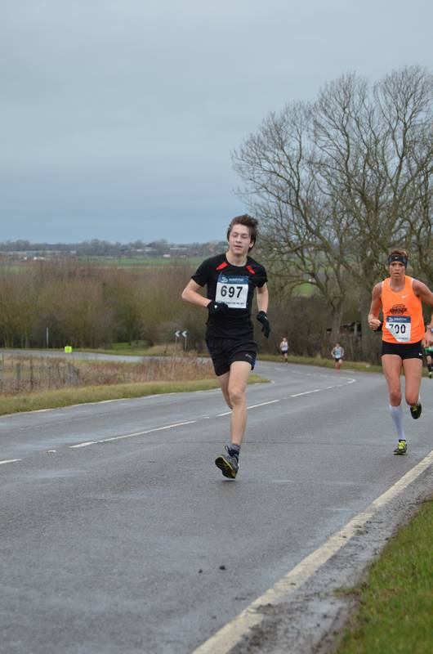 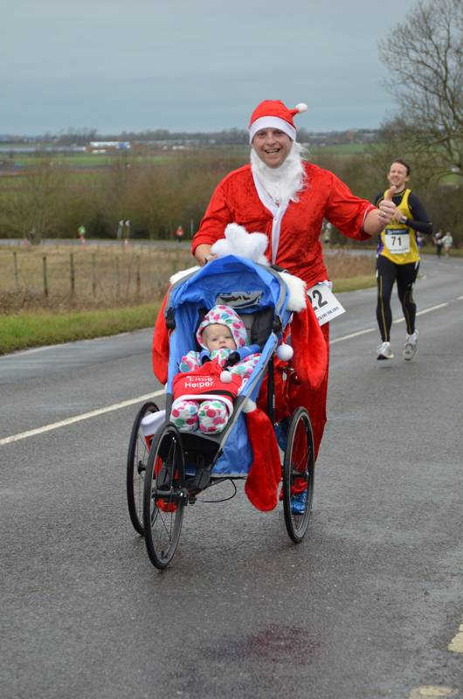
Ashley Pettit Mark Turner

Full Results:
6th Tom Bracegirdle 34:01 (2nd claim)
13th Ashley Pettit 35:06 (PB)(MJ Club Record)
22nd Gary Wilberforce 36:28
72nd Graham Chapman 40:20
202nd Lionel Smith 46:07
219th Lesley Wright 47:04 (PB)
265th Mark Turner 48:35
270th Tom Russell 48:50
273rd Kirstie Blencowe 48:59
278th Brent Crossman 49:12 (PB)
323rd John Crawford 51:10
408th Fran Crawford 55:02
427th Michael Turner 55:50
493rd Kevin Walker 1:00:05

The committee would like to thank all members who helped to make the event such a success.

TRAINING FOR JANUARY
Planned training sessions can be subject to change, being dependent on weather and ground conditions, visibility, numbers attending and suitability for those present.

Members are requested not to wear ear pieces during training because they will not be able to hear traffic approaching from behind. Members are reminded that they run/train at their own risk. For Route Maps see the website

High visibility bibs or t-shirts or jackets to be worn until daylight training resumes
Bibs are free to members from Emily Knight; emily@elyrunners.co.uk

Juniors to meet at 7 pm at the Paradise Centre on Tuesdays and train at one of the following venues, as decided by coaches, until daylight training resumes in 2012:

- Astro Turf at The King’s School, Ely
- Cam Drive x 4 laps
- King’s Avenue x 3 laps
- Lynn Road x 4 laps
- Stour Green laps

The selected junior venue will be on the club notice board in the foyer of the Paradise Centre.

Seniors’ Sunday training (usually 9 am Paradise car park) will be advised by weekly email.

Tuesday 3rd January
The Gallery intervals of 5 x 1m circuits to/from Cathedral lamppost
Interval from bottom of The Park hill, Broad St, Back Hill, Gallery 0.6m
Recovery Gallery, Porta, Cherry Hill 0.4m
Total about 5.6m from/to Paradise

Thursday 5th January
Round Ely circuit of 6.25m or shorter 4.8m finish via Police Station corner

Tuesday 10th January
6 x 1,000m intervals (Deacons Lane to Williams Close) and there/back recoveries to/from Davison Road (500m) and to/from Police Station (700m) on Lynn Road
About 6.5m to/from Paradise

Thursday 12th January
1 or 2 laps of 3.4m Ely Hills (6 climbs/6 descents/total about 275' climb per lap)
Fartlek or intervals + recovery options on hills
(3.9m or 7.3m to/from Paradise)

Tuesday 17th January
Lisle Lane & The Vineyards intervals
3 or 4 x 2.82km (1.75m) laps each with 3 fast/hill strides (125’ climb per lap) and 3 recoveries
Start/finish by Cheffins, Market Square
3 laps = 8.46km (5.26m), 4 laps 11.28km (7.01m) + 0.8km (0.5m) Paradise return
(Juniors: Astro Turf session at The King’s School, Ely)

Thursday 19th January
2, 3 or 4 laps of 1.9m Lynn Rd, Cam Dv, Downham Rd, Egremont St circuit
4.1m, 6m or 7.9m to/from Paradise

Tuesday 24th January
Lynn Road 4 x 1 mile lamppost intervals jog/run/stride/sprint repeats with 1m warm up and 1m warm down to/from Davison Road
About 6.5m to/from Paradise

Thursday 26th January
2 or 3 x 2.1 mile circuit Nutholt Lane, Lynn Rd, King's Av, New/High Barnes
About 4.2m or 6.3m to/from Paradise

Tuesday 31st January
Cam Drive (6/8/10 x 1k) alternate intervals: Lynn Rd to Stour Green roundabout 370m (slow), Stour Green roundabout to Nene Rd 320m (fast), Nene Rd to Lt Downham Rd 310m (slow). Return fast/slow/fast on same alternate intervals.
Total distances 3.75m/5m/6.25m + 1.5m return from/to the Paradise

For a full list of Training runs and advice please visit the club website. For Sunday training runs please look out for weekly emails from John Turner.

RACES & EVENTS GUIDE 2012
This includes local area and easily accessible races, club, county, regional and national championships, and a selection of UK/overseas events previously enjoyed by members.
Cambridge 5k Park Runs (at Milton) are every Saturday at 0900. Entry is free but before your first race, register on-line by 1800 on Friday,
http://www.parkrun.org.uk/cambridge/Home.aspx

January
01 Cleethorpes New Year’s Day 10k, Cleethorpes, Lincs, http://www.cleethorpesac.co.uk
01 New Year’s Day 10k, Wymondham, Norfolk, http://www.wymondhamac.org.uk/races/nyd10.asp
01 Stanwick New Year Recovery Run 5k/10k/Half-Marathon, Stanwick Lakes, Wellingborough, Northants, http://www.ultramarathon.org.uk
01 Trionium Knacker Cracker 10k, Box Hill, Surrey, http://www.trionium.com/knackercracker
08 Cambs AA XC Championships, Priory Park, St Neots, http://www.cambsathletics.org.uk/page4.htm
15 Frostbite League Race 4, ~5m, March, TBC, http://www.frostbiteleague.org.uk/
15 Ropsley Raid 6 & 13m, Ropsley, Grantham, Lincs, http://www.ropsleyroadrunners.co.uk
15 Ryston Runners XC Grand Prix Series 5k, Shouldham Warren, Nr Downham Market, http://www.rystonrunners.org.uk/cross.htm
15 UKA McCain UK Cross Challenge XC Series, U13/15/17/20 & Senior, Blackweir Fields, Cardiff, http://www.uka.org.uk/competitions/mccain-uk-cross-challenge/
15 Wellingborough MT 5k/10k/15k Round 1, Irchester Country Park, Irchester, Wellingborough, http://www.justracinguk.com
21 (Sat) UKA McCain UK Cross Challenge XC Series, U13/15/17/20 & Senior, Greenmount Campus, Antrim, Nl, http://www.uka.org.uk/competitions/mccain-uk-cross-challenge/
21-22 (Sat-Sun) Ultrarace 45/90 (45m/day), Northampton, Northants, http://www.ultrarace.co.uk/events/details/?eventid=113
22 Benfleet 15, Benfleet, Essex, http://www.benfleetrunningclub.com/benfleet15/
22 Folksworth 15, Folksworth, Nr Peterborough, http://www.yaxleyrunners.org.uk/folks%2015/racefhome.htm
22 Fred Hughes 10m, St. Albans, Herts, http://www.stalbansstriders.com/fredhughes10.html
22 Gloucester Half-Marathon & Marathon, http://beyondthelimitations.co.uk
25 (Wed) 56th Eric Humphries XC Race, Northampton, Northants
28 (Sat) Battle of Northampton Challenge Marathon, Northampton, Northants, http://www.madeyarun.com
28 (Sat) SEAA XC Champs, Main Champs, Stanmer Park, Brighton, http://www.seaa.org.uk
29 Brass Monkey 10k & 1.5m FR, Rockingham Speedway Circuit, Corby, Northants, http://www.lakelandshospice.org.uk
29 Ely Runners XC Championships (Private Event) Ely Meadows, Seniors 5.24m; Juniors 1.77m
29 Gayton Run 5k/10k, Gayton, Northampton, Northants, http://www.onyourmarksevents.org
29 Reedham 10, Reedham, Norfolk, http://www.gydac.org.uk/roadrunning_reedham

February
05 Asics Watford Half-Marathon, Watford, Herts, http://www.watfordharriers.org.uk
05 Frostbite League Race 5, ~5m, Bourne Woods, Bourne, http://www.frostbiteleague.org.uk/
05 Great Bentley Half-Marathon, Great Bentley, Essex, http://www.gbrc.org.uk/GBRC_Half.htm
05 Reepham Runners 10k XC, Reepham, Norfolk, http://www.reephamrunners.webs.com
05 Wellingborough MT 5k/10k/15k Round 2, Irchester Country Park, Irchester, Wellingborough, http://www.justracinguk.com
06 (Mon) Ely Runners AGM, Paradise Centre Meeting Room, Ely, 7:30pm onwards
12 Reading Road Runner’s Bramley 20m/10m, Bramley, Nr Reading, Berks, http://www.readingroadrunners.org/bramley.html
12 Ryston Runners XC Grand Prix Series 9k, Shouldham Warren, Nr Downham Market, http://www.rystonrunners.org.uk/cross.htm
12 St. Valentines 30k, Stamford, Lincs, http://www.stamfordstriders.co.uk/infusions/races/race1.php?raceId=3
12 The Valentine 10k, Swanton Abbott, Norwich, Norfolk, http://www.norfolkgazelles.co.uk
19 Caythorpe Dash Half-Marathon, Caythorpe, Grantham, Lincs, http://parishes.lincolnshire.gov.uk/CaythorpeandFrieston/section.asp?catId=31238
19 Cotswold Marathon, 35.2m Challenge & 9m FR/Walk, http://beyondthelimitations.co.uk
19 Sleaford Half-Marathon, RAF Cranwell, Sleaford, Lincs, http://www.sleafordhalf.com/
25 (Sat) Belvoir Challenge, Harby, Leics, http://www.belvoirchallenge.co.uk/
25 (Sat) Saucony National XC Championships, Parliament Hill, London, U13 boys/girls 3k; U15 boys/girls 4.5k/3k; U17 women/men 5k/6k; junior women/men 6k/10k; senior women/men 8k/12k, http://www.englishcrosscountry.co.uk
26 Roding Valley Half-Marathon, Woodford Green, Essex, http://www.rvhm.org.uk
26 Wellingborough MT 5k/10k/15k Round 3, Irchester Country Park, Irchester, Wellingborough, http://www.justracinguk.com

March
04 Frostbite League Race 6, 5m, Huntingdon, http://www.frostbiteleague.org.uk/
04 Stroke Association Resolution Half-Marathon, Richmond Park, London, http://www.stroke.org.uk/fundraising/fundraising_events/resolution_half.html
10 (Sat) UKA McCain UK Cross Challenge XC Series, U13/15/17/20 & Senior, Cofton Park, Birmingham, http://www.uka.org.uk/competitions/mccain-uk-cross-challenge/
11 Cambridge Half-Marathon, Cambridge, http://www.onestepbeyond.org.uk/cambridge-half-marathon.php?mid=4
11 Finchley 20, Ruislip, Middlesex, http://www.hillingdonac.co.uk/?page_id=88
11 Newton’s Fraction Half-Marathon, Grantham, Lincs, http://www.granthamac.com/nf/
11 Stroke Association Resolution 5k, Nowton Park, Bury St Edmunds, Suffolk, http://www.stroke.org.uk/fundraising/fundraising_events/resolution_5k_runs.html
18 Mud & Mayhem 10k, Thetford Forest, http://www.gobeyondultra.co.uk/events
18 Ryston Runners XC Grand Prix Series 6.5k, Shouldham Warren, Nr Downham Market, http://www.rystonrunners.org.uk/cross.htm
18 Stroke Association Resolution 5k, Luton Regional Sports Centre, Luton, Beds, http://www.stroke.org.uk/fundraising/fundraising_events/resolution_5k_runs.html
18 Stroke Association Resolution 5k/10k/15k, Clapham Commom, London, http://www.stroke.org.uk/fundraising/fundraising_events/resolution_5_10_15.html
18 Trionium Wife Carrying Race, The Nower, Dorking, http://www.trionium.com/wife
18 Trionium Leith Hill Half Marathon, The Nower, Dorking, http://www.trionium.com/leithhillhalf
24 (Sat) Frostbite Presentation Evening, The Plough, facet, Peterborough, http://www.frostbiteleague.org.uk/
25 Stroke Association Resolution 5k, Regent’s Park, London, http://www.stroke.org.uk/fundraising/fundraising_events/resolution_5k_runs.html
25 Stroke Association Resolution 5k/10k/15k, Swinley Forest, Bracknell, Berks, http://www.stroke.org.uk/fundraising/fundraising_events/resolution_5_10_15.html

April
01 Bedford Harriers Oakley 20, Oakley, Beds, http://www.bedfordharriers.co.uk/Oakley.htm
15 Brighton Marathon, http://brightonmarathon.co.uk/
15 Newnham Classic 10k, West Ham Park, stratford, London, http://www.newhamclassic10k.com/
22 Virgin London Marathon, http://www.virginlondonmarathon.com/
29 Milton Keynes Marathon, Milton Keynes, http://www.miltonkeynesmarathon.co.uk

May
05 (Sat) Fen Drayton 10k, Fen Drayton, Cambs, http://www.fendrayton10k.org.uk
20 Great Baddow Charity Race 10m & 2m FR, including Essex AAA champs, Great Baddow, near Chelmsford, http://www.baddowraces.org.uk/
20 Run Tewkesbury Half-Marathon & 5m FR, http://beyondthelimitations.co.uk

June
10 Heroes Half-Marathon, ATR Bassingbourn, Royston, Cambs, http://www.endurorunning.com
10 Strathearn Marathon, Comrie, Perthshire, Scotland, http://www.strathearnmarathon.org.uk
17 Stort 10 & 1m FR, Bishop’s Stortford, Herts, http://www.bsrc.org.uk/
23 (Sat) Trionium Picnic Marathon, Box Hill, Surrey, http://www.trionium.com/picnic
23 (Sat) Trionium Midsummer Munro Half-Marathon, Box Hill, Surrey, http://www.trionium.com/mm
24 North Devon AONB Marathon & Half-Marathon, Woolacombe, North Devon, http://www.northdevonmarathon.co.uk

July
01 Boddington Marathon, 50k & 10k Multi-Terrain, http://beyondthelimitations.co.uk

September
02 Run Cheltenham Half-Marathon, Cheltenham, Gloucs, http://www.runcheltenham.org.uk

NOTES
Races and events are on Sunday unless otherwise mentioned. Many events also have a concurrent Fun Run. These can provide valuable racing experience for junior members and beginners. Check the main race information for details. Courses are usually on roads and/or hard footpaths/cycle ways unless otherwise mentioned. Distances without units (m or k) are probably m = miles. Frostbite League races are about 5-6 miles for seniors and 1.5m for juniors. Entry (league membership) is paid for by the club.

Further details of events from the Club notice board in the Paradise Centre foyer, running magazines, websites, or from Steve Tovey, secretary@elyrunners.co.uk who also has details of all RRC/TRA long distance road/TR/XC races and FRA fell races.

National, regional and county championship team entries are via Heidi Uff, captain@elyrunners.co.uk but for -13,-15,-17 & juniors, first contact Lesley Wright, lesley@elyrunners.co.uk.

Ely Runners’ private club XC championships, 10k/1m handicaps, and TTR relay entries are via Matthew Holmes, (matt@elyrunners.co.uk).

Long distance team relay entries are via Alan Rutterford, alan@elyrunners.co.uk and paid for (if funds available) by the club.

Social events are via Julie Foreman, julie@elyrunners.co.uk

Junior training details from Junior Representative/Club Coach Alan Rutterford, alan@elyrunners.co.uk

Junior race details from Junior Secretary Lesley Wright, lesley@elyrunners.co.uk

Club website: http://www.elyrunners.co.uk
Grunty Fen 1/2M website: http://www.gruntyfen.co.uk
NYE10k website: http://www.newyearseve10k.co.uk
Turing Trail Relay website: http://www.turingrelay.co.uk
Association of Running Clubs website: http://www.runningclubs.org.uk
EVAC Webzine: http://www.easternveteran.co.uk/

Last Updated 3/01/2012

