

Ely Runners Newsletter

DECEMBER 2009



Apologies for the longer-than-usual newsletter this month. December is a busy month for the club, with various social, training and open events taking place. Deadlines for county and regional cross-country championships are also coming up, so details of these are included.

There have also been several updates to the “Useful Information” section of the newsletter (to be found at the end, after the “Events” section) this month. These have been highlighted for easy reference.

Best wishes to you all for a great festive season and happy and successful running in 2010,

RR
December, 2009
newsletter@elyrunners.co.uk

NEW MEMBERS
This month we welcome the following new members of the club:

Claudia Minns
Jon Pennington

ELY STANDARD SPORTS AWARDS 2009
The Committee made 4 nominations for this year’s Ely Standard Sports Awards:
- Adult Achievement (Men): Craig Holgate (short-listed)
- Adult Achievement (Women): Daisy Glover (winner)
- Veteran Achievement: Steve Pettit
- Club of the Year: Ely Runners

Daisy and Craig were both short-listed in their categories and therefore invited to attend the awards ceremony on 26 November, where Daisy was delighted to discover she had won her category! Congratulations must go to all 3 individual nominees for their impressive achievements over the past year or so that earned them nomination.

TRAINING NEWS
Changes to regular club training sessions over the festive period are detailed below:

Boxing Day
For the club’s traditional Boxing Day Run on Saturday 26th December, meet at the Paradise car park at 9:00 am for a choice of mixed terrain runs using the riverbanks:

- Short (6.1 miles) Paradise to Lode End Bridge (Barway pump) and back
- Medium (7.6 miles) Paradise to Barway loop via Lode End bridge and back
- Long (13.0 miles) Paradise via east bank to Chalk Pit, A1123 to Dimmock's Cote bridge, and back along west bank

Sunday 27th December
There will be training as usual on Sunday 27th December: please meet at the Paradise Centre car park at 9:00 am.

Thursday 31st December
There will NOT be any training on Thursday 31st December because it is the same day as the club’s New Year’s Eve 10k race.

CLUB EVENTS
Pre-Christmas Woodditton/Reach/Ely Training Runs
As in previous years, members are invited to take part in the traditional pre-Christmas long training runs from Woodditton (near Newmarket) back to Ely, on Sunday 20th December. There are short, medium and long options, as below:

  - Woodditton to Ely 18.5m
  - Reach to Ely 11.0m
  - Woodditton to Reach 7.5m

Route descriptions are available on the website: http://www.elyrunners.co.uk/routes/prexmas.htm

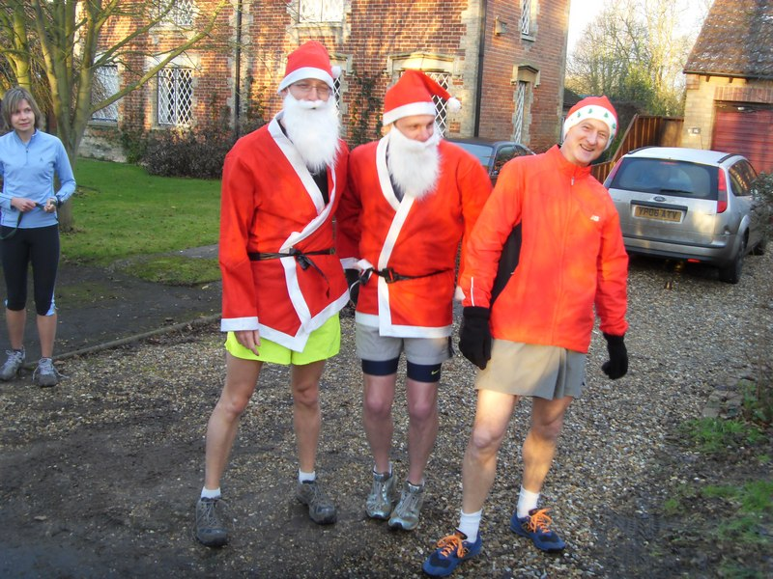
Natalle sees treble: Steve Tovey, Kevin Fox and Charlie Barker at Woodditton, December 2008

Tony Hall has, once again, kindly offered to provide support, with refreshments at checkpoints in Reach and at the Chalk Pit.

As it is necessary to coordinate transport from Ely to the start in Woodditton, please let John Turner (secretary@elyrunners.co.uk) know as soon as possible if you would like to run, indicating how far and whether you would be able to drive runners to the start or one of the other two checkpoints.

Following the run, members and their families/friends are invited to a carvery lunch (£8.95 per person) at 1pm at the High Flyer pub (adjacent to the Paradise car park). Please let Julie Foreman (julie@elyrunners.co.uk) know as soon as possible if you would like to attend, as she will need to book places shortly.

New Year’s Eve 10K – marshals needed
Brenan Morgan still needs a lot more marshals for the club’s New Year’s Eve 10k. If you are available for a couple of hours that morning to help, please let Brenan know as soon as possible (morgan191@ntlworld.com). The race starts at 11.00am in Main Street, Little Downham and the race HQ will be in the Village Hall, Little Downham, as in previous years.

Club Cross-Country Championships

The club’s cross-country championships will be held on Sunday 3 January 2010, on the c. 5-mile course starting from Ely Common at the top of Waterboard Hill. Please let organiser Steve Tovey (stevetovey@elyrunners.co.uk) know if you would like to run, or if you can help as a marshal or official.

Runners should meet at the Paradise car park at 9:30 am for a 10:00 start on Ely Common. Entry is free of charge to members and their invited guests. As this is a club event, please run in your club race kit. The course is suitable for trail shoes or (just about) an old pair of spikes. Road shoes are also suitable but not ideal in wet conditions.

There are perpetual shields (only club members are eligible for these) for the 1st M/F and 1st Age Graded M/F. Acting Chairman, Stephen Howard, will present these in the upstairs bar at the Paradise Centre at 11:30 am.

Ely Runners’ Annual General Meeting
The club’s AGM will be held on Monday 1st February 2010 at 7:30 pm at the Paradise Centre in the bar conference room. This is an important club event, so please try to attend.

During the meeting the following awards will be made:
- Eric Drury Shield: Most Improved New Member Runner
- Most Improved Female Runner
- Most Improved Male Runner
- Best Half Marathon
- Eric Drury Cup: Best Marathon
- Special Achievement Awards

Nominations and/or volunteers for the Committee and items for the agenda should be forwarded to John Turner (secretary@elyrunners.co.uk) as soon as possible.

SUBSCRIPTIONS and REGISTRATION
Subscriptions (£10) for existing members of the club are due by 1st January or on joining the club. (N.B. An exception is those members who joined after 15th November, whose subscription will cover them for 2010.)

Existing members who have not renewed by 1st January will be reminded by e-mail. If you do not renew by the end of March, you will be removed from the membership list.

Subs can be renewed online at www.elyrunners.co.uk > CLUB INFO > Membership. Please check you have renewed your subscription or you will not be entitled to attend training, represent the club in races, take part in club championships, claim affiliated entry fees, or wear club colours.

Benefits of membership of Ely Runners
The club’s open events contribute considerably to the club’s reputation and financial stability. This enables the club to provide many benefits (see below) and in return, members are expected to support the club by helping with the club’s open and private events.

The benefits of membership of Ely Runners include the £2 affiliated discount on open race entries, club affiliations to ARC, ABAC, UKA, EA, TRA, FRA & CAA, free registration (£5) with EA until 31st March 2010, free changing and showers at the Paradise Centre, free training and coaching advice, free night training bib, £12 subsidy on club fleeces, 10-20% discount at most specialist running kit shops, free entry to the club’s private events, free entry to the six Frostbite League races, free club team entry to county, regional and national championships and for club relay entries, entry into the draw (if a member’s ballot entry is rejected) for the club’s guaranteed London Marathon places, free snacks at club social events, shared transport to races and, most importantly, the friendship, stimulation and enjoyment of collective training and racing.

England Athletics Registration
To take part in UKA National and SEAA championships, members need to be registered with England Athletics (EA). Also, a few open events still require EA registration to claim affiliated entry fees. However, most events (especially locally) either have ARC permits or, if they have UKA permits, require only membership of an EA affiliated club, like Ely Runners. This year (2009-10) 35 members requested registration with EA. Please could members who would like to be registered from 1st April 2010 with EA for 2010-11, please contact John Turner secretary@elyrunners.co.uk. Subject to agreement at the AGM, the club will pay the £5 registration fee. Registration number confirmation and cards will be supplied when received from EA.

SOCIAL EVENTS
Christmas Drinks
The Christmas Drinks and draw for the club's London Marathon places will be on Thursday 3rd December this year. (The draw is open to members who were unsuccessful in the ballot for places in next year’s VLM.) Adam and Natalle Etches will once again be organising a raffle in aid of East Anglian Children’s Hospices. The venue this year will be The Cutter on Waterside. Please let John Turner (secretary@elyrunners.co.uk) know as soon as possible if you would like to attend or be included in the London Marathon draw.

To be eligible for the draw for the club’s three London Marathon 2010 places, you must have applied and been rejected in the ballot and provided evidence of rejection to John Turner prior to the draw. If you have not yet advised him about being rejected in the LM ballot and would like to be in the draw, please let him know before Thursday.

After Training Drinks
Social Secretary, Julie Foreman, organises the club’s 1st Thursday in the month After Training Drinks. As the club’s Christmas Drinks are on Thursday 3rd December, the next after training drinks are therefore on Thursday 7th January 2010.

FORTHCOMING EVENTS
Frostbite Friendly League
The third FFL race will be at Hinchingbrooke Park, Huntingdon on Sunday 13 December. The course is comprised of soft (sometimes muddy!) paths and tracks.

The club is currently 9th out of 17 teams in the senior league – an improvement from 12th after the first fixture but still disappointing when compared with recent performances in the league.

The junior team is now in 10th place (out of 13 teams), following strong performances from 4 members in the November fixture.

Junior races start at 10:15 am and Senior races start at 11:00 am. Any junior members wishing to take part should contact Alan Rutterford at alan@elyrunners.co.uk. Senior members should meet at the Paradise Centre car park at 9.15am to share transport.

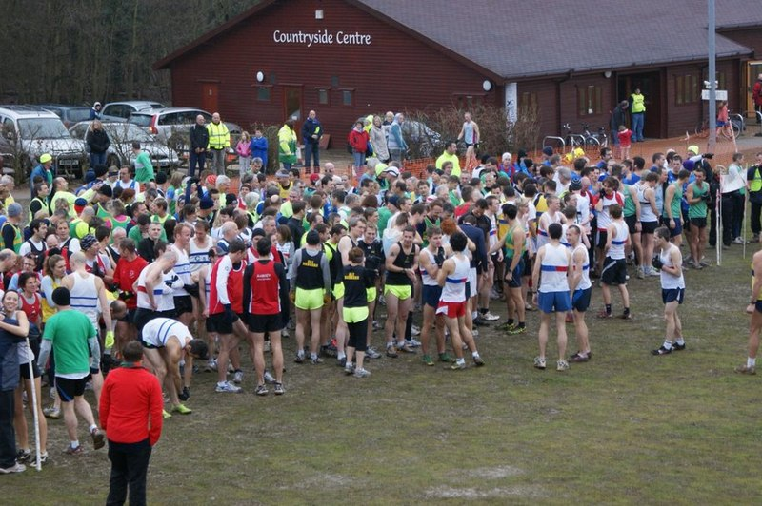
Before the start, Hinchingbrooke Park, December 2008

Remaining fixtures:
13 December 2009 Hinchingbrooke Park (Hunts AC)
17 January 2010 Ramsey Sports Centre (Ramsey Road Runners)
7 February 2010 Bourne Woods (Bourne)
7 March 2010 Huntingdon BRJ Club (BRJ)

Further details are available on www.frostbiteleague.org.uk.

Cambs AA Cross-Country Championships
These will be held on Sunday 10th January, 2010 at Priory Park, St Neots (the same venue as the October Frostbite race). Historically, the club has done well at these championships, though last year the turn-out was disappointing, so club captain, Charlie Barker, would like to encourage as many members as possible to take part this time. The following races will be held:

U11 girls & boys 11.15 1.5k
U13 girls 11.30 3k
U13 boys 11.35 3k
U15 girls 12.00 4.3k
SM/vets/U20JM 12.30 10k
U17 ladies 13.25 5k
U17 men 13.30 6k
SL/vets/JL 14.00 6k

Vet age groups are: Men 40/50/60 Women 35/45/55

To be eligible, you must have been born in Cambridgeshire or have 9 months prior residency. Members who perform well could be selected to run for the County.

The club will pay for team entries. Anyone wishing to run should contact Team Captain Charlie Barker well before the 30th December closing date on: charlie@xanzoe.freeserve.co.uk or 01353 778335 or 07908 436489 or at training.

On the list so far are: Alice Campbell, Daniel Mould, David Mould, Heidi Fochtmann, John Turner, Lionel Smith, Max d’Ayala, Nathan Pennington, Robert Campbell, Stuart Baumber.

SEAA Cross-Country Championships 2009-2010
The dates for the SEAA cross-country championships are as follows:

Saturday 30 January 2010 - Parliament Hill, Hampstead Heath
SEAA Cross-Country Main Championships
U13BG, U15 BG, U17MW, U20MW, SMW (closing date 3 December)
(Vets run as seniors)

Entries requested so far: Alice Campbell, Ian Day, John Turner, Robert Campbell, Stuart Baumber.

Sunday 14 March 2010 - Trent Park, Cockfosters, Herts
SEAA Masters Cross-Country Championships

To be eligible, members must have been born in the region or had 9 months of continuous residency. If you qualify by birth and residency for different regions, you may only run for one region during each competition year from October to September.

If you would like to run, please contact Charlie Barker, as above.

ARC Championships 2009
ARC Postal Marathon Championship 2009
Please send your best 2009 result to The ARC Championship Secretary, Ian Vaughan-Arbuckle, at championshipsecretary@runningclubs.org.uk.

Conditions of entry:
- You must be a member of an ARC-affiliated club
- The race must have been run under ARC/UKA rules and over a certified distance
- Your personal result must be verifiable either on a printed result list or on a race website
- The race must have been run during the period 1st Jan - 31st Dec 2009
- Application must be made in writing to Ian V-A’s email (championshipsecretary@runningclubs.org.uk), giving the following details:
Full name, gender, club. Age on race day. Name and date of race. Finishing time (gun to tape)
- Awards will be made at the discretion of the ARC committee.
- There is no entry fee.

Full details are available on the ARC website: www.runningclubs.org.uk > Championships

ECCA National Cross-Country Championships
The ECCA National Cross-Country Championships will be at Roundhay Park, Leeds on Saturday 27th February for all age groups from under-13 to Seniors. If you’d like to run, please contact Charlie Barker (captain@elyrunners.co.uk) ASAP to that he can make the team entries. Closing date for receipt of entries by ECCA is 11th January.

So far the following member has requested entry: Ian Day.

ODDS AND ENDS!
Cheap accommodation whilst racing away
John Turner has spotted that the Travelodge £9 sale has started for dates between 1st Feb and 6th June 2010 - great if you already have an idea of races you might be doing next year. For further information, see http://www.travelodge.co.uk/saver_rooms/

Any old t-shirts?
If you have any cotton rags (especially old t-shirts and towels) for disposal, please bring them to training and give them to John Turner so that he can take them to the Wells & Walsingham Light Railway for cleaning the steam locomotive and rolling stock.

RESULTS ROUND-UP
Alan Rutterford has provided the following report on the junior team’s performance at the November Frostbite Friendly League race:

On Sunday 8th November, 4 Ely Runners Juniors (also members of East Cambs Athletics Club) ran in the second race of the Frostbite Friendly Winter League at Bushfield, Peterborough. The weather was sunny but a little cold and the race was run on cycle and footpaths, with the distance being between a mile and mile and a half. Alexander Ellwood came home in 45th place in 9.41, with Nathan Pennington in 61st place in 10.05, Molly Butler in 71st place in 10.22 and Esme Wright in 78th place in 10.34. (There were 136 runners in total.) This race was the first race for Nathan, Molly and Esme, so club & ECAC coach Alan Rutterford was very pleased for them. The winner was James Downing of Hunts AC in 7.12. There has to be a minimum of 5 to score in a team and one must be a girl, so with a runner short Ely can make more progress in next months.

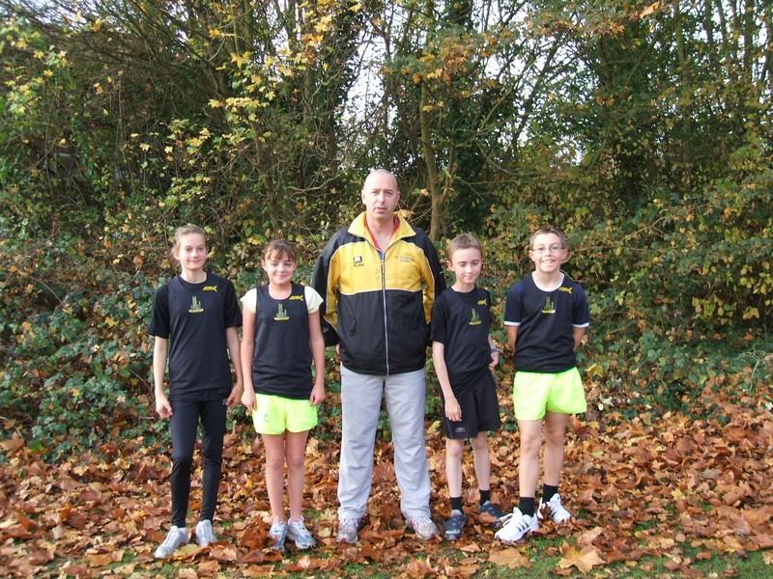
Alan and the junior team

In the senior race, Kieran Drane and Stuart Baumber were amongst the 8 members who set new 5-mile PBs in the senior race. Both then went on to run the St Neot’s Half-marathon the following weekend, where Stuart recorded another new PB, whilst Kieran consolidated his fine performance in October’s Great Eastern Run in Peterborough (a PB by 4 minutes) by recording a time only a few seconds slower over a much tougher course.

Once again, the club entered several teams in the Hereward Relay. A huge “thank you” is due to Alan Rutterford for coordinating this event for the club. It was another enjoyable and successful long distance relay, with 7 teams from the club taking part. Not only did Alan recruit runners for all the teams and oversee all the transport arrangements. He also took on responsibility for marshalling the section of stage 4 from Little Downham to Ely, which meant he was out on the course for several hours.

See Alan’s lively report below, for an insight into what it takes to organise this event for the club:

With a few weeks to go to the event I was still recruiting runners for the event and only had enough for 3 teams. It was very disappointing as the club has grown to 140 members, we’d had such a brilliant result at the Round Norfolk Relay and we usually have 7 teams in this event.

I sent out more emails and gradually more people put their name down, but it was always going to be a struggle to find marshals. For some reason this club is terrible for getting marshals for events and that is why I told Brenan Morgan as I have Darren [Murfitt] in previous years to leave it to me as they get stressed trying to recruit for other events.

Luckily Tony Hall as always and Natalle Etches offered to be recovery drivers. This is a very important job and timing is of the essence, but I knew they would do a good job. As always Eric Drury offered to do the finish area again, so with 2 weeks to go things were starting to take shape.

March AC kept phoning to see if we had enough marshals, as they had supplied 10 for our events and wanted the favour returned, but all I had was myself, and so as not to be too embarrassed by the lack of help from our club I told them I had.

With a week to go I had Simon Jackson and Steve Barker drop out with flu and Matthew Holmes with an injury, just what I was dreading. It was going to be a struggle to find last-minute recruits. The easy way out would have been to drop a team with 1 runner being disappointed but, a glutton for punishment, I got Rod to send a desperate plea for runners. With only 4 days to go, Craig Holgate, David Mould and Max D’Ayala came to the rescue (many thanks guys!) and with 2 days to go I got an email from Aimee Hockley who was in Somerset at the time saying she would be a reserve (thanks Aimee), so again it was race on.

With days to go March AC were still calling to check on things and how many marshals I had. Yep, still got enough I told them, but in reality it was only me and John Glover for sure, but Stuart Baumber and Adrian Stokes said they would offer. Many thanks to you both for running a leg and spending 3 hours marshalling in all weathers. I was busy checking my phone and emails Saturday in case someone else dropped out, but luckily they didn’t.

I had decided that rather than have the same old boring Ely A, B, C etc I would give them names like most other clubs and hopefully have a different topic every year. Would be nice to have feedback on your thoughts or whether you would prefer the ABC etc again.

On the day, I had to get up at 6am, which is normally a lie-in as I usually get up at 3.30/4am, but my lovely girlfriend, Ellie, and I had been out the night before and all I wanted was a lie-in for once, but NO, up you get and press on.

I made a flask and grabbed a cereal bar as I loaded the car and had to go to the club stores to collect 20 cones that March AC needed for the Welney changeover. I loaded them up and got to the football club at 06.50 and Tony & Stephen Howard were already there. I had to sort the numbers out, give them pins and last-minute instructions, and they were away at 07.05 - only 5 mins late, not bad.

Once they were away, I had to nip the cones over to Welney and return for the stage 2 runners at 8am. I got back and started marking out around the rugby club before attending to the stage 2 runners. They were away at 08.05, again only 5 mins late, so things were going well.

I had a quick drink from the flask before meeting Peter Jackman to mark out near Little Downham. We did that and then I finished marking more out at the finish area with him.

Before I knew it, the stage 3 runners were there at 09.30 and again I gave them their numbers etc and they were away 5 mins EARLY (this must be a first). By now the Rugby club were chasing me for marshals we had promised and March kept asking if they were turning up soon. “Yep,” I told them both (HELP !!!!) getting a bit stressed by then. I finished marking the last bits of the course at last and had my cereal bar.
Stage 4 runners had turned up by now at 11.00am and were away on Time. Yippee, I thought, that’s the runners dealt with, now all the cars to deal with.

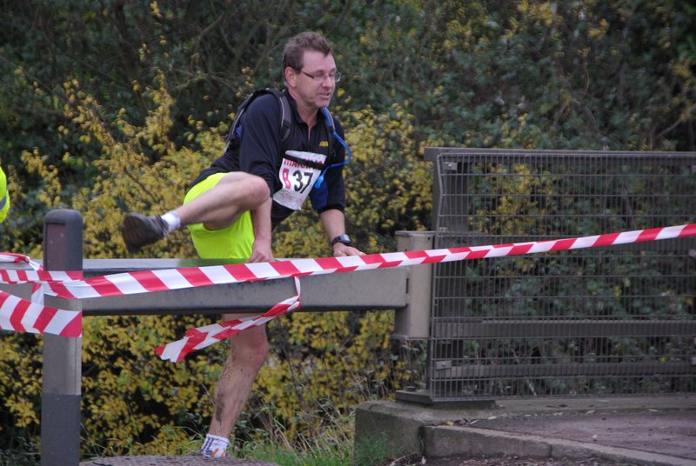
Ian Rutherford in full flight on stage 2

By now John Glover had turned up and Stuart and Adrian had returned from running stage 1, so we discussed our strategy, not knowing what a nightmare it was going to be.

We were in place by 12.30 and after all morning being sunny and lovely, the skies opened and it rained cats & dogs, so we were all soaked before the first runner came past. The traffic was getting busy at they had a football match, hockey match, rugby tournament , golf and all the runners trying to park anywhere. We were snowed under by traffic and trying to direct the runners and 3 hours later we stood down, tired, wet and dying for a hot drink. With 140 members, who came to help us so we could have a break? NO ONE!!!

My day still was not over as it was going to take me an hour to take all the signs etc down and back to the club stores. Luckily, Ellie and Eric Drury turned up and helped, so everything was packed up and in the stores and at 4.30pm I had finally finished. Some 10 ½ hours on the day. Anybody fancy the job next year?

The race was won by St.Edmunds Pacers A in 3:47:23. There were 115 teams entered, but only 106 finished. Amongst those were 7 Ely Runners teams:

5th Ely Cheetahs 4:02:22
7th Ely Tigers 4:11:34
11th Ely Leopards 4:24:53
31st Ely Panthers 4:44:23
41st Ely Lions 4:49:10
78th Ely Pumas 5:22:55
87th Ely Cougars 5:31:12

Alan Rutterford
November, 2009

CONTRIBUTIONS TO THE NEWSLETTER
As ever, please send your contributions to the newsletter to me (Rachel Roberts) at: newsletter@elyrunners.co.uk. Many thanks!

RACES & EVENTS GUIDE 2009/10

This includes local area/easily accessible races, club, county, regional and national championships, and a selection of UK/overseas events previously enjoyed by members.

December
03 (Thu) Ely Runner’s Christmas Buffet & Drinks, 2030 Cutter Inn, Ely
04 (Fri) Cambs AA AGM 1930 at Hemingford Grey Conference Centre
06 Nene Valley Harriers 10m, 1030 Peterborough, £7, EOD +£1
13 Frostbite League 5m (soft paths & tracks), 1100 Hinchingbrooke Park, Huntingdon (meet
Paradise Centre 0915 to share transport)
13 Bedford ½ Marathon, 1000 Wotton Upper School, Beds, £15.50 (no EOD),
www.bedfordharriers.co.uk
13 Bunwell Santa Fun Run, 5k/3k, 1100 Bunwell Village Hall, Bunwell, Norfolk, £10,
www.bunwellstrollers.co.uk
13 Buxton 5k Xmas Fun Run, 1030 (-15 at 1130), Buxton Norfolk, £5 (-15 £2),
n.marnold57@btinternet.com
20 Club Pre-Christmas training runs, Woodditton to Ely 18.5m, Woodditton to Reach 7.5m,
Reach to Ely 11m. Meet 0800 Paradise car park for transport to starts. Contact JT to run.
Lunch afterwards at the High Flyer at 1300 - contact julie@elyrunners.co.uk to book
26 (Sat) Boxing Day training, meet 0900 Paradise Centre car park
28 (Mon) Buntingford Year End 10m, 1030, Edwinstree School, Norfolk Rd, £12, no EOD
31 (Thu) The 10th Ely New Year's Eve 10k Road Race, 1100 Lt Downham, entries on-line
only, no EOD, www.newyearseve10k.co.uk RACE FULL - entries closed

January 2010
01 Wymondham New Year’s Day 10k, 1100 Central Hall, £8, EOD +£2
03 Ely Runners Club Cross-Country Championships, 5m/8k, meet 0930 Paradise for
1000 start on Ely Common (private ER event – entries to Steve Tovey).
10 Cambs AA XC Championships, Priory Park, St Neots (entries to Charlie Barker)
17 Frostbite League 5m (sports field, droves, farm roads), 1100 Ramsey Sports Centre
(meet Paradise Centre 0915 to share transport)
24 Folksworth 15m, £15, on-line entry only via Runners World, no EOD
30 (Sat) SEAA XC Championships, Parliament Hill Fields, Hampstead Heath, London,
-13B/G, -15 B/G , -17 M/W, -20 M/W, SM, SW. Club entry if teams of 4 women or 6 men,
otherwise individuals. Entries to Charlie Barker, www.seaa.org
31 Reedham 10m, 1100 Village Hall, Reedham, Norwich, £10, EOD +£2

February
01 (Mon) Ely Runners Annual General Meeting, 1930 Paradise Centre, upstairs bar room
07 Frostbite League 5m (soft & firm woodland paths and farm droves), 1100 Bourne Woods,
Lincs (meet Paradise Centre 0845 to share transport)
07 Gt Bentley ½ Marathon, 1030 Gt Bentley Village Hall, Essex, £16
14 St Valentine’s Day 30k, Stamford (further details to follow)
21 Elgood’s Brewery Great East Run 20k, 1100 Bungay Sports Hall, £15, EOD +£3
27 (Sat) ECCA National XC Championships, Roundhay Pk, Leeds. Entries via Charlie Barker
28 SEAA ½ Marathon Champs, Tunbridge Wells Half Marathon

March
06 Grantham Canal Run 29.3m, 0930 Cotgrave Leisure Centre, £25, no EOD, CD 28/2
07 Frostbite League 5m (roads & firm paths), 1100 BRJ Club, Huntingdon (meet Paradise
Centre 0915 to share transport)
07 Wymondham 20m 1000 Central Hall, Wymondham, £10.50, EOD +£2
07 Newton’s Fraction Half Marathon, 1030 S Kesteven Stadium, Grantham, £10, EOD +£2
14 SEAA Masters Cross-Country Championships, Trent Park, Cockfosters, London (further
details to follow)
14 Silverstone Half Marathon
21 Ely Runners Turing Trail Relay, 35.5m Ely-Cambridge-Ely (private self-navigation ER
team club event – entries to Steve Tovey)
21 SEAA 12/6 Stage Road Relays, Milton Keynes
27 (Sat) 1900-1930 Frostbite League Presentation Evening, (hog roast & live music by
Skyliners), Abbey College, Ramsey. Tickets £12.50 from Adrian Graham, 01487 812829 or
ramseyrunners@yahoo.co.uk
28 SEAA Inter Area (Road Race) Match, Eastleigh 10k

April
25 London Marathon

May
09 Eye 10k, Eye nr Peterborough (further details to follow)
23 March 5m Spud Run, 1100 Elm Rd Sports Field, March, £tba
29/30 (Sat/Sun) SEAA U15/U17 SEAA T&F Champs – venue tba

June
10 (Thurs) Ely Runners 10k Club Handicap, Little Downham
12/13 (Sat/Sun) SEAA U20/Senior T&F Champs – venue tba
19-20 (Sat-Sun) BMAF T&F Champs, Alexander Stadium, Birmingham (prov date & venue)
27 N Devon Marathon & 1/2 Mar, 1000 Woolacombe, £20/£18 www.northdevonmarathon.co.uk

July
08 (Thurs) Ely Runners 1m Club Handicap, Amherst sports field by railway station
15-24 European Masters T&F Champs, Nyiregyhaza, Hungary
24/25 (Sat/Sun) SEAA Combined T&F Events (all age groups), Barnet Copthall

August
28 (Sat) U15/U20 SEAA Inter-Counties T&F Champs, Barnet Copthall

September
05 The Beast (13m multi-terrain), Corfe Castle, Dorset, www.poole.ac.co.uk
12 Ely Standard 20th Grunty Fen Half Marathon, Witchford
25 (Sat) SEAA 6/4 Stage Road Relays (senior men & vets) – venue tba
26 SEAA 6/4 Stage Road Relays (women & young athletes) – venue tba

October
03 SEAA 10k Road Race Champs – venue tba
23 (Sat) Beachy Head Marathon, South Downs, Eastbourne

December
31 (Fri) Ely New Year’s Eve 10k Road Race, Little Downham

NOTES

Races and events are on Sunday unless otherwise mentioned.

Race entry fees are the affiliated (ARC/UKA or just UKA registered) fees

Courses are roads and/or hard footpaths/cycle ways unless otherwise mentioned.
Distances without units (m or k) are probably m = miles.
Frostbite League races are 5-6 miles and entry (league membership) is paid for by the club.
Further details of events from the Club notice board in the Paradise Centre foyer, running magazines, websites, or from John Turner secretary@elyrunners.co.uk) who also has details of all RRC/TRA long distance road/TR/XC races and FRA fell races.

National, regional and county championship team entries are via Charlie Barker (captain@elyrunners.co.uk).

Ely Runners’ private club XC championships, 10k/1m handicaps, and TTR relay entries are via Steve Tovey

Long distance team relay entries are via Alan Rutterford and paid for (if funds available) by the club.

Social Events are via Julie Foreman

Club website www.elyrunners.co.uk
Grunty Fen 1/2M website www.gruntyfen.co.uk
NYE10k website www.newyearseve10k.co.uk
Turing Trail Relay website www.turingrelay.co.uk (private club event for 2010)
Association of Running Clubs www.runningclubs.org.uk

Rachel Roberts
December 2009
newsletter@elyrunners.co.uk

USEFUL INFORMATION

Data Protection
Email circulations by the club to members are done by the Bcc (confidential) option so that member’s email addresses are not circulated and also these do not take up most of the first page of emails.
We now specify Ely Runners’ policy on data protection and use of photos and videos on the club’s website on www.elyrunners.co.uk > CLUB INFO > administration.

Membership
Subscriptions (£10) are due by 1st January or on joining the club. Those joining after 15th November are covered for the following year. Existing members who have not renewed by the due date will be reminded by e-mail. Those who have failed to renew by the end of March will be removed from the membership list. Subs can be renewed on-line at www.elyrunners.co.uk > CLUB INFO > Membership. Please check you have renewed your subscription or you will not be entitled to attend training, represent the club in races, take part in club championships, claim affiliated entry fees, or wear club colours. The club’s open events contribute considerably to the club’s reputation and financial stability. This enables the club to provide many benefits (see below) and in return, members are expected to support the club by helping with the club’s open and private events.

Benefits of membership include:
- £2 affiliated discount on open race entries
- club affiliations to ARC, ABAC, UKA, EA, TRA, FRA & CAA
- free registration (£5) with EA until 31st March 2010 (on request via John Turner)
- free changing and showers at the Paradise Centre
- free training and coaching advice
- free high-visibility bib for night-time training
- £12 subsidy on club fleeces
- 10-20% discount at most specialist running kit shops
- free entry to the club’s Cross-Country Championships, 10k Handicap and Straight Mile Handicap
- free entry to the six Frostbite League races
- free club team entry to county, regional and national championships and for club relay entries
- entry into the draw (if a member’s ballot entry is rejected) for the club’s guaranteed London Marathon places
- free snacks at club social events
- shared transport to races

Supporting the Club and its Events
Ely Runners hold two popular open races each year (Grunty Fen Half Marathon and Ely New Year’s Eve 10k Road Race) that contribute considerably to the club’s reputation and financial stability. This enables the club to provide the many benefits listed above. In return, members are expected to show commitment to the club by helping with these events and taking their share of responsibility. Please don’t just rely on the usual loyal helpers and think of the club only as a convenient way to promote fitness and enter races. We’re all busy these days but commitment is realising the mutual benefits of putting something back into the club and sport we enjoy.

Training
For details of club training sessions at 7pm on Tuesday (intervals/hills) and Thursday (steady 5-8m runs) evenings, please see the homepage of the club’s website. Details of 9am Sunday morning training runs are usually circulated by email a few days in advance.

When meeting at the Paradise Centre for training on Tuesdays and Thursdays, please assemble either in the balcony/bar area upstairs or outside, around the corner by the side of the building. Please do NOT assemble in the foyer or outside the main entrance.

The meeting place for Sunday morning runs is the Paradise car park. The car park toilets are open by 9:00 am and the Paradise Centre is open for showers afterwards.

Please ensure that new members, some of whom are new to running, feel part of the club and are not left alone on training runs.

Club training sessions are intended to cater for a wide range of abilities and racing objectives. If you require specific coaching advice, please ask Club Coach Alan Rutterford to help.

To measure the distance of a route before or after running, see Google Earth > Ruler (toolbar symbol) > Path. Provided measurement is done carefully, the distance should be of similar accuracy as GPS.

Club Noticeboard
This is in the foyer of the Paradise Centre, to the right of the main entrance. It includes details of club events, training sessions, route maps, local races and other events of interest to members. There are usually several copies of race entry forms on the board but please leave the last copy or ask staff at reception to photocopy (Ely Runners' account) a few more copies.

Club Website
The Ely Runners’ website (www.elyrunners.co.uk) is maintained by Club Webmaster Rod Baron who ensures that it provides an up-to-date record of the club's activities and a myriad of useful information. The website is frequently updated and well worth regular visits. For member’s general comments, there is a Message Board on the website’s home page and the photo and video section contains a huge selection of members in races. Rod also maintains the club’s websites for the Grunty Fen Half Marathon, New Year’s Eve 10k, and Turing Trail Relay.

Club Library
Grade 2 coach Max d'Ayala has obtained several books on running and injuries for the club. These books are in the club's locker at the Paradise Centre for use by members. There is a club book list on the web site. Borrowed books are to be recorded in a notebook in the club's locker. These books have been chosen carefully by Max to provide a combination of interest, information, advice and stimulation for all standards of runners.

John Turner has the latest (2009) Fell Runners Association Fixtures Calendar & Handbook. Members interested in running a fell race can borrow this booklet. Most fell races are ‘up north’, though there are also many in Wales and other hilly areas of the UK. There is a huge choice throughout the year, including many evening races in the summer, some not too far away in areas like the Peak District. Alternatively, if on holiday in such areas, you can often find a local fell race. They provide an enjoyable, challenging and worthwhile experience, even for Fenland-based runners.

A recent addition to the club’s library includes ‘Feet in the Clouds – A Tale of Fell Running and Obsession’ by Richard Askwith.

Racing
Some open races are very popular and reach the entry limit before the race day. Many races no longer accept entries on the day (marked ‘no EOD’ in the Races & Events Guide). If you are thinking of entering a race on the day, check with the organisers or on the race website before setting out that a place is still available – turning up does not guarantee that the organisers will allow you to run!

Wearing Club Kit
Members wear their Ely Runners’ colours with pride in races far and wide (see www.elyrunners.co.uk > RESULTS) and are encouraged to do so whenever appropriate. Guidelines to wearing Ely Runners' colours (minimum club vest) in all events entered as an individual or team member of Ely Runners are as follows:
1. Obligatory requirement of governing athletic organisations in leagues entered by the club, relays entered for or by the club, all championships and events incorporating championships. Exceptions are members running for county, regional or national teams when they will be given the appropriate team kit to wear.
2. Necessary to avoid disqualification as a team member in open races.
3. Members normally wear their club kit in open races but there are recognised exceptions such as representing a charity, necessary kit change in an ultra run, spur of the moment race entry, non-availability of kit for whatever reason etc.
4. Not wearing club kit also makes it harder for other runners, race officials, and photographers to distinguish club runners, especially in relays.
5. Our distinctive race kit defines us as ambassadors of a well-respected running club.

Race Results
When you send your race results to Stephen Howard (results@elyrunners.co.uk), please advise if you have achieved a PB, including vet categories, so that it can be included in press reports and to update PB information on the website. If possible, please send any information you have (including links to race results) by noon on Monday to Stephen to avoid the extra work involved in updating press reports. Please email any photographs or links to event photographs (with your race number) to Rod Baron at webmaster1@elyrunners.co.uk.

All notified results (from 25th October 2008) mentioned in the ER website Race Reports will have an age-graded % score calculated on uninterrupted running such as on the track or in a road race. This will be displayed on the results data base table (www.elyrunners.co.uk > RESULTS > Database, "View Most Recent Results") or the direct link is http://www.elyrunners.co.uk/MySQL_Results/View_Results.php?a=reset. In the past we only calculated age-graded scores for PBs or Club Records. Your best age graded score is taken from the results we have so far and displayed on the table "Most Prolific Racers" direct link http://www.elyrunners.co.uk/MySQL_Results_stats/query_3.php. Some members may not yet have a result where an age-graded score has been calculated. Where a result does not have a time or where the race distance is over 40 miles, the age-graded score will be shown as 0. There is a running average of all age-graded scores for each member. Scores of 0 will not be included in the averaging.

Several members have put themselves on www.athleticsdata.com. This is a statistical website showing:

- UK year rankings
- All-time rankings
- Comprehensive results service
- Athletes’ profiles

This website will enable you to check your form relative to rival runners and allow them to do the same. It’s also useful for the prediction of race results for both runners and organisers.

Payment of club entries into championships, relays and leagues will be funded by the club provided they are team entries made by the club. The club will not pay for individual entries into open races that have an incorporated championship.

To take part in UKA National and SEAA championships, members need to be registered with England Athletics (EA). Also, a few open events still require EA registration to claim affiliated entry fees. However, most events (especially locally) either have ARC permits or, if they have UKA permits, require only membership of an EA affiliated club, like Ely Runners. This year (2009-10) 35 members requested registration with EA. Please could members who would like to be registered from 1st April 2010 with EA for 2010-11, please contact John Turner secretary@elyrunners.co.uk. Subject to agreement at the AGM, the club will pay the £5 registration fee. Registration number confirmation and cards will be supplied when received from EA.

To enter a County (eg Cambs AA) or Regional (eg SEAA) Championship, members must have been born in the county/region or had 9 months of continuous residency. If you qualify by birth and residency for different counties, you may only run for one county/region during each competition year from October to September.

Club vets who are not members of EVAC may run as guests of the club’s EVAC members in EVAC Championships. EVAC events are included the list below and can be entered by email to eastvetm75@ntlworld.com. Subject to the availability of funds, the club will pay for club team entries to EVAC and BMAF Championships. EVAC website: www.evac.org.uk

BMAF (vets) events are too numerous to include all of them but they have been circulated to EVAC members via regional and national veteran magazines or see www.bmaf.org.uk/fix/fix.asp

Running Kit
Mary Gates oversees the club’s kit supplies. The club’s joining fee of £33 includes a free club race vest and shorts. Please contact Mary on 01353 861379 or mary@elyrunners.co.uk to order. See www.elyrunners.co.uk for full details of club kit.

New club vests now have the Ely Runners’ cathedral logo top centre on the front. Any members with older vests who would like to have the logo added will need to give their vest to Mary to send. The cost (£1.20 for the transfer + 25p for application) will be covered from club funds. Race vests will continue to have ELY RUNNERS on the back.
Club fleeces are available from Mary Gates at the subsidised price of £10 to members only. This price is for one fleece per member. Subsequent fleeces will be at the cost price of £22.
.

Discounts on Kit Purchases
If you buy running kit from Advance Performance at Cambridge or Peterborough, please show them your membership certificate and the club will receive 10% towards vouchers that we use for prizes for our Christmas charity raffle. Advance Performance do not otherwise give discounts although these can be usually be obtained from running shop suppliers such as Sweatshop in Cambridge who sponsor our open races. Sweatshop usually give 10-15% on non-sale items to members (show membership cert) of Ely Runners.

Natalle Etches has purchased a wide variety of fitness stock from a local Internet fitness company that closed down. She is re-selling the stock as low as half price to club members. The stock includes cycling, running, fitness and triathlon wear from brand names including Craft, Gore Bike Wear, Pearl Izumi, and Sugoi. If you’re interested, speak to Natalle at one of the training sessions or contact her on natalle@elyrunners.co.uk.

Social Events
Julie Foreman organises the club’s After Training Drinks on the first Thursday of the month.

