Ely Runners Newsletter

AUGUST 2009



NEW MEMBERS
This month we welcome the following new members of the club:

Andrew Balmford
Jason Mann
Ian Rutherford

IRONMAN NEWS
The mere thought of an Ironman event is enough to make most of us turn pale and start making excuses about how bad our swimming/cycling/running is. Ian Green has just tackled Ironman Switzerland (his third Ironman event) in swashbuckling style: a sub-13 hour time for the 3.8k swim, 180k cycle and 42.2k run is no mean feat! With far less training under his belt than in the run-up to either of the previous events, Ian was feeling far from confident as he lined up at the start of the swim (though, rumour has it, that didn’t stop him from setting himself an ambitious target in the bar beforehand…) However, Ian demonstrated that completing endurance events is as much about mental strength and the refusal to give in when the pain sets in as about physical preparedness. When the swim, usually a strong part of any triathlon for him, didn’t go according to plan, Ian regrouped and then used his experience to help him reclaim the ground he had lost throughout the cycle and the run.

For a full (and frank!) account of Ian’s experiences, visit the Results page on the website.

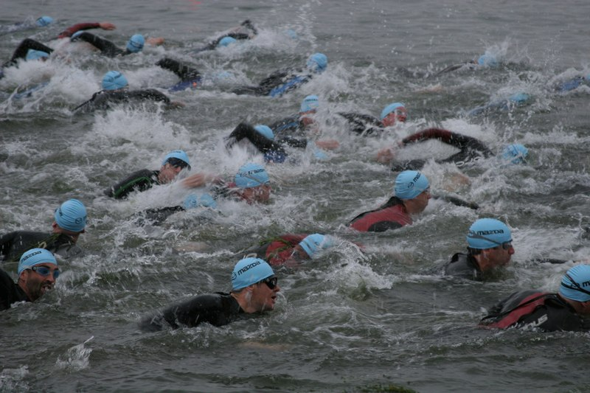

Meanwhile, David Richards is making the final preparations for his Ironman debut at Ironman UK in Bolton on 2 August. He is raising money for EACH (East Anglian Children’s Hospice) and has made the following plea to members:

“I've managed to avoid any bicycle/car collisions this year so I'll be doing the UK IronMan this Sunday (2nd August) in Bolton.
2.4 mile open water swim, 112 miles on the bike, then run a marathon at the end to finish off with.
First time I've done this distance triathlon, and it will probably be a while before the pleasure police (a.k.a the wife!) gives me the green light to do another, due to the long hours spent training over the last seven months - leaving her to manage with the kids!!
Given that it's a big event and one I'll get very few chances to pursue in the future, I am raising sponsorship for a local charity; EACH (East Anglian Children’s Hospices).
If anyone would like to donate they can do so at the following link....
http://www.justgiving.com/ironmandavid/
Thanks and regards,
David Richards.”

David is joined on Sunday by Ian, who will be attempting to complete the Double Ironman event. We wish them both the best of luck.

FORTHCOMING EVENTS

Round Norfolk Relay
The club’s two teams in this event (held over the weekend of 19th and 20th September) are beginning to take shape. Alan Rutterford (alan@elyrunners.co.uk) and Simon Jackson will be in touch shortly with those who have already volunteered but are meanwhile still looking for both reserve runners and helpers.

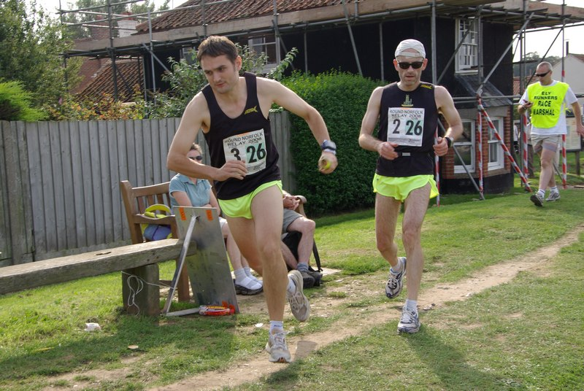
RNR 2008 –
John Manlow hands over to Simon Jackson whilst Alan Rutterford takes the time

SEAA Road Relay Championships
These will be held in Aldershot over the weekend of 26th and 27th September. The senior women’s and veteran women’s events (4 x 3851m) will be held on the Saturday, whilst the senior men’s (6 x 6k) and veteran men’s (4 x 6k) events will be on the Sunday.

Any members interested in taking part should contact Club Captain, Charlie Barker (captain@elyrunners.co.uk ).

ARC Postal Marathon Championship 2009
We are affiliated to The Association of Running Clubs, which has instigated a Postal Marathon Championship, which you are entitled to enter. Please send your best 2009 result to The ARC Championship Secretary, Ian Vaughan-Arbuckle (also an Ely Runner and Race Director of the Round Norfolk Relay!), at championshipsecretary@runningclubs.org.uk.

Conditions of entry:
- You must be a member of an ARC-affiliated club
- The race must have been run under ARC/UKA rules and over a certified distance
- Your personal result must be verifiable either on a printed result list or on a race website
- The race must have been run during the period 1st Jan - 31st Dec 2009
- Application must be made in writing to Ian V-A’s email (championshipsecretary@runningclubs.org.uk), giving the following details:
Full name, gender, club. Age on race day. Name and date of race. Finishing time (gun to tape)
- Awards will be made at the discretion of the ARC committee.
- There is no entry fee.

Full details are available on the ARC website: www.runningclubs.org.uk > Championships

ARC Half-Marathon Championships
These will be held as part of the Stevenage Half Marathon on 1 November, organised by Fairlands Valley Spartans RC. Entries are via www.fvspartans.org.uk.
ARC 10-Miles Championships
These will be held as part of the Oldbury Power Station 10-miles on 4 October, organised by Thornbury RC. Entries are via www.thornburyrunningclub.co.uk.
Frostbite Friendly League
We have now received the provisional dates for the 6 Frostbite League races in the 2009-2010 season. This is a team competition, in which the club has traditionally performed strongly. Whilst only the first 7 men and 3 women from each club score in each race, a large turn-out of runners from the club can affect the scores of other clubs by pushing their scoring runners down the field.

4 Oct St Neots
8 Nov Bushfield
13 Dec Huntingdon
17 Jan Ramsey (date still to be confirmed)
7 Feb Bourne
7 Mar BRJ

For the first time, the club will also be entering a junior team for the coming season. This will be comprised of runners currently being coached by Alan Rutterford and Melanie Fisher as part of East Cambs AC.

RESULTS ROUND-UP
July was a busy month for Stephen Howard, who gained commendable finishing positions in a hattrick of races. The Newmarket 10k saw him scooping the prize for first M45. He then went on to complete the Bushey 10k as fourth M45 but in a faster time than at Newmarket, before moving up in distance for the Harlow 10m, where he was fifth M40.

Stephen Howard 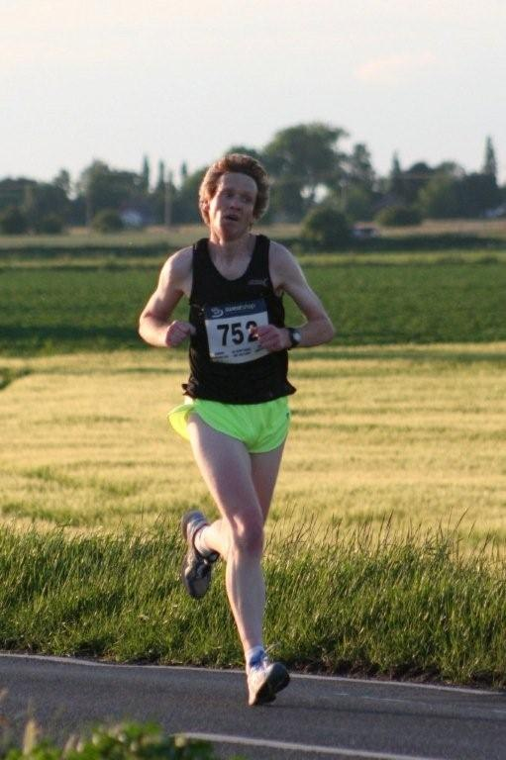

The club’s annual Straight Mile Handicap yielded its usual selection of impressive performances: for full details, see the race report on the website. Special mention, however, must go to Craig Holgate, who removed 19s from the senior men’s club record, and Peter Harris, who improved his own M55 club record by 5s.

Making his triathlon debut, Peter Foody was 38th out of 262 finishers in the Norwich Triathlon. This was all the more impressive given that the event was over the full Olympic distance, complete with an open-water swim.

The Thetford Forest Run/Bike Challenge has become an annual favourite for several Ely Runners. This year, Peter Gipp and Steve Pettit won the event outright, whilst Adam and Natalle Etches were second mixed team – all the more impressive because Adam had to cycle the last muddy 3 miles with a puncture!

CONTRIBUTIONS TO THE NEWSLETTER
As ever, please send your contributions to the newsletter to me (Rachel Roberts) at: newsletter@elyrunners.co.uk. Many thanks!

RR
July, 2009
newsletter@elyrunners.co.uk
USEFUL INFORMATION

Data Protection
Email circulations by the club to members are done by the Bcc (confidential) option so that member’s email addresses are not circulated and also these do not take up most of the first page of emails.
See www.elyrunners.co.uk > CLUB INFO > administration for the club’s policy on data protection and use of photos and videos on the club’s website.

Membership
Subscription renewals (£10) were due from 1st January 2009. Members who joined after 15th November 2008 are covered for 2009.

To renew online:
Go to www.elyrunners.co.uk > CLUB INFO > Membership
OR
Send a cheque, payable to ‘Ely Runners’, to Club Secretary: John Turner, 22 Cromwell Road, Ely, Cambs, CB6 1AS.

If you did not renew your membership by the end of March 2009, you will be removed from the membership list and will no longer be entitled to attend training, represent the club in races, take part in club championships, claim affiliated entry fees, or wear club colours.

Benefits of membership include:
- £2 affiliated discount on open race entries
- club affiliations to ARC, ABAC, UKA, EA, TRA, FRA & CAA
- free registration (£5) with EA until 31st March 2010 (on request via John Turner)
- free changing and showers at the Paradise Centre
- free training and coaching advice
- free high-visibility bib for night-time training
- £12 subsidy on club fleeces
- 10-20% discount at most specialist running kit shops
- free entry to the club’s Cross-Country Championships, 10k Handicap and Straight Mile Handicap
- free entry to the six Frostbite League races
- free club team entry to county, regional and national championships and for club relay entries
- entry into the draw (if a member’s ballot entry is rejected) for the club’s guaranteed London Marathon places
- free snacks at club social events
- shared transport to races

Supporting the Club and its Events
Ely Runners hold three popular open races each year (Turing Trail Relay, Grunty Fen Half Marathon, and Ely New Year’s Eve 10k Road Race) that contribute considerably to the club’s reputation and financial stability. This enables the club to provide the many benefits listed above. In return, members are expected to show commitment to the club by helping with these events and taking their share of responsibility. Please don’t just rely on the usual loyal helpers and think of the club only as a convenient way to promote fitness and enter races. We’re all busy these days but commitment is realising the mutual benefits of putting something back into the club and sport we enjoy.

Training
For details of club training sessions at 7pm on Tuesday (intervals/hills) and Thursday (steady 5-8m runs) evenings, please see the homepage of the club’s website. Details of 9am Sunday morning training runs are usually circulated by email a few days in advance.

When meeting at the Paradise Centre for training on Tuesdays and Thursdays, please assemble either in the balcony/bar area upstairs or outside, around the corner by the side of the building. Please do NOT assemble in the foyer or outside the main entrance.

The meeting place for Sunday morning runs is the Paradise car park. The car park toilets are open by 9:00 am and the Paradise Centre is open for showers afterwards.

Please ensure that new members, some of whom are new to running, feel part of the club and are not left alone on training runs.

Club training sessions are intended to cater for a wide range of abilities and racing objectives. If you require specific coaching advice, please ask Club Coach Alan Rutterford to help.

To measure the distance of a route before or after running, see Google Earth > Ruler (toolbar symbol) > Path. Provided measurement is done carefully, the distance should be of similar accuracy as GPS.

Club Noticeboard
This is in the foyer of the Paradise Centre, to the right of the main entrance. It includes details of club events, training sessions, route maps, local races and other events of interest to members. There are usually several copies of race entry forms on the board but please leave the last copy or ask staff at reception to photocopy (Ely Runners' account) a few more copies.

Club Website
Webmaster, Rod Baron, maintains the Ely Runners’ website (www.elyrunners.co.uk) to provide an up-to-date record of the club's activities and a myriad of useful information. The website is frequently updated and well worth regular visits. For member’s general comments, there is a Message Board on the website’s home page and the recently upgraded photo and video section contains a huge selection of members in races. Rod also maintains the club’s websites for the Grunty Fen Half Marathon, New Year’s Eve 10k, and Turing Trail Relay.

Club Library
Grade 2 coach Max d'Ayala has selected a range of books on running and injuries for use by club members. Please see http://www.dayala.co.uk/elyrunners/booklist.htm for details: they have been chosen to provide a combination of interest, information, advice and stimulation for all standards of runners. The books are stored in the club's locker (authenticate membership and ask for key at Reception) at the Paradise Centre staff room. Please record which books you have borrowed in the notebook in the club's locker.

John Turner has the latest (2009) Fell Runners Association Fixtures Calendar & Handbook. Members interested in running a fell race can borrow this booklet. Most fell races are ‘up north’, though there are also many in Wales and other hilly areas of the UK. There is a huge choice throughout the year, including many evening races in the summer, some not too far away in areas like the Peak District. Alternatively, if on holiday in such areas, you can often find a local fell race. They provide an enjoyable, challenging and worthwhile experience, even for Fenland-based runners.

A recent addition to the club’s library includes ‘Feet in the Clouds – A Tale of Fell Running and Obsession’ by Richard Askwith.

Racing
Some open races are very popular and reach the entry limit before the race day. Many races no longer accept entries on the day (marked ‘no EOD’ in the Races & Events Guide). If you are thinking of entering a race on the day, check with the organisers or on the race website before setting out that a place is still available – turning up does not guarantee that the organisers will allow you to run!

Wearing Club Kit
Members wear their Ely Runners’ colours with pride in races far and wide (see www.elyrunners.co.uk > RESULTS) and are encouraged to do so whenever appropriate. Guidelines to wearing Ely Runners' colours (minimum club vest) in all events entered as an individual or team member of Ely Runners are as follows:
1. Obligatory requirement of governing athletic organisations in leagues entered by the club, relays entered for or by the club, all championships and events incorporating championships. Exceptions are members running for county, regional or national teams when they will be given the appropriate team kit to wear.
2. Necessary to avoid disqualification as a team member in open races.
3. Members normally wear their club kit in open races but there are recognised exceptions such as representing a charity, necessary kit change in an ultra run, spur of the moment race entry, non-availability of kit for whatever reason etc.
4. Not wearing club kit also makes it harder for other runners, race officials, and photographers to distinguish club runners, especially in relays.
5. Our distinctive race kit defines us as ambassadors of a well-respected running club.

Race Results
When you send your race results to Stephen Howard (results@elyrunners.co.uk), please advise if you have achieved a PB (including in vet categories), so that it can be included in press reports and to update PB information on the website. If possible, please send Stephen any information you have (including links to race results) by noon on Monday to avoid the extra work involved in updating press reports. Please email any photographs or links to event photographs (with your race number) to Rod Baron at webmaster1@elyrunners.co.uk.

Several members have put themselves on www.athleticsdata.com. This is a statistical website showing:

- UK year rankings
- All-time rankings
- Comprehensive results service
- Athletes’ profiles

This website will enable you to check your form relative to rival runners and allow them to do the same. It’s also useful for the prediction of race results for both runners and organisers.

Payment of club entries into championships, relays and leagues will be funded by the club provided they are team entries made by the club. The club will not pay for individual entries into open races that have an incorporated championship.

To take part in UKA National and SEAA championships, members need to be registered with England Athletics (EA). Also, a few open events still require EA registration to claim affiliated entry fees. However, most events (especially locally) either have ARC permits or, if they have UKA permits, require only membership of an EA affiliated club, like Ely Runners. Please could members who would like to be registered from 1st April 2009 with EA for 2009-10 please contact John Turner secretary@elyrunners.co.uk. It was agreed at the recent AGM that the club will pay the £5 registration fee. Registration number confirmation and cards will be supplied when received from EA.

To enter a County (eg Cambs AA) or Regional (eg SEAA) Championship, members must have been born in the county/region or had 9 months of continuous residency. If you qualify by birth and residency for different counties, you may only run for one county/region during each competition year from October to September.

Club vets who are not members of EVAC may run as guests of the club’s EVAC members in EVAC Championships. EVAC events are included in the Races and Events Guide and can be entered by sending an email to eastvetm75@ntlworld.com. Subject to the availability of funds, the club will pay for club team entries to EVAC and BMAF Championships. EVAC website: www.evac.org.uk
BMAF (vets) events are too numerous to include all of them but they have been circulated to EVAC members via regional and national veteran magazines or see www.bmaf.org.uk/fix/fix.asp

Running Kit
Mary Gates oversees the club’s kit supplies. The club’s joining fee of £33 includes a free club race vest and shorts. Please contact Mary on 01353 861379 or mary@elyrunners.co.uk to order. See www.elyrunners.co.uk for full details of club kit.

New club vests now have the Ely Runners’ cathedral logo top centre on the front. Any members with older vests who would like to have the logo added will need to give their vest to Mary to send. The cost (£1.20 for the transfer + 25p for application) will be covered from club funds. Race vests will continue to have ELY RUNNERS on the back.
Club fleeces are available from Mary Gates at the subsidised price of £10 to members only. This price is for one fleece per member. Subsequent fleeces will be at the cost price of £22.
.

Discounts on Kit Purchases
If you buy running kit from Advance Performance at Cambridge or Peterborough, please show them your membership certificate and the club will receive 10% towards vouchers that we use for prizes for our Christmas charity raffle. Advance Performance do not otherwise give discounts. Other running shop suppliers such as Sweatshop in Cambridge (who sponsor our three open races: New Years Eve 10k, Turing Trail Relay, and Grunty Fen Half Marathon) will usually provide a 10% discount to members on production of a valid membership certificate.

Natalle Etches has purchased a wide variety of fitness stock from a local Internet fitness company that closed down. She is re-selling the stock as low as half price to club members. The stock includes cycling, running, fitness and triathlon wear from brand names including Craft, Gore Bike Wear, Pearl Izumi, and Sugoi. If you’re interested, speak to Natalle at one of the training sessions or contact her on natalle@elyrunners.co.uk.

Social Events
Julie Foreman organises the club’s After Training Drinks on the first Thursday of the month. The next will be after training on Thursday 2nd April.

RACES & EVENTS GUIDE 2009

This includes local area/easily accessible races, club, county, regional and national championships, and a selection of UK/overseas events previously enjoyed by members.

August
02 Wellingborough 5m, 1030 Old Grammarians Sports Field, Wellingborough, £8, WWW.familysupportlink.co.uk
07 (Fri) Wibbly Wobbly Log Jog (5m TR), 1930 Brandon Forest, £6, no EOD, www.bfh.org.uk
07 (Fri) Blisworth 5m, 1930 Blisworth Football Club, Northants, £6 or £11 for series, www.woottonroadrunners.co.uk

09 Wandlebury 5m XC, 1030 Wandlebury Woods, Shelford, £7 (+£2 EOD)

09 Great Yarmouth RR Half-Marathon, 1000 Emerald Park, Gorleston F.C., £10 (+£2 EOD)

16 Thorney 5m (CRRL), 1030 Bedford Hall, Thorney, nr Peterborough, £7, www.thorneyrunningclub.co.uk
16 Reepham Summer Sunday Run 10k (multi-terrain), 1000 Reepham, Norfolk, £8 (+£2 EOD)
19 (Wed) Nene Valley Harriers 5k (Cambs County Championship & CRRL) (prov date)

September
06 Wissey Valley ½ Marathon (EVAC & Norfolk Champs), 1030 Oxborough Village Hall, www.rystonrunners.org.uk
06 Budapest Half-Marathon, Budapest, www.budapestmarathon.com
06 Littleport Leisure 10k Run, 1045 Leisure Centre, £8, www.littleport10k.co.uk
13 Grunty Fen ½ Marathon (Cambs County Championship & CRRL), 1030 Witchford Village
College, Ely, www.gruntyfen.co.uk
13 The Jubilee 5, 1100 The Marriotts School, Telford Ave, Stevenage, £9.50 (no EOD), http://www.fvspartans.org.uk
13 Bourn to Run 10k, 1030 Bourn Recreation Ground, Bourn (Cambs), £10, http://www.bournschool.co.uk/
13 Langham 10k, 1100 Langham Community Centre, Langham, Essex, langham10k-registrations@yahoo.co.uk
19/20 (Sat/Sun) Round Norfolk Relay, www.roundnorfolkrelay.com
19/20 (Sat/Sun) Isle of Wight Fell Running Series, 3 races over 2 days, www.rydeharriers.co.uk
20 Cransley Hospice 9th Annual 10k and Half-Marathon, 1100 Cranford, Nr Kettering, £12 (+£2 EOD), www.cransleyhospice.org.uk
26 (Sat) SEAA Road Relay Championships – Senior and veteran women, Rushmoor Arena, Aldershot
27 SEAA Road Relay Championships – senior and veteran men, Rushmoor Arena, Aldershot
27 Arthur Rank Hospice Charity 8k, 1000 Jubilee Gardens, Ely, teams £40 (2 x 3k run + 2 x 1k walk), www.arhc.org.uk or tel 01223 723115

October
04 SEAA 10k Road Running Championships, 1100 Crystal Palace, London, www.seaa.org
04 Budapest Marathon, Budapest, www.budapestmarathon.com
04 New Balance English Half-Marathon, 0900 Centre Park Warrington, £27 (no EOD), http://www.english-half.co.uk/
10 (Sat) Peddar’s Way Relay (teams of 4), Castle Acre to Holme-Next-The-Sea, www.rystonrunners.org.uk
11 Great Eastern Run ½ Marathon, 1100 Laxton Square, Peterborough, £18 (no EOD)
18 Ampthill Trophy XC, Ampthill, Beds, www.AmpthillTrophy.org.uk (more details to follow)
25 Fenland 10m (CRRL)
24 (Sat) Beachy Head Marathon (3,500’ climb), 0900 Eastbourne, depart Paradise 0500

November
04 Loch Ness Marathon (&10k/5k), www.lochnessmarathon.com
15 St Neot’s ½ Marathon, 1000 St Neot’s Recreation Centre, http://www.half.riverside-runners.com/
21 (Sat) SE Inter-Counties XC Championships, Parliament Hill, London, www.seaa.org
22 Hereward 4 Stage Relay (39.1m Peterborough to Ely), club teams, provisional date

December
20 Long/medium/short club pre-Christmas trail training runs, Woodditton to Ely 18.5m,

Woodditton to Chalk Pit 12m, Reach to Ely 11m, Woodditton to Reach 7.5m, meet 0800

Paradise for transport to starts
26 (Sat) Boxing Day training, meet 0900 Paradise Centre car park
31 (Thu) The 10th Ely New Year's Eve 10k Road Race, 1100 Lt Downham, entries on-line
only, no EOD, www.newyearseve10k.co.uk

2010

January
30 (Sat) SE XC Championships, Parliament Hill, London, www.seaa.org

NOTES

Races and events are on Sunday unless otherwise mentioned.

Race entry fees are the affiliated (ARC/UKA or just UKA registered) fees

Courses are roads and/or hard footpaths/cycle ways unless otherwise mentioned.
Distances without units (m or k) are probably m = miles.
Frostbite League races are 5-6 miles and entry (league membership) is paid for by the club.
Further details of events from the Club notice board in the Paradise Centre foyer, running magazines, websites, or from John Turner secretary@elyrunners.co.uk) who also has details of all RRC/TRA long distance road/TR/XC races and FRA fell races.

National, regional and county championship team entries are via Charlie Barker (captain@elyrunners.co.uk).

Club championship & club handicap entries are via Steve Tovey

Long distance team relay entries are via Alan Rutterford and paid for (if funds available) by the club.

Club website www.elyrunners.co.uk
Grunty Fen 1/2M website www.gruntyfen.co.uk
NYE10k website www.newyearseve10k.co.uk
Turing Trail Relay website www.turingrelay.co.uk
Association of Running Clubs www.runningclubs.org.uk

Rachel Roberts
July 2009
newsletter@elyrunners.co.uk

