Ely Runners Newsletter
April 2011



NEW MEMBERS

We warmly welcome the following new members who joined the club this month. Look forward to seeing you all at training and club social events!

Graham Riminton
Gary Elcombe
Luke Crisp
Sharon Leonard
Lewis Leonard

NEWS & NOTICES

Ely Runners bid for glory in the London Marathon
17 Ely Runners will take to the streets of the capital later this month, all aiming for personal bests or just to get round the course for the first time.

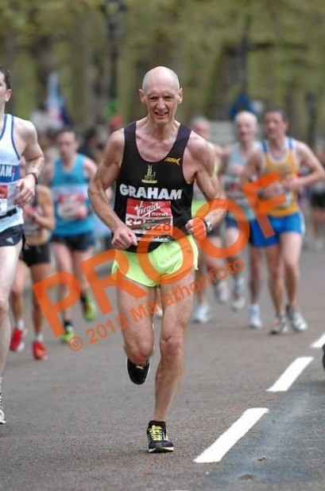
Graham Chapman
The list of known ER participants is:

Emily Knight
Fraser Badcock
Hannah Shiell
Ian Blatchford
John Manlow
Jon Pennington
Jose Perez
Kieren Drane
Melanie Fisher
Stephen Petitt
Stephen Tovey (WRVS)
Steven Hardwick
William Wilson
Graham Chapman
Nicola Bramley
Mark Turner
Clare Durrant

Eric Drury and his 'Disco Tropicana' will be in its usual place outside the Tooke Arms in West Ferry Road at about 16.5 miles to cheer them on. Good luck to you all!

Robyn Seabright wins Sports Girl of the Year award
Junior Ely Runner Robyn Seabright was recently named Key Stage 3 'Sports Girl of the Year' by her school Witchford Village College.
The award was given in recognition of her all round performance in many sports and activities, representing the College and District (basketball, netball, rounders badminton and football) and County (Cross Country); her role as a college Young Ambassador (being a role model and leader at local Primary Schools sports festivals) and her commitment to sports outside of college (korfball, netball and running).

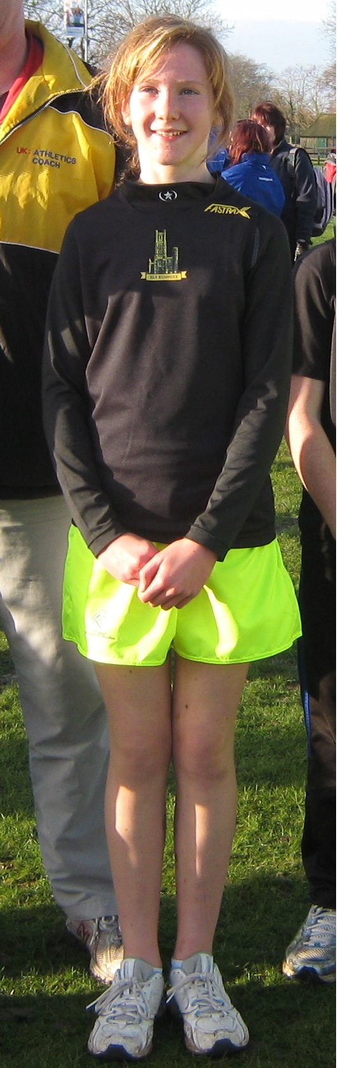
Robyn Seabright
Frostbite Tribute - Diana Gipp
The final Frostbite of the 2010 – 2011 season took place at Hinchingbrooke Country Park. Before the race Chairman Stephen Howard said a few words in memory of Diana Gipp who sadly passed away on February 17th. The assembled runners responded with applause.

Contributions to the Newsletter
If any members have any short articles about their running experiences which other members may find useful, interesting or just entertaining, please send them with a suitable picture (800x600, portrait) to newsletter@elyrunners.co.uk

CLUB EVENTS

Turing Relay attracts hard core cross country enthusiasts
12 hardy souls took part in the club Turing Trail Relay on Sunday 20th March, split into four teams of three which ran from Minster Place in Ely to the outskirts of Cambridge and back again.

After a particularly warm Saturday the wintry weather came as something of a shock to many of the runners, as did the perils of over familiar dogs, a tough going dry and uneven riverbank, and a consistently strong headwind on stages one and two. Not forgetting, of course, the self-navigation aspect which once again proved a source of confusion for a minority or participants.

Official Results 1st Team A (Linden Smith 1:40:05, Lionel Smith 1:01:47, Kieren Drane 1:19:49) 4:01:41 2nd Team C (Mark Turner 1:36:34, Adam Etches 1:00:21, Steven Hardwick 1:42:39) 4:19:34 3rd Team B (Stephen Howard 1:40:05, Matt Holmes 1:05:53, Peter Harris 1:37:32) 4:23:30 4th Team D (Steve Tovey 1:27:14, Ashley Blackmore 1:03:41, Stuart Baumber 2:02:49) 4:33:44
Stage one runners 11.7-miles, 1st Steve Tovey in 1:27:04, 2nd Mark Turner in 1:40:05, joint 3rd Linden Smith and Stephen Howard in 1:40:05
Stage two runners 8.0-miles, 1st Adam Etches in 1:00:21, 2nd Lionel Smith in 1:01:47, 3rd Ashley Blackmore in 1:03:41 and 4th Matt Holmes in 1:05:53
Stage three runners 12.1-miles, 1st Kieren Drane in 1:19:49, 2nd Peter Harris in 1:37:32, 3rd Steven Hardwick in 1:42:39 and 4th Stuart Baumber in 2:02:49

Unfortunately no pictures of the event are available owing to the Newsletter Editor forgetting his camera (sorry).

SOCIAL EVENTS

After training drinks
After training drinks are usually held on the first Thursday of each calendar month, with all members more than welcome to attend. That said (and providing this newsletter reaches you on time), the next opportunity to see what your training partners look like with their clothes on will be Thursday 7th April at the West End pub from around 8:30pm onwards. Further information is available from Julie Foreman (Julie@elyrunners.co.uk).

SELECTED RESULTS ROUND-UP – February

Nicetri Hurden 9 - Offord D’arcy
Three Ely Runners travelled to Offord D’arcy to take part in the inaugural Nicetri Hurden 9. The race was named after Riverside Runner Derek Hurden who sadly passed away following a training run in February 2009.
Official Results 6th Maurice Reed 0:55:03 (1st MV40) 40th Heidi Uff 1:07:01 43rd Melanie Fisher 1:07:49 94th Colin Doak 1:25:11

English Schools XC Champs – Wollaton Park, Nottingham
Ashley Pettit competed in the ASAA XC Championships at Wollaton Park in Nottingham. A team of 8 selected from schools in the county represented each county. Ashley ran in the intermediate boy’s event over 5.7km of mud/grass/sand & incorporating hills (a testing course).
Official Results 147th Ashley Pettit 19:49

Lydd Half Marathon – Lydd, Kent
Stuart Baumber and Sarah Edwards travelled down to Lydd to take part in the mixed terrain, out and back race on a very flat and exposed route across the desolate landscape of the Kent coast, but with new born lambs to look at and the chance to cool off with retail therapy at Primark on the way home.

Official Results (gun time) 158th Stuart Baumber 1:43:58:20 159th Sarah Edwards 1:43:58:25

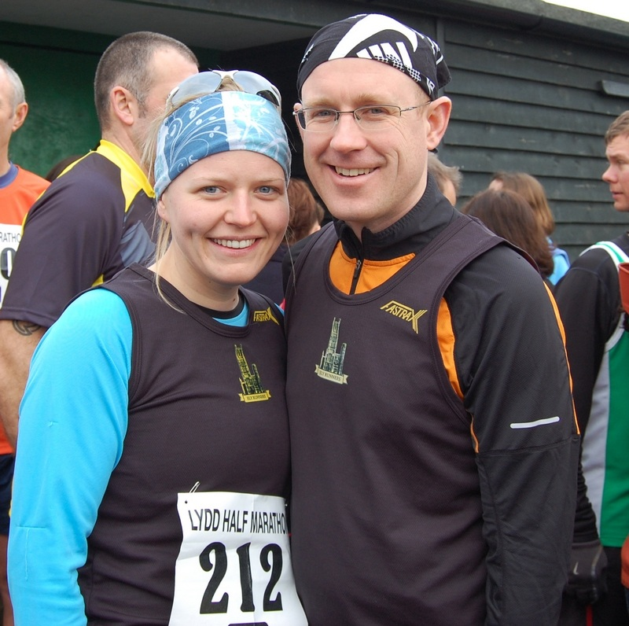
Sarah Edwards and Stuart Baumber finishing together at the Lydd half marathon

Wymondham 20m – Norfolk
Three Ely Runners took part in a race involving 2 laps of quiet country roads.
Official Results 11th Kieren Drane 2:10:23 (PB) 87th Mel Fisher 2:37:22 (PB)(1st 20m)(1st Senior Lady) 108th Ian Blatchford 2:43:10 (PB)
Norwich Half – Norwich, Norfolk
Official Results (Chip Times) 13th Stephen Pettit 1:17:19 (1st MV45) 629th Tanya Shenton 1:47:03 (PB) 640th Miranda Paul 1:47:15 (PB)

Nene Valley 10 – Peterborough
Official Results 9th Stephen Pettit 58:53 (New Club MV45 Record by 1 second) 12th John Manlow 59:52 13th John Uff 1:00:00 (PB) Second Claim

Silverstone Half Marathon – Silverstone Race Track
Official Results 1641th Fraser Badcock 1:49:24 1882nd Jason Pattinson 1:51:18 (PB)

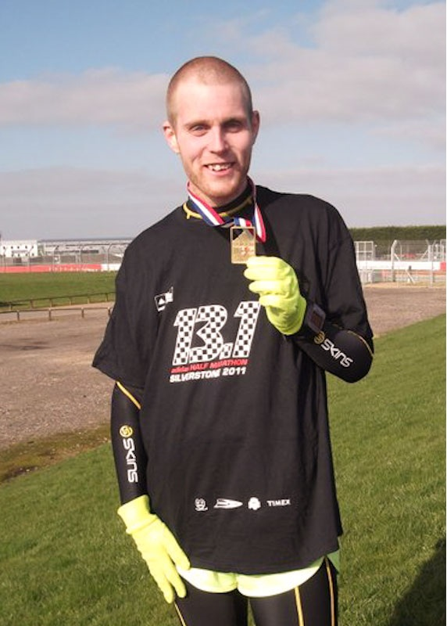
Jason Pattinson
Cambridge University Hare and Hounds Boundary Run – Cambridge
Official Results Half Marathon – 477 finishers 33rd Jason Mann 1:30:31 72nd Jose Perez 1:38:30 79th Graham Chapman 1:39:00 227th Linden Smith 1:52:19 303rd John Crawford 2:00:21 343 Francesca Crawford 2:05:46 351st Miranda Paul 2:08:04 Full Marathon - 144 finishers 24th Graham Chapman 3:31:58 106th Miranda Paul 3:54:41 Men’s Team 6th Total Time 6:41:19 Jason Mann 1:30:51 Jose Perez 1:38:30 Graham Chapman 3:31:58 Ladies Team 5th Total Time 8:51:46 Linden Smith 1:52:19 Francesca Crawford 2:05:46 Miranda Paul 4:53:41

Event photographs
Race/club event photographs should now be sent to Charlie Barker - (charlie@elyrunners.co.uk) Ideally they should be resized to 800x600 pixels (ish) and preferably be less than 100k in size.

FORTHCOMING EVENTS

EVENTS GUIDE

Other Events

See the following RACES & EVENTS GUIDE starting on below

RACES & EVENTS GUIDE 2011
This includes local area and easily accessible races, club, county, regional and national championships, and a selection of UK/overseas events previously enjoyed by members.
Cambridge 5k Park Runs (at Milton) are every Saturday at 0900. Entry is free but before your first race, register on-line by 1800 on Friday, www.parkrun.org.uk/cambridge/Home.aspx
April
03 Belvoir Half-Marathon, Harby, www.hosevillage.org.uk/bhm.htm
03 Broadland Half-Marathon, South Walsham, www.nrr.org.uk
03 Cambridge Cambourne 10k, www.cambridgefestivalofrunning.com

03 Cambs AA General Meeting, Hemingford Grey
03 Friskney Half-Marathon, Boston, www.bostonanddistrictac.com
03 Grantham Cup 10k Trail Race, www.granthamac.com/road/grantham_cup.htm
03 Lincoln 10k, Lincoln, www.lincoln10k.co.uk
03 Sandy 10m, Sandy, www.sandy10.org.uk
08 (Fri) Cambs AA General Meeting, Hemingford Grey
10 Bungay Marathon & Half-Marathon, www.bungayblackdogrunningclub.co.uk/marathon/about.asp
10 Flitwick 10k, free 1m Junior FR, www.flitwick10K.org.uk
10 Newham Classic 10k, Stratford, London, www.newhamclassic10k.com/
17 Virgin London Marathon, www.virginlondonmarathon.com
19 (Tue) Eastern Athletic Assoc. AGM, Cambridge
20 (Wed) Great Yarmouth 5m Series (Race 1), www.gyrr.co.uk
22 (Fri) Sudbury 5m Fun Run
24 Monster Racing Duathlon, Littleport, www.monsterracing.net
24 St. George's Day 10k & Half-Marathon, Wellingborough, www.ultramarathon.org.uk
24 Trowse 10k, Trowse, Norwich, www.conac.org.uk
24 Tulip 10k Charity Road Race, Salding, www.spaldingtri.co.uk
30 (Sat) 3 Peaks Race, www.threepeaksrace.org.uk/raceinfo2011
May
01 Bespak Grand East Anglia Run (GEAR) 10k/1.2m FR, King's Lynn, www.grandeastangliarun.co.uk
01 Glastonbury Road Run 3k/5k/10k/FR, www.glastonburyroadrun.info
01 Suffolk Heritage Coast Run/Walk, Thorpeness
01 Titchmarsh 10k, Kettering, www.titchmarshplayingfield.org.uk/events/10k.php
02 (Mon) Ashdon 10k & 3k, Ashdon, Saffron Walden, ashdon.handycandy.co.uk/
02 (Mon) Breckland 10k, Croxton, www.thetford-ac.co.uk
02 (Mon) Great Weston 5m, Towcester, www.greatweston5.co.uk
04 (Wed) EVAC Track & Field, Match 1
04 (Wed) Great Yarmouth 5m Series (Race 2), www.gyrr.co.uk
04 (Wed) Silverstone Grand Prix 10k, Silverstone Race Circuit, www.silsonjoggers.org.uk
05 (Thu) Newmarket Heath 6k, newmarketjoggers.co.uk/?page_id=1221
07 (Sat) Fen Drayton 10k & FR, www.fendrayton10k.org.uk/
08 Bluebell 5m, Benfleet, users.aber.ac.uk/aiv/bluebell5.htm
08 Colchester Trinity Rotary Charity 10k, Colchester, www.colchestercharityraces.org
08 Eye 10k & 3k FR, Eye, www.eye10k.co.uk
08 Frinton & Walton Half-Marathon, Frinton-on-Sea, www.ttc.uk.net
08 Frostbite Friendly League AGM
08 Halstead & Esse Marathon, Halstead, www.halsteadandessexmarathon.co.uk
08 Rotary Shakespeare Marathon, Stratford-upon-Avon, www.shakespearemarathon.org.uk
08 Saffron Crocus Trail 10, Saffron Walden, www.saffroncrocustrail.co.uk
13-15 European Road Races & Walks, Thionville, France
14 (Sat) Cambs AAA Track & Field Championships, Wilberforce Road, www.cambsathletics.org.uk
14 (Sat) Frostbite Presentation Evening, www.frostbiteleague.org.uk/Presentation/Presentation
15 Deepings Rotary 10k & 3k FR, Deeping St. James,
15 Dereham 10m, www.derehamrunners.co.uk/
15 Ross Peers Half-Marathon, Soham, www.rosspeers-sportscentre.co.uk/
15 Shuttleworth 5m Trail Race, Shuttleworth College
15 Woodbridge 10k, www.woodbridgeshufflers.org.uk/
18 (Wed) Great Yarmouth 5m Series (Race 3), www.gyrr.co.uk
21 (Sat) BMAF Road Relays, Sutton Coldfield, www.bmaf.org.uk
22 Great Baddow Charity Race 10m, Chelmsford, www.baddowraces.org.uk
28 (Sat) Eastern AA Track & Field Championships, Cambridge University Track
29 Bupa London 10k, www.london10000.co.uk/
29 CAU Inter County Track & Field Championships, Bedford Stadium
June
01 (Wed) EVAC Track & Field, Match 2
04 (Sat) Moulton Race Walks 5m, 1k (10+) & 500m (-10)
05 (Sat) BMAF Track 10k Champs, Oxford
05 Harewood House Chase 10k (Near Leeds), www.bingleyharriers.org.uk/html/harewood/hwood.htm
08 (Wed) Peterborough 5k series Race 1, Ferry Meadows, Peterborough
09 (Thu) Ely Runners 10k Club Handicap (Private Event)
11 (Sat) South Downs Marathon & Marathon relay, Petersfield www.209events.com/uk-events-lists.php
12 Abbey 10k & 3k FR, Ramsey, www.ramseyroadrunners.org.uk
12 The Heroes Half-Marathon, ATR Brassingham, Royston, www.endurorunning.com
17 (Fri) Marston Forest 5k, www.MarstonForest5K.org.uk
17 (Fri) Summer Solstice 10k, Grantham, www.granthamrc.btinternet.co.uk/solstice_10k
18 (Sat) Trionium Picnic Marathon/Half-Marathon, Box Hill, Surrey, www.trionium.com
19 BMAF 5k Road Champs, Horwich
19 Huntingdon 10k charity run, Huntingdon, www.huntingdon10kcharityrun.co.uk
22 (Wed) Peterborough 5k series Race 2, Eye, Peterborough
25 (Sat) Greensand Ridge Relay (6 stages/33m) Leighton Buzzard to Bedford, www.smoc.info/GSRR/
26 Humpty Dumpty 10k, Great Yarmouth, www.gydac.org.uk/roadrunning
26 Sutton Feast Beast, 7m, Sutton
26-27 BMAF Track & Field Champs, Birmingham
July
06 (Wed) EVAC Track & Field League, Match 3
06 (Wed) Peterborough 5k series Race 3, Ferry Meadows, Peterborough
06-17 World Masters T & F Champs, Sacremento, California, USA
10 Bushy 10k, Bushfield, Peterborough, www.bushfieldjoggers.co.uk/
14 (Thurs) Ely Runners 1m Club Handicap (Private Event)
17 St. Ives 10k & 3k FR, www.huntsac.org.uk
20 (Wed) Peterborough 5k series Race 4, Stamford
24 Luton 10k
24 Spartan Race 5k with obstacles, ATR Bassibgbourn, Royston, www.spartanrace.com/
27 Bungay 10k
29-31 (Fri-Sun) Montane Lakleand 100m, www.lakeland100.com
30/31 (Sat/Sun) Montane Lakeland 50m, www.lakeland100.com
31 EVAC Track & Field Champs, Kings Lynn
August
03 (Wed) EVAC Track & Field League, Match 4
03 (Wed) Peterborough 5k series Race 5, Werrington, Peterborough
07 Veterans Inter Area Competition, Solihull
11 (Thu) Eye 5m Charity Race, Eye, www.eyerunners.co.uk
14 Great Yarmouth Half-Marathon, www.gyrr.co.uk
14 Thorney 5m, outa-stock.co.uk/trc/raceinfo.htm
16-25 European Vets Championships, Stadia
21 BMAF Half-Marathon Champs, Leek
21 Monster Racing Middle Triathlon, Ely, www.monsterracing.net
September
04 BMAF 10m Road Champs, Hexham
04 Budapest Half-Marathon, www.budapestmarathon.com
04 Ely sprint triathlon & Aquathlon, Ely, www.entrycentral.com
04 Wissey Half-Marathon, www.rystonrunners.org.uk/
11 EVAC Track & Field League Final, Bedford
11 Grunty Fen Half Marathon, Witchford, www.gruntyfen.co.uk
17/18 (Sat/Sun) Round Norfolk Relay, www.roundnorfolkrelay.com
21-24(Wed-Sat) Great Barrow Challenge, Suffolk, www.greatbarrowchallenge.co.uk
October
02 BMAF 10k Championships, Exmouth
02 Budapest Marathon, www.budapestmarathon.com
02 Royal Parks Half-Marathon, London, http://royalparkshalf.com/
22 (Sat) Beachy Head Marathon, www.beachyheadmarathon.org.uk/events/BeachyHeadMarathon.aspx
23 Ampthill Trophy XC, www.AmpthillTrophy.org.uk
23 East Coast 10k, Great Yarmouth, www.gyrr.co.uk
23 Trionium Greensand Marathon, Dorking, www.trionium.com
30 Fenland 10, Wisbech, www.fenlandrunners.org.uk/
November
06 Adnams Great Eastern Run, www.bungayblackdogrunningclub.co.uk
20 St Neots Half-Marathon, www.riversiderunnersraces.co.uk
27 Bath hilly Half-Marathon, Bath, www.trionium.com
27 (prov date) Hereward Relay, www.marchathleticclub.co.uk
December
02 (Fri) Ely Runner's Christmas Buffet & Drinks, (Private Event) Cutter Inn, Ely (Prov)
11 Bedford Harriers Half-Marathon, www.bedfordharriers.co.uk/
18 Club Pre-Christmas training runs, (Private Event) Woodditton/Ely 18.5m, Woodditton/Reach 7.5m, Reach/Ely 11m. Lunch afterwards at the High Flyer
31 (Sat) Ely New Year’s Eve 10k Road Race, 1100 Little Downham, www.newyearseve10k.co.uk
NOTES
Races and events are on Sunday unless otherwise mentioned.
Many events also have a concurrent Fun Run. These can provide valuable racing experience for junior members and beginners. Check the main race information for details.
Courses are usually on roads and/or hard footpaths/cycle ways unless otherwise mentioned.
Distances without units (m or k) are probably m = miles.
Frostbite League races are about 5-6 miles for seniors and 1.5m for juniors. Entry (league membership) is paid for by the club.
Further details of events from the Club notice board in the Paradise Centre foyer, running magazines, websites, or from Steve Tovey, secretary@elyrunners.co.uk who also has details of all RRC/TRA long distance road/TR/XC races and FRA fell races.
National, regional and county championship team entries are via Heidi Uff, captain@elyrunners.co.uk but for -13,-15,-17 & juniors, first contact Lesley Wright, lesley@elyrunners.co.uk.
Ely Runners’ private club XC championships, 10k/1m handicaps, and TTR relay entries are via Matthew Holmes, (matt@elyrunners.co.uk).Long distance team relay entries are via Alan Rutterford, alan@elyrunners.co.uk and paid for (if funds available) by the club.
Social events are via Julie Foreman, julie@elyrunners.co.uk
Junior training details from Junior Representative/Club Coach Alan Rutterford, alan@elyrunners.co.uk
Junior race details from Junior Secretary Lesley Wright, lesley@elyrunners.co.uk
Club website: www.elyrunners.co.uk
Grunty Fen 1/2M website: www.gruntyfen.co.uk
NYE10k website: www.newyearseve10k.co.uk
Turing Trail Relay website: www.turingrelay.co.uk
Association of Running Clubs website: www.runningclubs.org.uk
Last Updated 02/04/2011

